UNITED STATES
SECURITIES AND EXCHANGE COMMISSION
WASHINGTON, D.C. 20549

SCHEDULE 14A
Proxy Statement Pursuant to Section 14(a) of the
Securities Exchange Act of 1934
(Amendment No. )

Filed by the Registrant ☒ |  | Filed by a Party other than the Registrant ☐
Check the appropriate box:

☐ |  | Preliminary Proxy Statement
☐ |  | Confidential, for Use of the Commission only (as permitted by Rule 14a-6(e)(2))
☒ |  | Definitive Proxy Statement
☐ |  | Definitive Additional Materials
☐ |  | Soliciting Material Pursuant to § 240.14a-12
EAGLE MATERIALS INC.
(Name of Registrant as Specified In Its Charter)
(Name of Person(s) Filing Proxy Statement, if other than the Registrant)
Payment of Filing Fee (Check all boxes that apply):
☒ | No fee required
☐ | Fee paid previously with preliminary materials
☐ | Fee computed on table in exhibit required by Item 25(b) per Exchange Act Rules 14a-6(i)(1) and 0-11



2023
Proxy Statement and Notice of
Annual Meeting of Stockholders



5960 Berkshire Ln., Suite 900
Dallas, Texas 75225
June 23, 2023
Dear Fellow Stockholder:
It is my pleasure to invite you to our Annual Meeting of Stockholders, which will be held on Thursday, August 3, 2023, at the Douglas Conference Center, 8343 Douglas Avenue, Suite 125, Dallas, TX 75225, at 8:00 a.m., local time. We hope that you will attend the meeting, but we encourage you to vote by proxy whether or not you plan to attend the meeting in person.
This year we are again taking advantage of the Securities and Exchange Commission rules that allow companies to furnish their proxy materials over the Internet. As a result, beginning on June 23, 2023, we are mailing to many of our stockholders a Notice Regarding the Availability of Proxy Materials, or Notice, instead of a paper copy of the materials for the Annual Meeting. The Notice contains instructions on how to access the proxy materials over the Internet and vote online, as well as how stockholders can elect to receive paper copies of the materials. We believe that this process expedites stockholders’ receipt of proxy materials and provides stockholders with the information they need, while also conserving natural resources and reducing the costs of printing and distributing our proxy materials.
If you attend the Annual Meeting and desire to vote your shares personally rather than by proxy, you may withdraw your proxy at any time before it is exercised. Your vote is very important, whether you own one share or many.
Thank you for your continued support and interest in Eagle.

Sincerely,
MICHAEL R. HAACK
President and Chief Executive Officer

EAGLE MATERIALS INC.
5960 Berkshire Ln., Suite 900
Dallas, Texas 75225
NOTICE OF ANNUAL MEETING OF STOCKHOLDERS
To Be Held August 3, 2023

To the Stockholders of Eagle Materials Inc.:
The annual meeting of stockholders of Eagle Materials Inc., which we refer to as the “Company,” will be held at the Douglas Conference Center, 8343 Douglas Avenue, Suite 125, Dallas, TX 75225, at 8:00 a.m., local time, on Thursday, August 3, 2023.
At the meeting, stockholders will:
 | (1) | Elect the four Class II directors identified in the accompanying Proxy Statement, each to hold office for three years.
 | (2) | Vote on an advisory resolution regarding the compensation of our Named Executive Officers.
 | (3) | Vote on an advisory resolution regarding the frequency of future advisory votes on the compensation of our Named Executive Officers.
 | (4) | Vote on the Eagle Materials Inc. 2023 Equity Incentive Plan, which we refer to as the “2023 Plan.”
 | (5) | Vote to approve the expected appointment of Ernst & Young LLP as the Company’s independent auditors for the fiscal year ending March 31, 2024.
 | (6) | Any other matters properly brought before the annual meeting, or any adjournment thereof.
The Company’s Board of Directors has fixed the close of business on June 6, 2023 as the record date for the determination of stockholders entitled to notice of and to vote at the meeting or any adjournment thereof. Only record holders of the Company’s common stock, par value $0.01 per share (“Common Stock”) at the close of business on the record date are entitled to notice of and to vote at the annual meeting. A list of holders of Common Stock will be available for examination by any stockholder at the meeting and, during the ten-day period preceding the meeting date at the executive offices of the Company located at 5960 Berkshire Ln., Suite 900, Dallas, Texas 75225.
For further information regarding the matters to be acted upon at the annual meeting, I urge you to carefully read the accompanying Proxy Statement. If you have questions about these proposals or would like additional copies of the Proxy Statement, please contact: Eagle Materials Inc., Attention: Matt Newby, Secretary, 5960 Berkshire Ln., Suite 900, Dallas, Texas 75225 (telephone: (214) 432-2000).
You are cordially invited to attend the annual meeting. Your vote is important. Whether or not you expect to attend the annual meeting in person, please vote through the Internet (as described in the Notice) or by telephone or fill in, sign, date and promptly return the accompanying form of proxy in the enclosed postage-paid envelope so that your shares may be represented and voted at the annual meeting. This will not limit your right to attend or vote in person at the annual meeting. Your proxy will be returned to you if you choose to attend the annual meeting and request that it be returned. Shares will be voted in accordance with the instructions contained in your proxy, but if any proxies that are signed and returned to us do not specify a vote on any proposal, such proxies will be voted in the manner, if any, recommended by the Board.

By Order of the Board of Directors
MATT NEWBY
Executive Vice President,
General Counsel and Secretary
Dallas, Texas
June 23, 2023
IMPORTANT NOTICE REGARDING THE AVAILABILITY OF PROXY MATERIALS
FOR THE ANNUAL MEETING OF STOCKHOLDERS TO BE HELD ON AUGUST 3, 2023.
Our Proxy Statement and 2023 annual report to stockholders are available
to you at www.proxyvote.com.

TABLE OF CONTENTS

 | Page
Introduction |  | 6
Date, Time and Place of the Annual Meeting |  | 6
Purposes of the Annual Meeting and Recommendations of our Board of Directors |  | 6
About the Meeting |  | 8
Who Can Vote |  | 8
How Proxies Will be Voted |  | 8
How to Revoke Your Proxy |  | 8
Quorum and Required Vote |  | 8
Expenses of Soliciting Proxies |  | 9
How You Can Vote |  | 9
Proposal No. 1: Election of Directors and Related Matters |  | 10
General |  | 10
Director Independence |  | 11
Nominees |  | 12
Recommendation of the Board |  | 12
Director Qualifications |  | 13
Board Meetings and Attendance Records |  | 17
Board Compensation |  | 18
Non-Employee Director Compensation for Fiscal Year 2023 |  | 19
Board Leadership Structure and Role in Risk Oversight |  | 21
Board Committees |  | 22
Compensation Committee Interlocks and Insider Participation |  | 24
How to Contact Our Board |  | 25
Executive Officers Who Are Not Directors |  | 26
Compensation Committee Report |  | 27
Compensation Discussion and Analysis |  | 28
Our Year in Review |  | 28
Named Executive Officers |  | 28
Compensation Philosophy |  | 28
Determining Executive Compensation |  | 31
Primary Elements of Executive Compensation |  | 33
Other Elements of Executive Compensation |  | 39
Other Compensation Policies and Practices |  | 42
Fiscal 2024 Compensation Developments |  | 43

 | Page
Executive Compensation |  | 44
Summary Compensation Table |  | 44
Grants of Plan-Based Awards |  | 46
Outstanding Equity Awards at Fiscal Year-End |  | 47
Option Exercises and Stock Vested |  | 49
Nonqualified Deferred Compensation in FY 2023 |  | 50
Potential Payments Upon Termination or Change  in Control |  | 51
Change in Control Continuity Agreements |  | 51
Payments Made Upon Any Termination |  | 52
CEO Pay Ratio |  | 54
Pay Versus Performance |  | 55
Stock Ownership |  | 59
Management |  | 59
Certain Beneficial Owners |  | 61
Related Party Transactions |  | 62
Delinquent Section 16(a) Reports |  | 62
Employee, Officer and Director Hedging |  | 63
Code of Conduct |  | 63
Proposal No. 2: Advisory Vote on Compensation of Our Named Executive Officers |  | 64
Recommendation of the Board |  | 64
Proposal No. 3: Advisory Vote on Frequency of Future Advisory Votes on the Compensation of our NEOs |  | 65
Recommendation of the Board |  | 65
Proposal No. 4: Approval of the Eagle Materials Inc. 2023 Equity Incentive Plan |  | 66
Recommendation of the Board |  | 74
Proposal No. 5: Approval of the Expected Appointment of Independent Auditors |  | 75
Recommendation of the Board |  | 75
Relationship with Independent Public Accountants |  | 76
Audit Committee Report |  | 77
Other Matters Which May be Presented for Action at the Meeting |  | 78
Delivery of Documents to Stockholders |  | 78
Stockholder Proposals and Nominations for the 2024 Annual Meeting |  | 78
Appendix A: Eagle Materials Inc. 2023 Equity Incentive Plan |  | 79

EAGLE MATERIALS INC.
5960 Berkshire Ln., Suite 900
Dallas, Texas 75225
PROXY STATEMENT

INTRODUCTION
The accompanying proxy, mailed or provided online, together with this Proxy Statement, is solicited by and on behalf of the Board of Directors of Eagle Materials Inc. (the “Company”) for use at the annual meeting of stockholders of the Company and at any adjournment or postponement thereof. References in this Proxy Statement to “we,” “us,” “our” or like terms also refer to the Company. References to our “Board of Directors” or “Board” refer to the board of directors of the Company. The Notice Regarding the Availability of Proxy Materials, this Proxy Statement and accompanying proxy were first mailed to our stockholders on or about June 23, 2023.
Date, Time and Place of the Annual Meeting
The 2023 annual meeting of our stockholders will be held at the Douglas Conference Center, 8343 Douglas Avenue, Suite 125, Dallas, TX 75225, at 8:00 a.m., local time, on Thursday, August 3, 2023.
Purposes of the Annual Meeting and Recommendations of our Board of Directors
At the meeting, action will be taken upon the following matters:
 | (1) | Election of Directors. Stockholders will be asked to elect the four Class II directors identified in this Proxy Statement, each to hold office for a term of three years.
Our Board of Directors recommends that you vote FOR the election of its four nominees for director named in this Proxy Statement.
 | (2) | Advisory Vote on Compensation of our Named Executive Officers. We are asking you to approve a non-binding advisory resolution regarding the compensation of our Named Executive Officers as reported in this Proxy Statement.
Our Board of Directors recommends that you vote FOR the non-binding advisory resolution approving the compensation of our Named Executive Officers.
 | (3) | Advisory Vote on Frequency of Future Advisory Votes on the Compensation of our Named Executive Officers. We are asking you to make a non-binding recommendation regarding the frequency of future advisory votes on the compensation of our Named Executive Officers.
Our Board of Directors does not make a recommendation regarding the frequency of future advisory votes on the compensation of our Named Executive Officers.
 | (4) | Approval of the 2023 Plan. We are asking you to approve the Eagle Materials Inc. 2023 Equity Incentive Plan, which we refer to as the “2023 Plan.”
Our Board of Directors recommends that you vote FOR the approval of the 2023 Plan.
 | (5) | Approval of the Expected Appointment of Ernst & Young LLP. We are asking you to approve the expected appointment by our Audit Committee of Ernst & Young LLP as the Company’s independent auditors for the fiscal year ending March 31, 2024.
Our Board of Directors recommends that you vote FOR the approval of the expected appointment of Ernst & Young LLP as the Company’s independent auditors for the fiscal year ending March 31, 2024.
 | (6) | Other Business. In addition, you may be asked to vote upon such other matters, if any, as properly come before the annual meeting, or any adjournment thereof.
Our Board of Directors does not know of any matters to be acted upon at the meeting other than the matters set forth in items (1) through (5) above.
_______________________________
Eagle Materials Inc. * 2023 PROXY STATEMENT 6

IMPORTANT NOTICE REGARDING THE AVAILABILITY
OF PROXY MATERIALS FOR THE ANNUAL MEETING
OF STOCKHOLDERS TO BE HELD ON
AUGUST 3, 2023.
Our Proxy Statement and 2023 Annual Report to
stockholders are available to you at www.proxyvote.com.

_______________________________
Eagle Materials Inc. * 2023 PROXY STATEMENT 7

ABOUT THE MEETING

Who Can Vote
The record date for the determination of holders of the Company’s Common Stock, par value $0.01 per share, which we refer to as our “Common Stock,” entitled to notice of and to vote at the meeting, or any adjournment or postponement of the meeting, is the close of business on June 6, 2023. In this Proxy Statement, we refer to this date as the record date. As of the record date, there were 35,516,173 shares of our Common Stock issued and outstanding and entitled to vote at the meeting. Our stock transfer books will not be closed in connection with the meeting. Our Common Stock is listed on the New York Stock Exchange (“NYSE”) under the symbol EXP.
How Proxies Will be Voted
Shares represented by valid proxies will be voted at the meeting in accordance with the directions given. If the enclosed proxy card is signed and returned without any direction given, the shares will be voted in the manner, if any, recommended by the Board. The Board does not intend to present, and has no information indicating that others will present, any business at the annual meeting other than as set forth in the attached Notice of Annual Meeting of Stockholders. However, if other matters requiring the vote of our stockholders properly come before the meeting, it is the intention of the persons named in the accompanying form of proxy to vote the proxies held by them in accordance with their best judgment in such matters.

How to Revoke Your Proxy
You have the unconditional right to revoke your proxy at any time prior to the voting thereof by submitting a later-dated proxy, by attending the meeting and voting in person, or by written notice to us addressed to: Eagle Materials Inc., Attention: Matt Newby, Secretary, 5960 Berkshire Ln., Suite 900, Dallas, Texas 75225. No such revocation shall be effective, however, unless and until received by the Company at or prior to the meeting.
Quorum and Required Vote
Before any business can be transacted at our annual meeting, a quorum must be present. The presence at the meeting, in person or represented by proxy, of the holders of a majority of the voting power of the shares of our capital stock entitled to vote on any matter shall constitute a quorum for purposes of such matter. Abstentions will be included in determining the presence of a quorum at the meeting. Broker non-votes will be included in determining the presence of a quorum at the meeting in relation to matters that are considered “routine matters.” The holders of Common Stock will be entitled to one vote per share on each matter that may properly be brought before the meeting or any adjournment thereof. There is no cumulative voting. A summary of the required vote is as follows:

Proposal |  | Required Vote |  | Effect of Abstentions |  | Effect of Broker Non-Votes
Election of Directors |  | Majority of votes cast by the shares present in person or represented by proxy at the meeting (more FOR votes than AGAINST votes) |  | No effect |  | No effect
Advisory vote on compensation of our Named Executive Officers |  | Majority of shares present in person or represented by proxy at the meeting |  | Counted as a vote—same effect as votes against proposal |  | No effect
Advisory recommendation regarding frequency of future votes on compensation |  | The frequency receiving the greatest number of votes |  | No effect |  | No effect
Approval of the 2023 Plan |  | Majority of shares present in person or represented by proxy at the meeting |  | Counted as a vote—same effect as votes against proposal |  | No effect
_______________________________
Eagle Materials Inc. * 2023 PROXY STATEMENT 8

Proposal |  | Required Vote |  | Effect of Abstentions |  | Effect of Broker Non-Votes
Approval of the expected appointment of Ernst & Young LLP as our independent auditors for the fiscal year ending March 31, 2024 |  | Affirmative vote of a majority of the shares present in person or represented by proxy at the meeting |  | Counted as a vote—same effect as votes against proposal |  | Brokers have discretionary authority to vote

Pursuant to the rules of the NYSE, brokers do not have discretionary authority to vote in the election of directors if they did not receive instructions from the beneficial owner because the election of directors is not considered a routine matter. The advisory vote regarding executive compensation, the advisory vote regarding the frequency of future votes on executive compensation and the approval of the 2023 Plan are also not considered routine, and brokers may not vote your shares with respect to such matters without instructions from you.

Expenses of Soliciting Proxies
The cost of soliciting proxies for the meeting will be borne by the Company. Solicitations may be made on behalf of our Board by mail, personal interview, telephone or other electronic means by officers and other employees of the Company, who will receive no additional compensation therefor. To aid in the solicitation of proxies, we have retained the firm of Kingsdale Advisors, which will receive a fee of approximately $20,000, in addition to the reimbursement of out-of-pocket expenses.

We will request banks, brokers, custodians, nominees, fiduciaries and other record holders to forward copies of this Proxy Statement to persons on whose behalf they hold shares of Common Stock and to request authority for the exercise of proxies by the record holders on behalf of those persons. In compliance with the regulations of the Securities and Exchange Commission (“SEC”) and the NYSE, we will reimburse such persons for reasonable expenses incurred by them in forwarding proxy materials to the beneficial owners of our Common Stock.

How You Can Vote
You can vote your shares at the meeting, by telephone, over the Internet or by completing, signing, dating and returning your proxy in the enclosed envelope. If you have any questions, or require assistance, please contact the Company’s shareholder advisor and proxy solicitation agent, Kingsdale Advisors, at 1-888-327-0821 (toll free in North America), or at 416-867-2272 (collect outside North America), or by email at contactus@kingsdaleadvisors.com.

_______________________________
Eagle Materials Inc. * 2023 PROXY STATEMENT 9

PROPOSAL NO. 1: ELECTION OF DIRECTORS AND RELATED MATTERS

General
Our Board of Directors is the ultimate decision-making body of the Company, except with respect to those matters reserved to our stockholders. The primary responsibilities of our Board include:
 | • | the selection, compensation and evaluation of our Chief Executive Officer and oversight over succession planning;
 | • | oversight of our strategic planning;
 | • | approval of material transactions and financings;
 | • | oversight of processes that are in place to promote compliance with law and high standards of business ethics;
 | • | advising management on major issues that may arise; and
 | • | evaluating the performance of the Board and its committees, and making appropriate changes where necessary.

Members of our Board of Directors are divided into three classes based on their term of office (Class I, II and III). The directors in each class hold office for staggered terms of three years each. At present, Class I has three directors, Class II has four directors and Class III has three directors. The following table and graphics show the composition by class, the tenure, the independence and diversity of our Board as of August 3, 2023, assuming the election of the proposed slate of Class II director nominees.

Class |  | Term Expires |  | Directors
I |  | 2025 |  | George J. Damiris  Martin M. Ellen  David B. Powers
II |  | 2026 |  | Margot L. Carter  Michael R. Nicolais  Mary P. Ricciardello  Richard R. Stewart
III |  | 2024 |  | Richard Beckwitt  Mauro Gregorio  Michael R. Haack

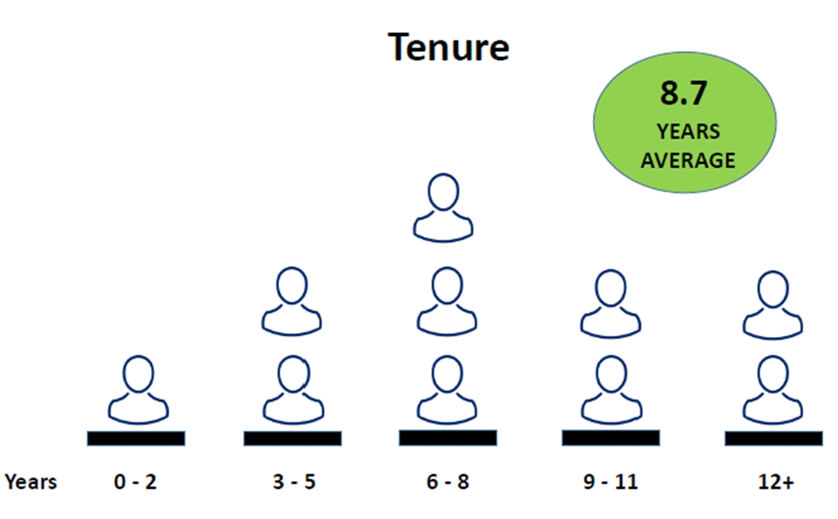

_______________________________
Eagle Materials Inc. * 2023 PROXY STATEMENT 10

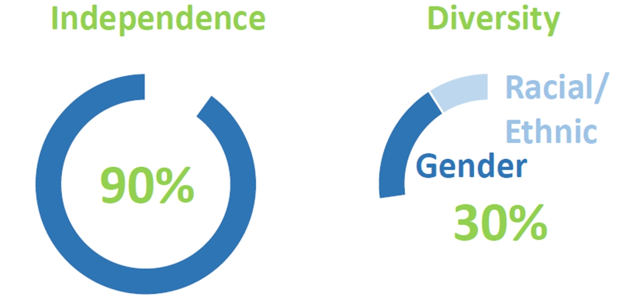

Director Independence
NYSE corporate governance rules require that our Board of Directors be comprised of a majority of independent directors. Our Board of Directors has determined, upon the recommendation of our Corporate Governance, Nominating and Sustainability Committee (“Governance Committee”), that all members of our Board of Directors, other than Mr. Haack, are “independent” within the meaning of the specific provisions of the Securities Exchange Act of 1934, as amended (“Exchange Act”) and the corporate governance rules of the NYSE.
In determining that nine of our ten continuing directors are independent, our Board of Directors did not identify any material relationship that would potentially cause Mses. Carter and Ricciardello and Messrs. Beckwitt, Damiris, Gregorio, Ellen, Nicolais, Powers and Stewart not to be independent for purposes of the Exchange Act or the corporate governance rules of the NYSE. Our Board of Directors considered the fact that Mr. Powers served as Chief Executive Officer of the Company until July 1, 2019 and thereafter entered into an Advisory Agreement with the Company which expired in March 31, 2020—but determined that over three years have passed since the expiration of the Advisory Agreement, and Mr. Powers does not have other ties with the company that the Board of Directors considers to affect his independence.
________________________________

Our Board includes leaders with a diverse set of skills across several fields that are material to our business. The matrix below illustrates some of the key skills, qualifications and demographics that our directors bring to the Board:
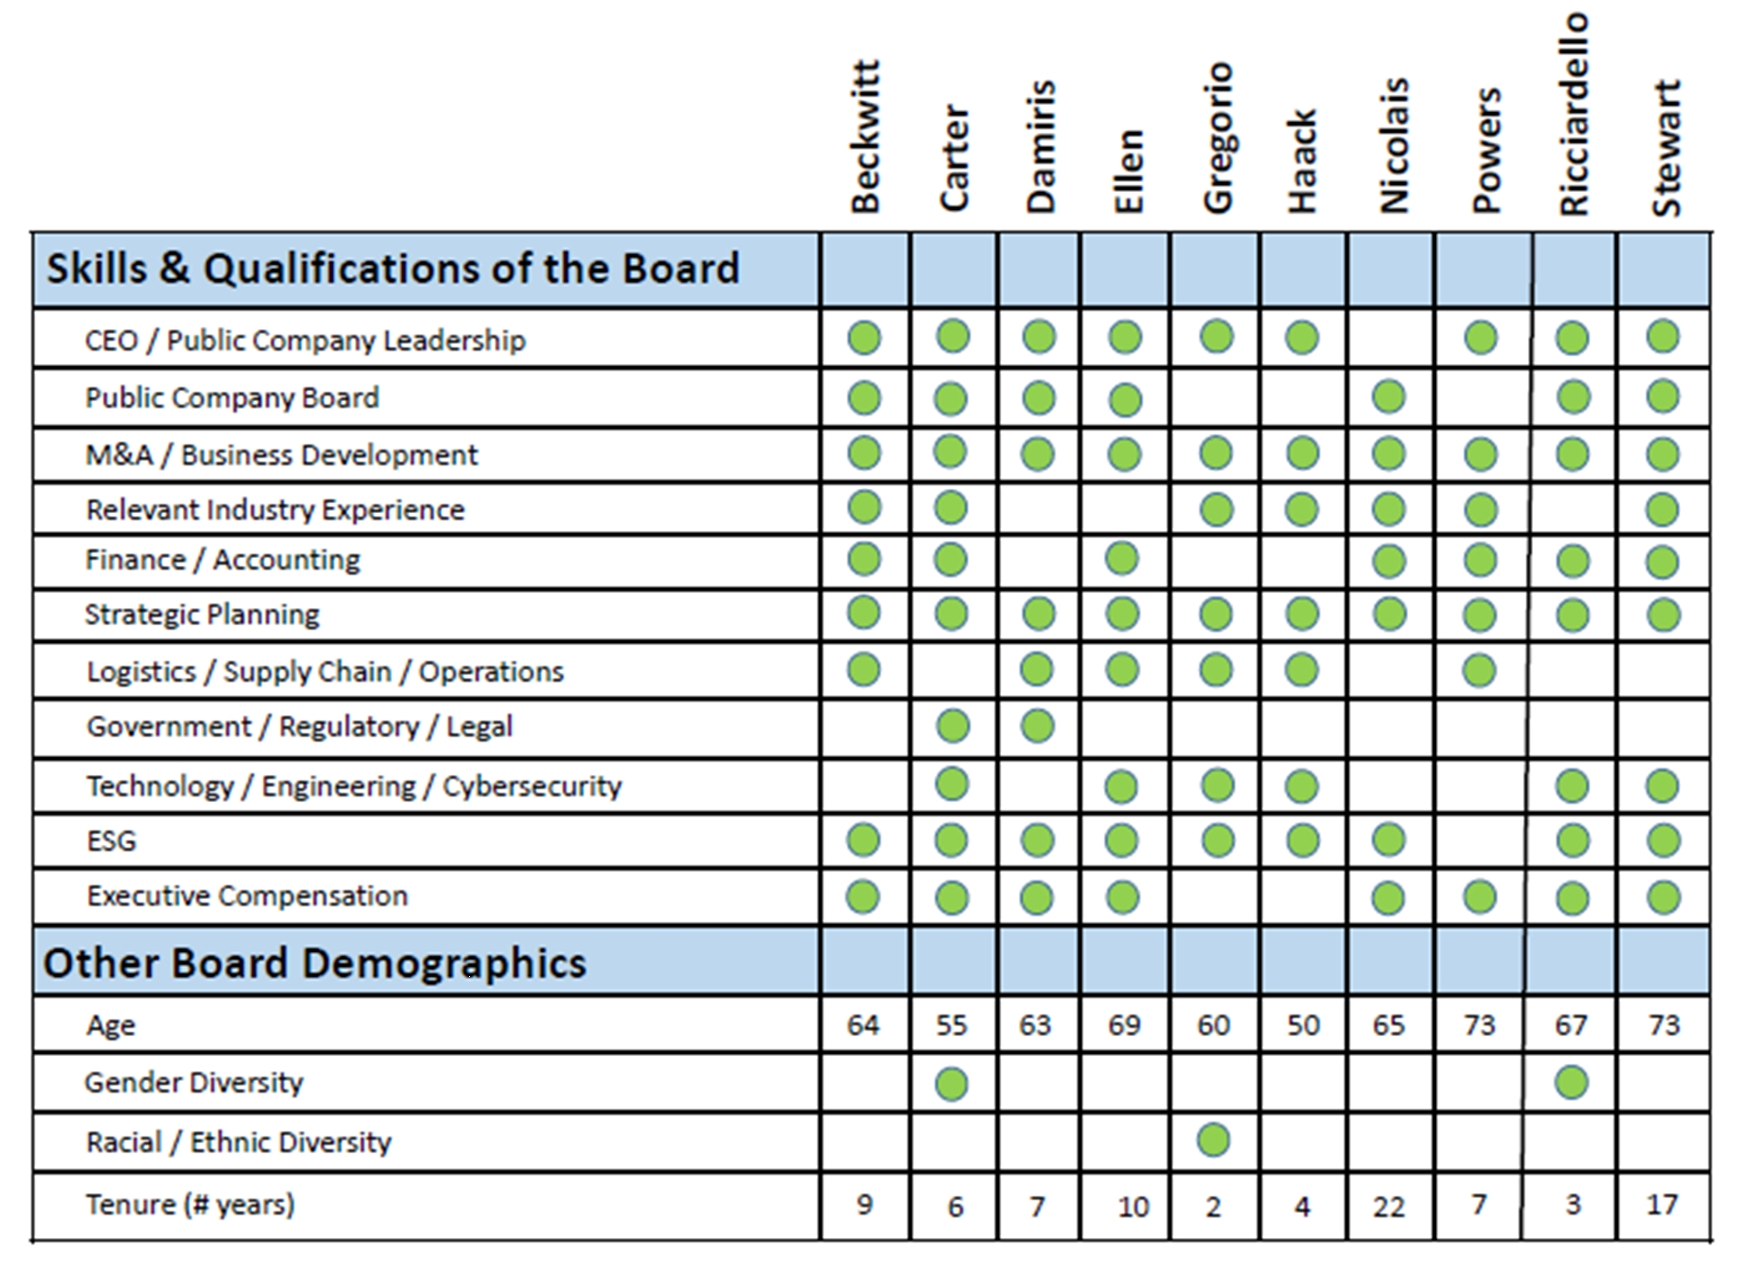
_______________________________
Eagle Materials Inc. * 2023 PROXY STATEMENT 11

Nominees
Each of the nominees listed below is currently a member of our Board of Directors. Each of these nominees has been recommended for nomination by our Governance Committee after considering the criteria described below under the heading “Corporate Governance, Nominating and Sustainability Committee.” We have no reason to believe that any of the listed nominees will become unavailable for election, but if for any reason that should be the case, proxies may be voted for substitute nominees.
Because this is an uncontested election of directors, a majority of votes cast by the holders of our Common Stock present in person or represented by proxy at the meeting (number of shares voted “for” a director nominee must exceed the number of votes cast “against” the director nominee) will be required to elect the nominees for director in accordance with our Bylaws. (A plurality voting standard would apply in a contested election.) Under our Corporate Governance Guidelines, the Governance Committee will not nominate any director candidate until such director candidate has submitted in writing his or her resignation as a director, which resignation would become effective if the director candidate fails to receive the required majority vote in an uncontested election and the Board accepts such resignation. If a director candidate fails to receive the required majority vote, a special committee of independent directors will consider the resignation and make a recommendation to the Board as to whether to accept or reject such resignation. The Board will then publicly disclose its decision regarding the resignation and the rationale behind the decision.
Although each of the nominees is standing for election to a three-year term, Mr. Stewart may (if elected) retire from the Board in 2025 before the completion of his full term in accordance with the Company’s director retirement policy. Our Corporate Governance Guidelines generally require directors to retire at the first annual meeting that occurs after the director’s 75th birthday unless the Board (other than the affected director) waives the requirement upon the recommendation of the Governance Committee.

Recommendation of the Board
Our Board of Directors recommends that holders of Common Stock vote FOR the election of the four nominees listed below to serve as Class II directors for a three-year term ending at our 2026 annual meeting of stockholders:
Margot L. Carter
Michael R. Nicolais
Mary P. Ricciardello
Richard R. Stewart

_______________________________
Eagle Materials Inc. * 2023 PROXY STATEMENT 12

Director Qualifications
Set forth below is information about the nominees standing for election at our 2023 annual meeting, as well as our continuing directors whose terms of office do not expire at such annual meeting. The biographical information appearing below regarding the nominees for director and continuing directors has been furnished to us by the respective nominees and directors. Also included below is a brief description of how each individual’s experience qualifies him or her to serve as a director of the Company.
Nominees Whose Terms Expire at our 2023 Annual Meeting
(Class II Directors)

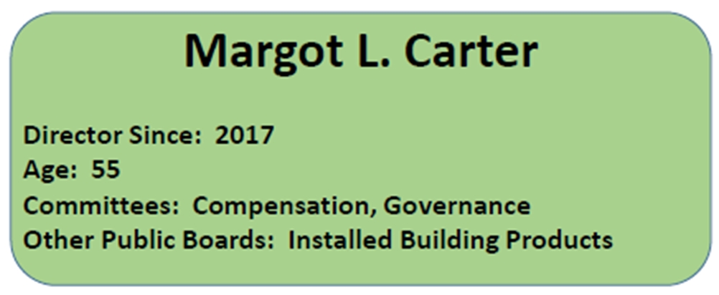George J. Damiris Director Since: 2016 Age: 61 Committees: Compensation
Career Highlights: Ms. Carter has been a director of Installed Building Products, Inc., an installer of insulation and complementary building products, since 2014. She serves as IBP’s lead independent director, the Chair of its Nominating and Governance Committee and a member of the Audit Committee. From 2010 to 2015, Ms. Carter served as Executive Vice President, Chief Legal Officer and Secretary for RealPage, Inc. Since 1998, Ms. Carter has served as the President and founder of Living Mountain Capital, L.L.C., a business advisory firm. She is the Chair of the NACD North Texas Chapter.

Skills and Qualifications: Ms. Carter brings to the Board and the committees on which she serves her proven leadership and business experience gained as a general counsel and director at other public companies. Ms. Carter also brings strategy, business development, M&A experience and corporate governance and finance knowledge gained from over 20 years of executive and board experience at other public companies.

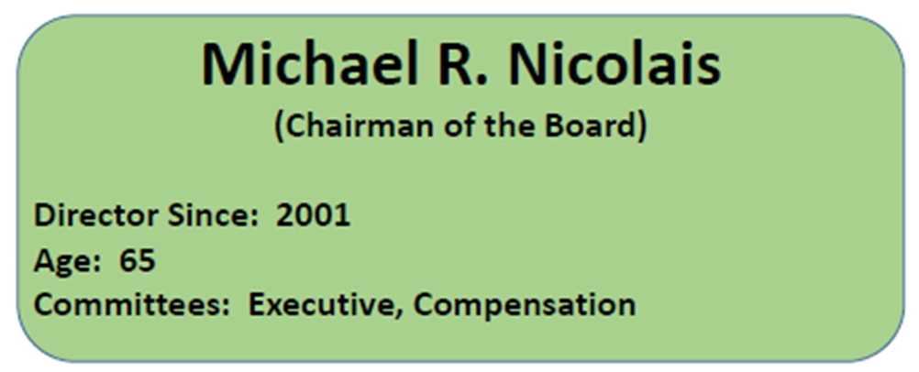
Career Highlights: In January 2020, Mr. Nicolais founded and is Managing Partner of Roble Drive Investment Company, a private investment firm, following his retirement as Vice Chairman and Chief Executive Officer of Highlander Partners L.P., an investment partnership—an office he held from January 2017 through December 2019. Previously, Mr. Nicolais served Highlander Partners as President from April 2004 through December 2016. From August 2002 until March 2004, Mr. Nicolais served as Managing Director of Stephens, Inc., an investment banking firm. Prior to joining Stephens, Inc., he was a partner in the private investment firm of Olivhan Investments, L.P. from March 2001 until August 2002. From August 1986 to December 2000, he was employed by Donaldson, Lufkin & Jenrette Securities Corporation’s Investment Banking Division, most recently in the position of Managing Director and co-head of that firm’s Dallas office.

Skills and Qualifications: Mr. Nicolais brings to the Board and the committees on which he serves his extensive knowledge of capital markets, mergers and acquisitions and financial analysis and financial oversight experience gained through his work as an investment banker and investment manager.

_______________________________
Eagle Materials Inc. * 2023 PROXY STATEMENT 13

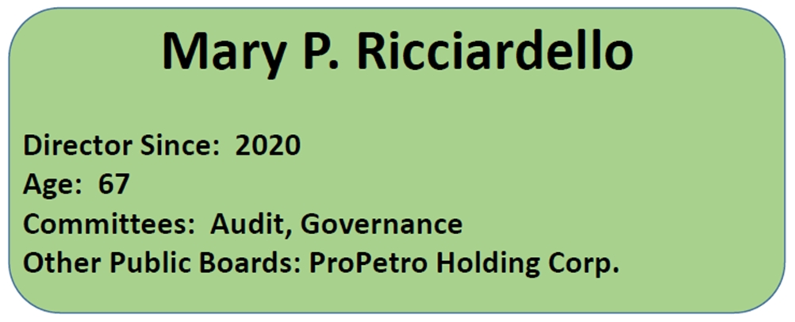
Career Highlights: In 2002, Ms. Ricciardello retired after a 20-year career with Reliant Energy Inc., a leading independent power producer and marketer. She served in various financial management positions with the company, including Comptroller, Vice President and most recently Senior Vice President and Chief Accounting Officer. Ms. Ricciardello has been a director of ProPetro Holding Corp. since January 2023. Ms. Ricciardello also served as a director of Devon Energy from 2007 to January 2021. She also served on the Noble Corporation board from 2003 until May 2020, on the EnLink Midstream board from 2014 until 2018, on the Midstates Petroleum board from 2010 until 2013 and on the U.S. Concrete board from 2003 until 2010. Ms. Ricciardello currently sits on the advisory board of the NACD TriCities Chapter (Houston).

Skills and Qualifications: Ms. Ricciardello is a licensed Certified Public Accountant and a financial executive with over 30 years of experience. She brings to the Board her extensive experience with corporate finance, accounting and tax matters and her experience as a board member for energy and construction products companies.

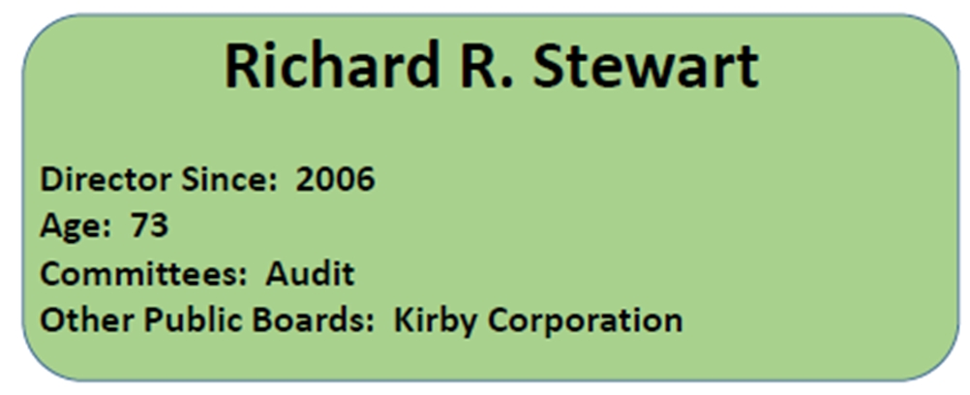
Career Highlights: From 1998 until 2006 Mr. Stewart served as President and CEO of GE Aero Energy, a division of GE Power Systems and as an officer of General Electric Company. Mr. Stewart retired from General Electric in 2006. Mr. Stewart’s career at General Electric began in 1998 as a result of General Electric’s acquisition of the gas turbine business of Stewart & Stevenson Services, Inc. Mr. Stewart began his career at Stewart & Stevenson in 1972 and while at Stewart & Stevenson served in various positions including as Group President and member of the board of directors. Mr. Stewart has been a director of Kirby Corporation since 2008, currently serving as Chair of the Audit Committee. Mr. Stewart has also served as a director of Plug Power Inc. from July of 2003 to March of 2006. Mr. Stewart was a director of Lufkin Industries, Inc. from 2009 until its acquisition by GE Oil & Gas in 2013 and served a director of Exterran Corp. from 2015 to 2018.

Skills and Qualifications: Mr. Stewart brings to the Board and the committee on which he serves his proven leadership and business experience as the former CEO of a manufacturing company. Mr. Stewart also brings corporate governance experience gained from membership on the boards of other public companies and as an officer with General Electric.

Director Since: 2011 Age: 74 Committees: Compensation (Chair)

_______________________________
Eagle Materials Inc. * 2023 PROXY STATEMENT 14

Continuing Directors Whose Terms Expire at our 2024 Annual Meeting
(Class III Directors)
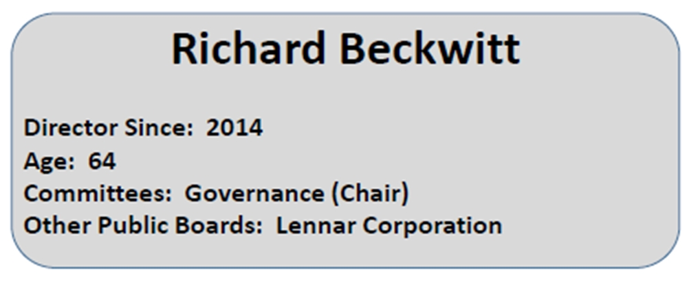Margot L. Carter Director Since: 2017 Age: 53 Committees: Compensation Governance Other Public Boards: Installed Building Products, Inc.
Career Highlights: Mr. Beckwitt is the Co-Chief Executive Officer and Co-President of Lennar Corporation, positions he has held since November 2020. He also serves on the Lennar Board of Directors. He joined Lennar in March 2006 as an Executive Vice President, became President in April 2011 and was promoted to CEO in April 2018. Mr. Beckwitt served on the Board of Directors of D.R. Horton, Inc. from 1993 to November 2003. From 1993 to March 2000, he held various executive officer positions at D.R. Horton, including President of the Company. From March 2000 to April 2003, Mr. Beckwitt was the owner and principal of EVP Capital, L.P., a venture capital and real estate advisory company. From 1986 to 1993, Mr. Beckwitt worked in the Mergers and Acquisitions and Corporate Finance Departments at Lehman Brothers. Mr. Beckwitt also served as a director of Five Point Holdings from May 2016 to June 2020.

Skills and Qualifications: Mr. Beckwitt brings to the Board and the committee on which he serves his extensive executive experience gained through his service as the Chief Executive Officer and executive officer of public companies within the homebuilding industry, as well as finance-related experience with a major investment banking firm.

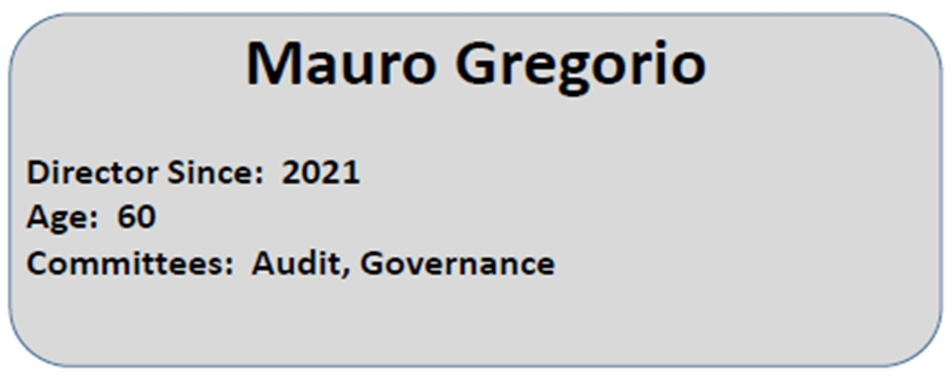
Career Highlights: Mr. Gregorio is the President of Performance Materials and Coatings at Dow. With annual sales of $9 billion, this business provides innovative solutions to global markets in infrastructure and transportation as well as other segments. Mr. Gregorio also has executive oversight for Dow’s business in the Latin America Region. Mr. Gregorio joined Dow in 1984. He has significant market and international experience after working at several Dow locations globally. He was recognized as #1 on the Empower Top 100 Ethnic Minority Senior Business Leader Role Models list for 2020.
Skills and Qualifications: Mr. Gregorio, a senior executive at a global manufacturing company, brings to the Board and the committee on which he serves extensive executive and industrial business management experience acquired through several assignments that included supply chain, commercial, innovation and M&A transactions. We also benefit from his experience and reputation building inclusive growth-oriented organizations.

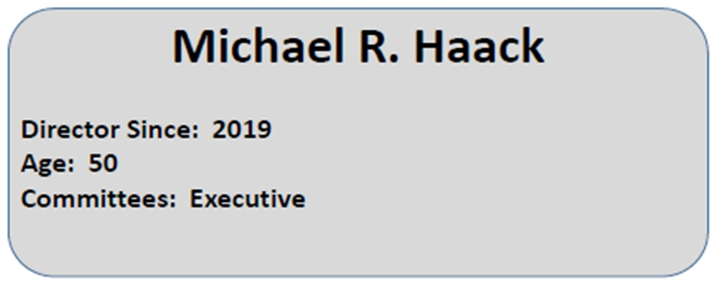
Career Highlights: Mr. Haack has been the Company’s President and Chief Executive Officer since July 1, 2019. Prior to that time, he has served as President and Chief Operating Officer since August 2018 and was Executive Vice President and Chief Operating Officer from December 2014 through August 2018. Mr. Haack was employed at Halliburton Energy Services for the 17 years prior to joining the Company, most recently as Global Operations Manager at Halliburton’s Sperry Drilling division.
Skills and Qualifications: Mr. Haack brings to the Board his extensive knowledge of the Company’s operations, as well as his executive and operations experience gained in heavy industry over the previous 20 years.

_______________________________
Eagle Materials Inc. * 2023 PROXY STATEMENT 15

Continuing Directors Whose Terms Expire at our 2025 Annual Meeting
(Class I Directors)

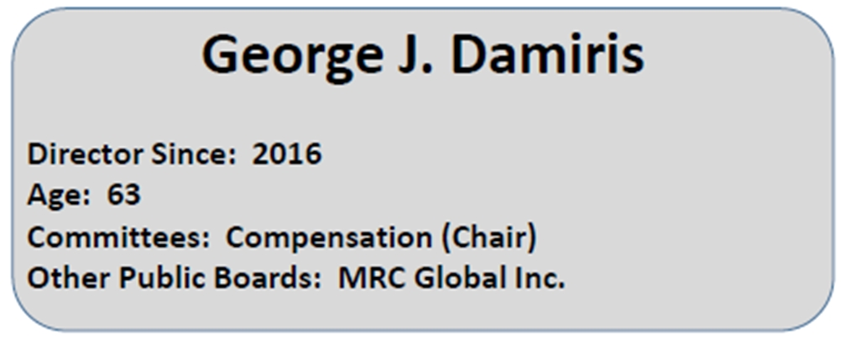F. William Barnett Director Since: 2003Age: 74 Committees: Governance (Chair)
Career Highlights: Mr. Damiris served as Chief Executive Officer and President of HollyFrontier Corporation from 2016 through 2019 and as a director from 2015 through 2019. He previously served as Executive Vice President and Chief Operating Officer from September 2014 to January 2016 and as Senior Vice President, Supply and Marketing from January 2008 until September 2014. Prior to his retirement in 2019, Mr. Damiris also served as a director of Holly Logistics Services, L.L.C., the general partner of the general partner of Holly Energy Partners, L.P., since February 2016, as CEO since November 2016 and as President since February 2017. Mr. Damiris has served as a director of MRC Global Inc. since 2021.

Skills and Qualifications: Mr. Damiris brings to the Board and the Compensation Committee his extensive management and operational experience gained from his time as a senior executive at a large, public industrial company.

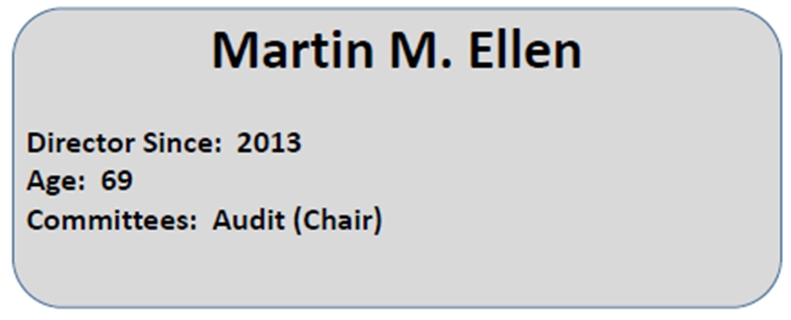
Richard Beckwitt Director Since: 2014 Age: 62 Committees: Audit
Governance Other Public Boards: Lennar Corporation
Career Highlights: Mr. Ellen retired as Chief Financial Officer and Executive Vice President at Dr Pepper Snapple Group, Inc. in July 2018, having served in that capacity since April 2010. Mr. Ellen also served as the Chief Financial Officer and Senior Vice President - Finance of Snap-on Inc. from November 2002 to March 2010.

Skills and Qualifications: Mr. Ellen brings to the Board and the Audit Committee his extensive management, finance and audit experience gained from over 25 years serving as chief financial officer with public and private companies and prior experience with a major public accounting firm.

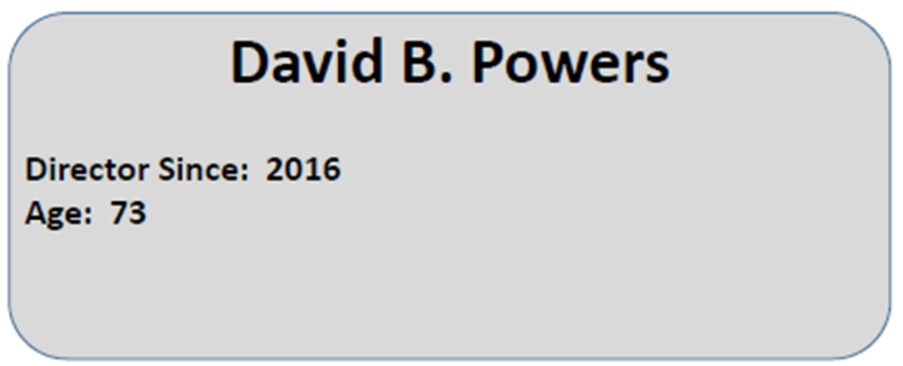

Career Highlights: Mr. Powers served as the Company’s President and Chief Executive Officer from March 2016 until his retirement on July 1, 2019. Prior to his promotion to President and Chief Executive Officer of the Company, Mr. Powers served as Executive Vice President – Gypsum of the Company and as President of American Gypsum Company LLC, a subsidiary of the Company (“American Gypsum”), since January 2005. Mr. Powers previously served as Executive Vice President – Marketing, Sales and Distribution of American Gypsum, beginning in June 2002.

Skills and Qualifications: Mr. Powers brings to the Board his extensive executive and operations experience in the construction products industry, including over 35 years of experience in the gypsum wallboard industry, and his knowledge of the Company and its business and operations.

_______________________________
Eagle Materials Inc. * 2023 PROXY STATEMENT 16

Board Meetings and Attendance Records
During the Company’s fiscal year ended March 31, 2023, our Board of Directors held four regularly scheduled meetings and no special meetings. During such fiscal year, all of the incumbent directors attended at least 75% of the meetings of the Board and the committees of the Board on which they served. In accordance with our informal policy, we anticipate that all continuing directors and nominees will attend our 2023 annual stockholders meeting. All of our then-current directors attended our 2022 annual meeting. We strongly encourage all directors to attend our stockholder meetings. Our non-employee directors (which currently constitute all our directors, except for Mr. Haack) meet immediately after all Board meetings without management present. The Chairman presides at all executive sessions of the non-employee directors.

_______________________________
Eagle Materials Inc. * 2023 PROXY STATEMENT 17

BOARD COMPENSATION

Board compensation for the 12-month period from August 2022 through July 2023 was approved by our Board of Directors in August 2022. The Board adopted a director compensation structure in which directors who are not employees of the Company or any of our subsidiaries received compensation for their services during the 12-month period from August 2022 through July 2023 by electing one of the following two compensation package alternatives:
 | (1) | total compensation valued at $230,000, of which $105,000 is paid in cash and the remainder is provided in the form of an equity grant valued at $125,000; or
 | (2) | an equity grant valued at $261,500.
The grant date value of the equity grant under either alternative is allocated between restricted stock and options to purchase Common Stock (based upon the recommendation of the Compensation Committee) with respect to each non-employee director.
In accordance with the terms of the Eagle Materials Inc. Amended and Restated Incentive Plan (“2013 Incentive Plan”) the exercise price of stock options is set at the closing price of the Common Stock on the NYSE on the date of grant. The number of option shares granted is determined as of the date of grant by using the Black-Scholes method. All the options granted to directors in August 2022 were fully exercisable when granted and have a ten-year term.
The number of shares of restricted stock is determined as of the date of grant using the closing price of the Common Stock on the NYSE on the date of grant. The restricted stock granted to directors in August 2022 was subject to vesting requirements, with the shares becoming fully vested (unrestricted) on the earliest to occur of (i) February 5, 2023; (ii) the recipient’s retirement from the Board in accordance with the Company’s director retirement policy, or under such circumstances as are approved by the Compensation Committee; or (iii) the recipient’s death. During the restriction period the director will have the right to vote the shares. In addition, the director will also be entitled to cash dividends as and when the Company issues a cash dividend on the Common Stock.
Non-employee directors who chair committees of the Board of Directors receive additional annual compensation. The chairs of the Audit Committee, Compensation Committee and Governance Committee each receive a fee of $20,000 per year. The Chairman of the Board received a fee of $125,000 during the past year. Chairpersons who choose compensation package alternative one (part equity and part cash) receive this additional compensation in the form of cash. Chairpersons who choose compensation package alternative two (all equity) receive this additional compensation in the form of equity, in which case a 30% premium is added to such fees when valuing the equity to be received by such chairperson.
In certain prior years, equity grants were in some cases made in the form of restricted stock units, which we refer to as “RSUs.” In the case of non-employee directors who hold unvested RSUs (which currently only includes Mr. Nicolais), these directors will receive dividend equivalent units as and when the Company pays a cash dividend on the Common Stock in accordance with the terms of the RSUs.
All directors are reimbursed for reasonable expenses of attending meetings.

_______________________________
Eagle Materials Inc. * 2023 PROXY STATEMENT 18

Non-Employee Director Compensation for Fiscal Year 2023
The table below summarizes the compensation paid by the Company to our non-employee directors for the fiscal year ended March 31, 2023.

Name |  | Fees Earned  or  Paid in Cash  ($) |  |  |  | Stock  Awards  ($)(1) |  |  |  | Option  Awards  ($) |  |  |  | Non-Equity  Incentive Plan  Compensation  ($) |  |  |  | Change in Pension  Value and  Nonqualified  Deferred  Compensation  Earnings  ($) |  |  |  | All Other  Compensation  ($)(2) |  |  |  | Total  ($)
F. William Barnett(3) |  | $ | — |  |  | $ | — |  |  | $ | — |  |  | $ | — |  |  | $ | — |  |  | $ | 5,203 |  |  | $ | 5,203
Richard Beckwitt(4) |  |  | — |  |  |  | 287,618 |  |  |  | — |  |  |  | — |  |  |  | — |  |  |  | 5,530 |  |  |  | 293,148
Ed H. Bowman(3) |  |  | — |  |  |  | — |  |  |  | — |  |  |  | — |  |  |  | — |  |  |  | 5,243 |  |  |  | 5,243
Margot L. Carter(5) |  |  | 70,000 |  |  |  | 125,018 |  |  |  | — |  |  |  | — |  |  |  | — |  |  |  | 489 |  |  |  | 195,507
George J. Damiris(6) |  |  | — |  |  |  | 287,618 |  |  |  | — |  |  |  | — |  |  |  | — |  |  |  | 1,125 |  |  |  | 288,743
Martin M. Ellen(7) |  |  | 125,000 |  |  |  | 125,018 |  |  |  | — |  |  |  | — |  |  |  | — |  |  |  | 2,341 |  |  |  | 252,359
Mauro Gregorio(8) |  |  | — |  |  |  | 261,541 |  |  |  | — |  |  |  | — |  |  |  | — |  |  |  | 1,349 |  |  |  | 262,890
Michael R. Nicolais(9) |  |  | — |  |  |  | 318,169 |  |  |  | 106,076 |  |  |  | — |  |  |  | — |  |  |  | 6,613 |  |  |  | 430,858
David B. Powers(5) |  |  | 105,000 |  |  |  | 125,018 |  |  |  | — |  |  |  | — |  |  |  | — |  |  |  | 489 |  |  |  | 230,507
Mary P. Ricciardello(8) |  |  | — |  |  |  | 196,220 |  |  |  | 65,424 |  |  |  | — |  |  |  | — |  |  |  | 768 |  |  |  | 262,412
Richard R. Stewart(5) |  |  | 105,000 |  |  |  | 125,018 |  |  |  | — |  |  |  | — |  |  |  | — |  |  |  | 4,039 |  |  |  | 234,057

(1) | The amounts in this column reflect the value of restricted stock awards made to the directors in the fiscal year ended March 31, 2023 and are consistent with the grant date fair value of the award computed in accordance with FASB ASC Topic 718. For assumptions used in determining these values, refer to footnote (L) to the Company’s audited financial statements for the fiscal year ended March 31, 2023, included in the Company’s Annual Report on Form 10-K filed with the SEC on May 19, 2023 (“Fiscal 2023 Form 10-K”).
(2) | The amounts in this column represent dividend payments made in fiscal 2023 to the directors with respect to restricted stock held by such directors.
(3) | Messrs. Barnett and Bowman retired from the Board effective August 5, 2022.
(4) | Mr. Beckwitt is the Chair of the Governance Committee. He elected to receive 100% of his director compensation in the form of equity (including his chairperson fee).
(5) | Ms. Carter and Messrs. Powers and Stewart selected the compensation package where they receive a portion of their director compensation in the form of equity and a portion in cash.
(6) | Mr. Damiris is the Chair of the Compensation Committee. He elected to receive 100% of his director compensation in the form of equity (including his chairperson fee).
(7) | Mr. Ellen is Chair of the Audit Committee. He selected the compensation package where he receives a portion of his director compensation in the form of equity and a portion in cash. Mr. Ellen received his chairperson fee in cash.
(8) | Mr. Gregorio and Ms. Ricciardello elected to receive 100% of their director compensation in the form of equity.
(9) | Mr. Nicolais served as Chairman of the Board during fiscal 2023. He elected to receive 100% of his director compensation in the form of equity (including his chairperson fee).

_______________________________
Eagle Materials Inc. * 2023 PROXY STATEMENT 19

The following chart shows the number of outstanding stock options, RSUs and shares of restricted stock held by each non-employee director as of March 31, 2023.

Name |  | Stock Options(1) |  |  |  | RSUs(2) |  |  |  | Restricted Stock(3)
F. William Barnett |  |  | — |  |  |  | — |  |  |  | —
Richard Beckwitt |  |  | 2,070 |  |  |  | — |  |  |  | 4,405
Ed H. Bowman |  |  | — |  |  |  | — |  |  |  | —
Margot L. Carter |  |  | — |  |  |  | — |  |  |  | —
George J. Damiris |  |  | — |  |  |  | — |  |  |  | —
Martin M. Ellen |  |  | — |  |  |  | — |  |  |  | 1,852
Mauro Gregorio |  |  | — |  |  |  | — |  |  |  | —
Michael R. Nicolais |  |  | 18,669 |  |  |  | 3,935 |  |  |  | 5,368
David B. Powers |  |  | — |  |  |  | — |  |  |  | —
Mary P. Ricciardello |  |  | 4,747 |  |  |  | — |  |  |  | —
Richard R. Stewart |  |  | — |  |  |  | — |  |  |  | 3,550

(1) | All of these stock options were fully exercisable as of March 31, 2023.
(2) | The RSUs granted to non-employee directors (and any accrued dividend equivalent RSUs) are not payable until the non-employee director’s service on the board terminates because of the director’s death or the director’s retirement in accordance with the Company’s director retirement policy, or under such circumstances as are approved by the Compensation Committee. The number of RSUs reflected in this column includes the following aggregate dividend equivalent units, which are accrued by holders of our RSUs at any time we pay a cash dividend on our Common Stock: Mr. Nicolais – 635 RSUs.
(3) | The restrictions on these restricted stock awards will not lapse until the non-employee director’s service on the board terminates because of the director’s death or the director’s retirement in accordance with the Company’s director retirement policy, or under such circumstances as are approved by the Compensation Committee. Any cash dividends declared and paid by the Company during the restricted period are paid in cash with respect to such restricted stock.

_______________________________
Eagle Materials Inc. * 2023 PROXY STATEMENT 20

Board Leadership Structure and Role in Risk Oversight
The positions of Chairman of the Board and Chief Executive Officer (“CEO”) are performed by two different individuals. Mr. Haack, our CEO, focuses on the day-to-day operation of the Company’s businesses and also participates in long-term strategy and development. Mr. Nicolais, our Chairman, oversees the Company’s general strategic direction and leads and manages the Board. In particular, Mr. Nicolais (i) presides at Board meetings; (ii) approves agendas and adds agenda items for Board meetings and meetings of independent directors; (iii) acts as liaison between independent directors and the CEO; (iv) presides over executive sessions of independent directors; (v) where appropriate, engages and consults with major shareholders and other constituencies; (vi) meets one-on-one with the CEO following executive sessions of independent directors; and (vii) guides the Board in its consideration of CEO succession.
As part of its primary risk management function, the Audit Committee oversees the preparation by management of a risk report on a quarterly basis. However, our entire Board of Directors is also involved in the oversight of management’s efforts to identify, evaluate and manage risks on behalf of the Company, and the Board discusses these topics with management and the Audit Committee throughout the year. For example, at quarterly Audit Committee meetings (at which the rest of the Board is also present), management provides updates on cybersecurity, including third-party engagement regarding the cybersecurity landscape and emerging threats, the results of annual cybersecurity training for all personnel with network access, and the results of periodic employee phishing exercises.
Further, the independent directors address risk management in executive sessions without management present. As appropriate in the context of their chartered roles, the Board’s other committees also perform risk management and oversight activities during the year. For example, the Governance Committee is responsible for overseeing governance issues that may create governance risks, such as board composition, director selection and other governance policies and practices that are critical to the success of the Company.
Risk Assessment in Compensation Programs
Consistent with SEC disclosure requirements, management, the Compensation Committee and the Board have assessed the Company’s compensation programs. Based upon all of the facts and circumstances available to the Company at the time of the filing of this Proxy Statement, the Board has concluded that risks arising from the Company’s compensation policies and practices are not reasonably likely to have a material adverse effect on the Company or encourage unnecessary and excessive risk-taking.
This assessment was overseen by the Compensation Committee, in consultation with management. The Board reviewed the compensation policies and practices in effect for our executive officers, senior management and other employees and assessed the features the Company has built into the compensation programs to discourage excessive risk-taking. These features include, among other things, a balance among different elements of compensation, use of different performance metrics for different elements of compensation, restrictions on pricing authority, review and approval of material contracts, and stock ownership guidelines for senior management.
Oversight of ESG Matters
Our Board is committed to effective oversight of environmental, social and governance (“ESG”) matters, including our climate-related risks, and ensuring progress across our sustainability initiatives. In particular, pursuant to its charter, our Governance Committee has formal responsibility for leading the Board’s oversight of these matters in coordination with management and other Board committees as appropriate. The Governance Committee’s ESG oversight responsibilities include providing updates and making recommendations to the Board regarding current and emerging ESG trends affecting the Company’s business, reviewing the Company’s environmental initiatives related to sustainability and climate change impacts and overseeing and reviewing the Company’s public disclosures on ESG matters and related metrics (including, for example, the Company’s Environmental and Social Disclosure Report, which is hosted on the Company’s website). The Governance Committee reviews ESG matters at its regular quarterly meetings. Our Board is supported in its oversight by our CEO and other senior executives across functions including executive management, operations, engineering, legal and investor relations. Working together, our Board and management ensure we are implementing and properly disclosing a responsible climate and sustainability strategy that serves the best interests of the Company and its stakeholders.

_______________________________
Eagle Materials Inc. * 2023 PROXY STATEMENT 21

Board Committees
The standing committees of our Board of Directors include the Audit Committee, the Compensation Committee, the Governance Committee and the Executive Committee. The following table lists the chairperson and members of each committee as of March 31, 2023, and the number of meetings held by each committee during the fiscal year ended March 31, 2023:

Director |  | Audit |  |  |  | Compensation |  |  |  | Governance |  |  |  | Executive
Richard Beckwitt |  |  |  |  |  |  |  |  |  | Chair
Margot L. Carter |  |  |  |  |  | Member |  |  |  | Member
George J. Damiris |  |  |  |  |  | Chair
Martin M. Ellen |  | Chair
Mauro Gregorio |  | Member |  |  |  |  |  |  |  | Member
Michael R. Haack |  |  |  |  |  |  |  |  |  |  |  |  |  | Member
Michael R. Nicolais |  |  |  |  |  | Member |  |  |  |  |  |  |  | Chair
David B. Powers
Mary P. Ricciardello |  | Member |  |  |  |  |  |  |  | Member
Richard R. Stewart |  | Member
Number of Meetings in Fiscal 2023 |  |  | 7 |  |  |  | 10 |  |  |  | 4 |  |  |  | —

Audit Committee
Our Board has a standing Audit Committee, composed of at least three independent directors. Our Audit Committee assists the Board in fulfilling its responsibility to oversee the integrity of our financial statements, our compliance with legal and regulatory requirements, the qualifications, independence and appointment of our independent auditors, the performance of our internal audit function and independent auditors and the assessment of risks, including cybersecurity risks. Our Audit Committee is governed by an amended and restated Audit Committee charter, a copy of which may be viewed on our website at www.eaglematerials.com and will be provided free of charge upon written request to our Secretary at our principal executive office.
Our Board has determined that each member of our Audit Committee is independent within the meaning of applicable (1) corporate governance rules of the NYSE and (2) requirements set forth in the Exchange Act and the applicable SEC rules. In addition, our Board has determined that each member of our Audit Committee satisfies applicable NYSE standards for financial literacy and that, based on his auditing and financial experience, including over 25 years of experience as a chief financial officer with public and private companies and prior experience with a major public accounting firm, the Chair of the Audit Committee, Mr. Ellen, is an audit committee financial expert within the meaning of the rules of the SEC.
Unless otherwise determined by the Board, no member of our Audit Committee may serve as a member of an audit committee of more than two other public companies.
Certain key functions and responsibilities of our Audit Committee are to:
 | • | select, appoint, compensate, evaluate, retain and oversee the independent auditors engaged for purposes of preparing or issuing an audit report or related work or performing other audit, review, or attestation services for us;
 | • | obtain and review, at least annually, a formal written statement from our independent auditors describing all relationships between our auditors and the Company and engage in a dialogue with our auditors with respect to any disclosed relationships or services that may affect the objectivity and independence of the auditors and to recommend appropriate action in response to the reports to our Board;
 | • | pre-approve all audit engagement fees and terms and all permissible non-audit services provided to us by our independent auditors, in accordance with the committee’s policies and procedures for pre-approving audit and non-audit services;
 | • | establish procedures for (i) the receipt, retention and treatment of complaints received by the Company regarding accounting, internal accounting controls or auditing matters and (ii) the confidential, anonymous submission by employees of the Company of concerns regarding questionable accounting or auditing matters;
 | • | discuss our annual audited financial statements, quarterly financial statements and other significant financial disclosures with management and our independent auditors;
 | • | discuss with management the types of information to be disclosed and the types of presentations to be made in our earnings press releases, as well as the financial information and earnings guidance we provide to analysts and rating agencies;
_______________________________
Eagle Materials Inc. * 2023 PROXY STATEMENT 22

 | • | annually review and assess the performance of the Audit Committee and the adequacy of its charter;
 | • | discuss policies with respect to risk assessment and risk management;
 | • | consider the effectiveness of our internal control systems, including information technology security and control; and
 | • | prepare the report that is required to be included in our annual proxy statement regarding review of financial statements and auditor independence.
Our Audit Committee’s report on our financial statements for the fiscal year ended March 31, 2023 is presented below under the heading Audit Committee Report.
Our Audit Committee meets separately with our independent auditors and with members of our internal audit staff outside the presence of the Company’s management or other employees to discuss matters of concern, to receive recommendations or suggestions for change and to exchange relevant views and information.
Compensation Committee
Our Board’s Compensation Committee is composed of independent directors who meet the corporate governance standards of the NYSE, including the enhanced NYSE independence requirements for directors serving on compensation committees, and who qualify as non-employee directors within the meaning of Rule 16b-3(b)(3) of the Exchange Act and as “outside directors” within the meaning of the Internal Revenue Code.
Under its amended and restated charter, which you may review on our website at www.eaglematerials.com (and a copy of which will be provided to you free of charge upon written request to our Secretary at our principal executive office), the primary purposes of our Compensation Committee are to assist the Board in discharging its responsibilities relating to compensation of our Chief Executive Officer and other senior executives and to direct the preparation of the reports regarding executive compensation that the rules of the SEC require to be included in our annual proxy statement.
The Compensation Committee is authorized to hire outside advisers after considering all factors relevant to the adviser’s independence from management. For additional information regarding outside advisers engaged by the Compensation Committee, please see “Compensation Discussion and Analysis” beginning on page 28 of this Proxy Statement.
Certain key functions and responsibilities of our Compensation Committee are to:
 | • | periodically review and make recommendations to our Board as to our general compensation philosophy and structure, including reviewing the compensation programs for senior executives and all of our benefit plans to determine whether they are properly coordinated and achieve their intended purposes;
 | • | annually review and approve corporate goals and objectives relevant to the compensation of our Chief Executive Officer, evaluate his or her performance as measured against such goals and objectives and to set the salary and other cash and equity compensation for our Chief Executive Officer based on such evaluation;
 | • | review and, after the end of the fiscal year and in consultation with our Chief Executive Officer, approve the compensation of our senior executive officers who are required to make disclosures under Section 16 of the Exchange Act (“senior executive officers”);
 | • | administer the Company’s compensation plans for which it is named as plan administrator, including our 2013 Incentive Plan;
 | • | report on compensation policies and practices with respect to our executive officers as required by SEC rules;
 | • | review and recommend to the Board the compensation of non-employee directors;
 | • | recommend stock ownership guidelines and monitor compliance therewith; and
 | • | review and assess the performance of the Compensation Committee and the adequacy of its charter annually and recommend any proposed changes to the Board.
In accordance with the terms of our 2013 Incentive Plan, the Compensation Committee has delegated to the Special Situation Equity Award Committee (whose sole member is our CEO) the authority to grant time-vesting stock options and restricted stock in certain circumstances. Under this authorization, the Special Situation Equity Award Committee may grant stock options and restricted stock to employees under terms set by the Compensation Committee. This authority for fiscal 2023 was limited to an aggregate of up to 60,000 stock options and up to 25,000 shares of restricted stock, no one individual may receive more than 15,000 options and 6,250 shares of restricted
_______________________________
Eagle Materials Inc. * 2023 PROXY STATEMENT 23

stock, and senior executive officers may not receive awards pursuant to this authority. Awards granted in fiscal 2023 under this delegation of authority vest 25% per year commencing on the first anniversary of the grant date. During fiscal 2023, 6,925 stock options were granted to employees under this authority out of a maximum of 60,000, and 3,150 shares of restricted stock were granted out of a maximum of 25,000.
Our Compensation Committee’s report for the fiscal year ended March 31, 2023 is presented below under the heading “Compensation Committee Report” beginning on page 27 of this Proxy Statement.
Our Compensation Committee meets as often as it deems appropriate, but no less than twice per year.
Compensation Committee Interlocks and Insider Participation
No member of our Compensation Committee had a relationship during the fiscal year ended March 31, 2023 that requires disclosure as a Compensation Committee interlock.
Corporate Governance, Nominating and Sustainability Committee
Our Board’s Governance Committee is composed of independent directors who meet the corporate governance standards of the NYSE. The primary purposes of this committee are: (1) to advise and counsel our Board and management regarding, and oversee, our governance, including our Board’s selection of directors; (2) to develop and recommend to the Board a set of corporate governance principles for the Company; (3) to oversee the evaluation of our Board and management; and (4) to oversee the Company’s initiatives, opportunities, risks and reporting on material ESG matters.
Our Governance Committee has adopted a written charter, and our Board has also adopted Corporate Governance Guidelines. Both the Governance Committee charter and the Corporate Governance Guidelines may be viewed on our website at www.eaglematerials.com and will be provided free of charge upon written request to our Secretary at our principal executive office.
Certain key functions and responsibilities of our Governance Committee are to:
 | • | develop, periodically review and recommend to the Board a set of corporate governance guidelines for the Company;
 | • | periodically review corporate governance matters generally and recommend action to the Board where appropriate;
 | • | review and assess the adequacy of its charter annually and recommend any proposed changes to our Board for approval;
 | • | monitor the quality and sufficiency of information furnished by management to our Board;
 | • | actively seek, recruit, screen, and interview individuals qualified to become members of the Board, and consider management’s recommendations for director candidates;
 | • | evaluate the qualifications and performance of incumbent directors and determine whether to recommend them for re-election to the Board;
 | • | establish and periodically re-evaluate criteria for Board membership;
 | • | recommend to the Board the director nominees for each annual stockholders’ meeting;
 | • | recommend to the Board nominees for each committee of the Board; and
 | • | in coordination with management and other Board committees, as appropriate, review and oversee the Company’s initiatives, opportunities, risks and reporting with respect to material ESG matters (including those relating to climate risk and sustainability).
The Governance Committee initiates and oversees an annual evaluation of the effectiveness of the Board and each committee, as well as the composition, organization (including committee structure, membership and leadership) and practices of the Board. The format of this evaluation varies from year-to-year, as determined by the Governance Committee each year. In some years, discussion questions are circulated prior to a meeting for discussion at the meeting. In other years, the chair of the Governance Committee conducts one-on-one interviews with each director and synthesizes the take-aways from those conversations at a meeting. In the most-recent year, directors reacted to a series of questions with a score/ranking, which then sparked further in-person discussion at a meeting. Part of the Governance Committee’s self-evaluation process involves an assessment of the effectiveness of the Company’s corporate governance policies, which includes the Company’s policies surrounding diversity.
Among the criteria the Governance Committee uses in evaluating the suitability of individual nominees for director (whether such nominations are made by management, a stockholder or otherwise) are their integrity, experience, achievements, judgment, intelligence, personal character, ability to make independent analytical inquiries, willingness to devote adequate time to Board duties and the likelihood
_______________________________
Eagle Materials Inc. * 2023 PROXY STATEMENT 24

that he or she will be able to serve on the Board for a sufficient period of time to make a meaningful contribution. The Governance Committee also gives consideration to whether the nominees and Board members reflect a diversity in perspectives, backgrounds, business experiences, professional expertise, gender and ethnic background. The Governance Committee’s charter provides that, subject to its fiduciary duties and applicable laws and regulations, when searching for new directors, the Governance Committee will identify qualified diverse candidates, including women and individuals from minority groups, to include in the pool of candidates from which director nominees are chosen. The Governance Committee has made progress with regard to diversity on the Board—its three most-recent independent director appointments have been diverse candidates.
Members of the Governance Committee, other members of the Board or executive officers may, from time to time, identify potential candidates for nomination to our Board. All proposed nominees, including candidates recommended for nomination by stockholders in accordance with the procedures described below, will be evaluated in light of the criteria described above and the projected needs of the Board at the time. As set forth in its charter, the Governance Committee may retain a search firm to assist in identifying potential candidates for nomination to the Board of Directors.
Our Governance Committee will consider candidates recommended by stockholders for election to our Board. A stockholder who wishes to recommend a candidate for evaluation by our Governance Committee should forward the candidate’s name, business or residence address, principal occupation or employment and a description of the candidate’s qualifications to the Chairman of the Governance Committee at the following address: Eagle Materials Inc., Attention: Secretary, 5960 Berkshire Ln., Suite 900, Dallas, Texas 75225.
Our Bylaws provide that only persons who are eligible for election as directors are candidates nominated (a) by our Board (or a committee thereof, such as the Governance Committee) or (b) by a stockholder in accordance with certain procedures set forth in our Bylaws. Under our Bylaws, to be considered at the 2024 annual meeting, stockholder nominations for the Board of Directors must be submitted in writing and received by our Secretary at the executive offices of the Company during the period beginning on April 5, 2024 and ending May 5, 2024, and must contain the information specified by and otherwise comply with the terms of our Bylaws. Any stockholder wishing to receive a copy of our Bylaws should direct a written request to our Secretary at the Company’s principal executive offices. No nominees for election to the Board at our 2023 annual meeting of stockholders were submitted by stockholders.
Executive Committee
The principal function of our Board’s Executive Committee is to exercise all of the powers of the Board to direct our business and affairs between meetings of the Board, except that the Executive Committee may not amend our Certificate of Incorporation or Bylaws, adopt an agreement of merger or consolidation under Delaware law, recommend the sale of all or substantially all of our assets or recommend the dissolution of the Company or the revocation of a dissolution. In addition, unless authorized by resolution of our Board of Directors, the Executive Committee may not declare a dividend, authorize the issuance of stock or adopt a certificate of ownership and merger under Delaware law.
How to Contact Our Board
Shareholders and other interested parties can communicate directly with our Board, a committee of our Board, our independent directors as a group, our Chairman of the Board or any other individual member of our Board by sending the communication to Eagle Materials Inc., 5960 Berkshire Ln., Suite 900, Dallas, Texas 75225, to the attention of the director or directors of your choice (e.g., Attention: Chairman of the Board of Directors or Attention: All Independent Directors, etc.). We will relay communications addressed in this manner as appropriate. Communications addressed to the attention of the entire Board are forwarded to the Chairman of the Board for review and further handling.

_______________________________
Eagle Materials Inc. * 2023 PROXY STATEMENT 25

EXECUTIVE OFFICERS WHO ARE NOT DIRECTORS

Following are the names, ages as of the date of this Proxy Statement and principal occupations of each person who was an executive officer of the Company during the fiscal year ended March 31, 2023 and who is not also a member of our Board. All of these persons were elected to serve until the next annual meeting of our Board or until their earlier resignation or removal.
D. Craig Kesler
Age: 47
Position: Executive Vice President – Finance and Administration and Chief Financial Officer (has held current office since August 2009; Vice President – Investor Relations and Corporate Development from March 2005 through August 2009; Audit Manager with Ernst & Young LLP from April 2002 through September 2004).
Robert S. Stewart
Age: 69
Position: Executive Vice President – Strategy, Corporate Development and Communications (has held current office since August 2009; Senior Vice President of Centex from 2000 through August 2009). Mr. Stewart is expected to retire from the Company on July 3, 2023.

Matt Newby
Age: 46
Position: Executive Vice President, General Counsel and Secretary (has held current office since June 2022; Associate General Counsel from June 2012 through May 2022).
Steven L. Wentzel
Age: 62
Position: President – American Gypsum Company LLC (has held current office since June 2020; Vice President Manufacturing of American Gypsum from July 2012 through May 2020). Mr. Wentzel retired from the Company on June 1, 2023.
William R. Devlin
Age: 57
Position: Senior Vice President, Controller and Chief Accounting Officer (has held current office since August 2009; Vice President and Controller from October 2005 through August 2009; Director of Internal Audit from September 2004 through September 2005; Senior Manager with PricewaterhouseCoopers LLP from July 1999 through August 2004).
Tony Thompson
Age: 50
Position: Senior Vice President, Cement East (has held current office since 2019; Vice President - Cement, Concrete & Aggregates East Region from 2018 until 2019; President of Texas Lehigh Cement Company LP from 2010 until 2018).
Eric Cribbs
Age: 51
Position: Executive Vice President of Concrete & Aggregates, Advanced Cementitious Materials, Logistics, and Procurement & Materials (has held current office since January 2021; Vice President of Concrete and Aggregates, Safety, Logistics, and Procurement & Materials from January 2020 until January 2021; Vice President of Concrete and Aggregates from November 2018 until January 2020). Effective June 1, 2023, Mr. Cribbs assumed the position of President – American Gypsum Company LLC.

_______________________________
Eagle Materials Inc. * 2023 PROXY STATEMENT 26

COMPENSATION COMMITTEE REPORT
The Compensation Committee has reviewed and discussed the Compensation Discussion and Analysis contained in this Proxy Statement with management, which has the responsibility for preparing the Compensation Discussion and Analysis. Based on such review and discussion, the Compensation Committee recommended to the Board of Directors that the Compensation Discussion and Analysis be included in this Proxy Statement.
Compensation Committee
George J. Damiris, Chairman
Margot L. Carter
Michael R. Nicolais
This report of the Compensation Committee does not constitute soliciting material and should not be considered to be filed or incorporated by reference into any of the other Company filings under the Securities Act of 1933 or the Securities Exchange Act of 1934, except to the extent the Company specifically requests that the information be treated as soliciting material or specifically incorporates this report by reference therein.

_______________________________
Eagle Materials Inc. * 2023 PROXY STATEMENT 27

COMPENSATION DISCUSSION AND ANALYSIS

This Compensation Discussion and Analysis is intended to provide investors with a more complete understanding of our compensation policies and decisions during fiscal 2023. The Compensation Committee strives to establish a strong link between pay and performance in order to better align our compensation program with the financial interests of our stockholders. The Compensation Committee’s decision-making was guided by long-standing principles, including aligning pay with performance; driving business results and long-term shareholder value; and paying competitively, while mitigating compensation-related risk and supporting effective succession planning.
The Compensation Committee is firmly committed to providing our executives with compensation opportunities that are tied to Company performance and stockholder value creation. We encourage our stockholders to review the complete description of the Company’s executive compensation program prior to casting a vote on this year’s say-on-pay advisory vote proposal (Proposal No. 2).
Our Year in Review
Focus on Strong Performance and Sustainability
In fiscal 2023, Eagle again generated strong financial performance, achieving record revenue of $2.1 billion and record diluted earnings per share of $12.46. Eagle’s accomplishments this year are a testament to the operating strength of our businesses and the focus of our talented people. Our safety performance also continued to outperform the industry average.
During the fiscal year, the Company also made meaningful progress on several ESG and sustainability initiatives. Although primarily the responsibility of the Governance Committee, ESG remained a focus of the Compensation Committee, which included items in the goals and objectives of the executive team to engage and align their efforts in these areas. Once again, half of our Chief Executive Officer’s annual bonus related to factors advancing the Company’s ESG priorities—including overseeing publication of the Company’s updated Environmental and Social Disclosure Report; continued development of our Portland Limestone Cement product, which has lower carbon intensity than standard cement with similar performance attributes; and increased use of alternative fuels.
Named Executive Officers
The following persons were Named Executive Officers during fiscal year 2023:
Michael R. HaackPresident and Chief Executive Officer
D. Craig KeslerExecutive Vice President – Finance and Administration and Chief Financial Officer
 | Robert S. Stewart | Executive Vice President – Strategy, Corporate Development and Communications (retiring effective July 3, 2023)
Matt NewbyExecutive Vice President, General Counsel and Secretary
Steven L. WentzelPresident, American Gypsum Company (retired effective June 1, 2023)
James H. GraassRetired Executive Vice President, General Counsel and Secretary

Compensation Philosophy
Our Core Tenet: Pay for Performance
Our compensation philosophy is based on the principles that executive compensation should:
 | • | Align the interests of our executives with those of our stockholders,
 | • | Reflect the Company’s performance as well as the executive’s individual performance,
 | • | Motivate management to achieve the Company’s operational and strategic goals,
 | • | Reward performance by both our executives and the Company relative to our peers’ performance in light of business conditions, and
 | • | Be designed to attract, retain and motivate highly qualified and talented executives over time.
_______________________________
Eagle Materials Inc. * 2023 PROXY STATEMENT 28

We believe that a significant portion of an executive’s compensation should be “at risk” – that is, contingent on the achievement of performance goals and other important company objectives, such as in the areas of ESG or safety, and the individual’s performance and continued employment. Our performance-based compensation philosophy is evidenced by the charts below showing that 86% of our Chief Executive Officer’s target compensation opportunity for fiscal 2023 and 78% of our other continuing Named Executive Officers’ target compensation opportunity for fiscal 2023 was performance-based or at-risk.

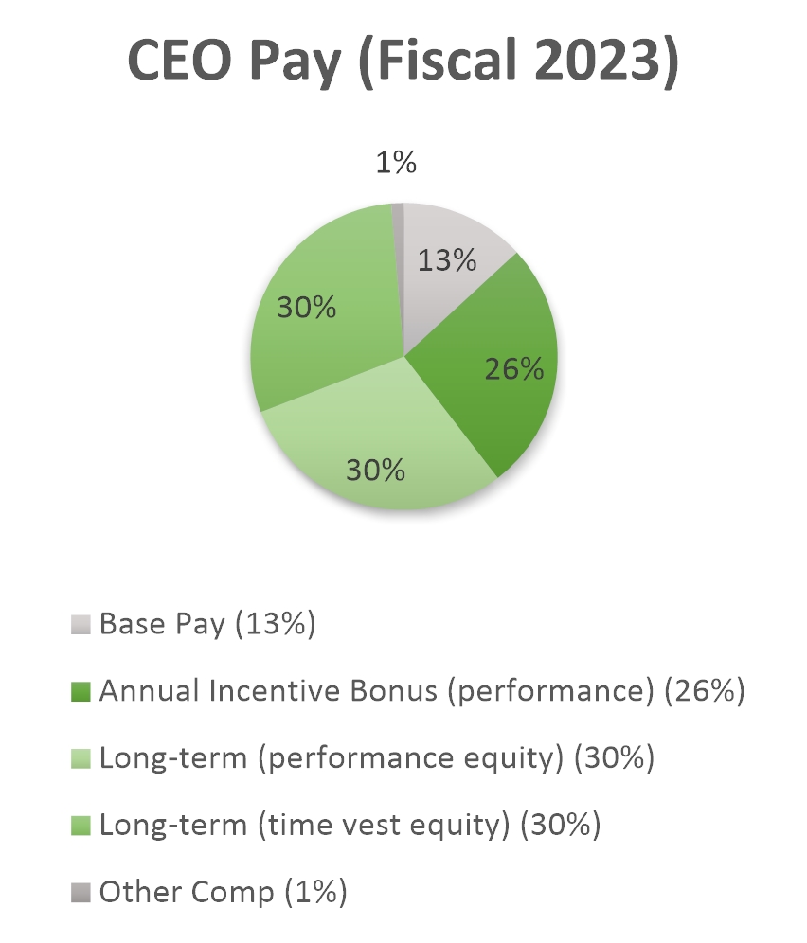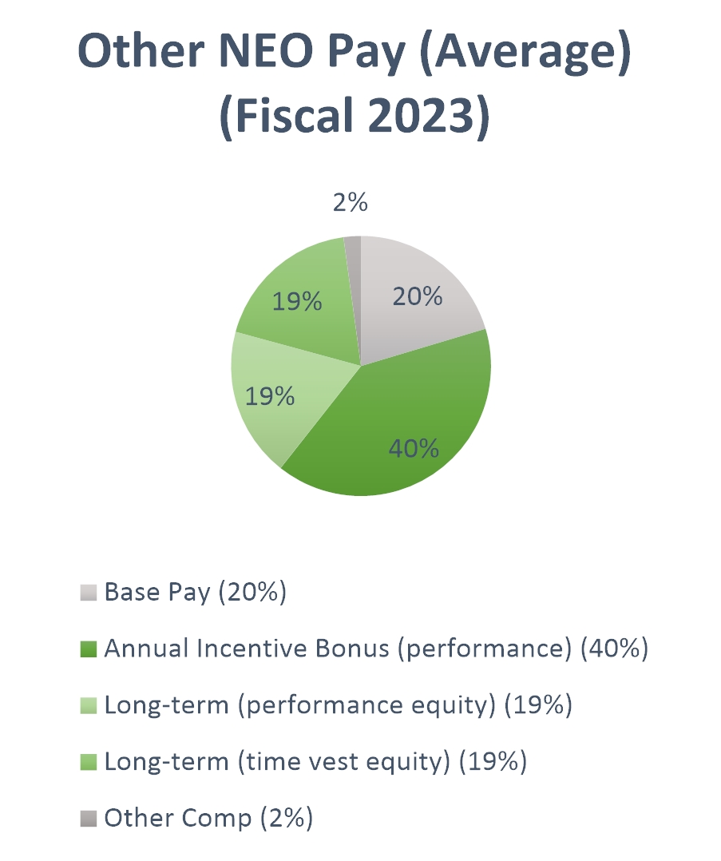

To achieve our compensation objectives for fiscal 2023, our executive compensation program used a combination of short-term and long-term elements: (1) annual salary, (2) annual incentive bonus, and (3) long-term incentive compensation in the form of stock options and restricted stock, both with time and performance vesting conditions. Each element of long-term and short-term compensation is discussed more fully below under the heading “Primary Elements of Executive Compensation” on page 33 of this Proxy Statement. The key features of our executive compensation program include the following:

(1) We seek to align the interests of executives with those of our stockholders by:
• Creating a direct and substantial link between the executive’s annual cash incentive bonus and our annual operating earnings,
• Structuring long-term compensation as equity awards, so that executives have an appropriate incentive to contribute to the creation of long-term stockholder value, and
• Requiring executives to meet stock ownership guidelines that will result in each executive holding a meaningful equity stake in the Company.
(2) We seek to encourage improved performance by:
• Establishing our annual incentive bonus potential based on our operating earnings, with the ability for the Committee to reduce the bonus based on individual performance goals, and
• Tying the ability to earn a substantial portion of our equity-based awards to the achievement of financial goals.

_______________________________
Eagle Materials Inc. * 2023 PROXY STATEMENT 29

Our Compensation Practices
Pay-for-performance is a longstanding core tenet of our compensation philosophy and one of the keys to Eagle’s long-term success. For years, our executive compensation programs have incorporated pay-for-performance and many other compensation best practices, including the following:


Things We Don’t Do
• | Have employment agreements currently in effect with our executives.
• | Provide for tax gross-up agreements with our executives.
• | Provide defined benefit plans for our executives.
• | Allow re-pricing of options (prohibited under our 2013 Incentive Plan – and under the 2023 Plan submitted as Proposal No. 4 in this Proxy Statement).
• | Allow employees or executives to speculate in our securities or engaging in transactions designed to hedge their ownership interests (prohibited under our Insider Trading Policy).


Things We Do
• | Align officer pay with performance.
• | Provide limited perquisites.
• | Provide our executives a defined contribution Retirement Plan determined on the same basis as the benefits provided to all salaried employees.
• | Maintain stock ownership guidelines requiring executives to align their long-term interests with those of our stockholders.
• | Maintain a recoupment (clawback) policy allowing the Company to pursue reimbursement or forfeiture of incentive-based compensation (whether cash or equity) if there is an accounting restatement of our financial statements due to the material noncompliance of the Company with any financial reporting requirement under the securities laws.

_______________________________
Eagle Materials Inc. * 2023 PROXY STATEMENT 30

Determining Executive Compensation
Advisory Vote on Executive Compensation; Central Role of Stockholder Engagement
We value feedback from our stockholders and regularly engage in a dialogue with a significant portion of our stockholders throughout the fiscal year to better understand their opinions on our business strategy and objectives and to obtain feedback regarding other matters of investor interest, such as executive compensation and ESG matters. The Company’s updated Environmental and Social Disclosure Report was a topic of engagement during fiscal 2023.
At the 2022 Annual Meeting of Stockholders, the Company’s stockholders voted to approve a non-binding advisory resolution approving the compensation paid to our Named Executive Officers as disclosed in the proxy statement for the 2022 Annual Meeting of Stockholders. This “say-on-pay” proposal received the approval of 94.5% of the votes cast.
In light of the stockholder support of the executive compensation program (reflected through the 2022 say-on-pay vote results), no substantive changes were made to the executive compensation program for fiscal 2023; however, following a comprehensive review of the Company’s compensation programs during the course of the fiscal year and taking into consideration stockholder feedback, the Compensation Committee did make several modifications to the Company’s compensation programs going forward, as described in greater detail below under “Fiscal 2024 Compensation Developments.”
Authority of the Compensation Committee
Our Compensation Committee meets regularly (ten times in fiscal 2023) to oversee and administer the compensation program of the CEO and the other senior executive officers. See “Board Committees — Compensation Committee” on page 23 of this Proxy Statement. The senior executive officers include all of the Named Executive Officers. In particular, the Compensation Committee is charged with the responsibility to:
 | • | Review and make recommendations regarding our general compensation philosophy and structure;
 | • | Annually review and approve corporate goals and objectives relevant to the compensation of our CEO;
 | • | Evaluate our CEO’s performance in light of such goals and objectives;
 | • | Set the salary and other cash and equity compensation for our CEO based on such evaluation;
 | • | Review and approve the compensation of our other senior executive officers;
 | • | Administer each of our plans for which our Compensation Committee has administrative responsibility;
 | • | Grant cash awards (including annual incentive bonuses) under our annual bonus programs and equity awards (including options, restricted stock and restricted stock units) under the 2013 Incentive Plan to our officers and other key employees;
 | • | Review and recommend to the Board the compensation of our non-employee directors; and
 | • | Recommend to the Board stock ownership guidelines for our executive officers and non-employee directors and monitor compliance therewith.
The Compensation Committee consists solely of directors who are independent under the NYSE listing standards (including the enhanced independence requirements for compensation committee members). The Compensation Committee is authorized to hire such outside advisors as it deems appropriate. The Compensation Committee’s charter may be found in the “Investor Relations/Corporate Governance” section of our website www.eaglematerials.com.
The Compensation Committee sets compensation for the Named Executive Officers on an annual basis. In general, the process for setting compensation involves the following steps:
As early as practicable after the beginning of each fiscal year, the Compensation Committee determines:

(1) the salary of each Named Executive Officer for such fiscal year;
(2) the overall size of the annual incentive bonus pools based on a percentage of our operating earnings or EBITDA in which the Named Executive Officers will have the opportunity to participate during such year and the percentage of the pool assigned to each Named Executive Officer;
(3) whether the Compensation Committee will make any long-term incentive compensation awards in such fiscal year;
_______________________________
Eagle Materials Inc. * 2023 PROXY STATEMENT 31

(4) if the Compensation Committee decides to make long-term compensation awards for such fiscal year, the amount, nature of and terms applicable to such awards, including the form any such awards will take (e.g., options, restricted stock, restricted stock units and/or cash), the performance- or time-vesting criteria (or both) that will apply to any such awards, and the exercisability or payment schedules that will apply to any such awards if the performance criteria are satisfied; and
(5) the Eagle Materials Special Situation Program for such fiscal year and the overall funding levels for such program based on operating earnings.
For fiscal 2023, the Compensation Committee made these determinations at two meetings held early in the fiscal year, in May 2022.
After the end of the fiscal year, the Compensation Committee then:

(1) reviews and approves the annual incentive bonus pools;
(2) determines the extent to which the performance criteria for the prior fiscal year applicable to any long-term incentive awards were satisfied;
(3) determines the amount of the downward adjustment, if any, to be made to the annual incentive bonus payment to each Named Executive Officer based on individual performance; and
(4) if applicable, makes awards under the Eagle Materials Special Situation Program.
The Compensation Committee made these determinations for fiscal 2023 at two meetings held after the completion of the fiscal year, in May 2023.
Role of Management
Our CEO participates to a limited extent in the administration of our compensation program for Named Executive Officers, other than himself. Following the end of each fiscal year, the CEO provides input to the Compensation Committee on the performance of each of the other Named Executive Officers during the fiscal year and recommends compensation adjustments (salary adjustments for the upcoming fiscal year, any downward adjustments to annual incentive bonus levels for the recently completed fiscal year, and annual incentive bonus levels for the upcoming fiscal year) and, if applicable, long-term incentive award levels for such Named Executive Officers. The CEO also provides input on the structure of our long-term incentive awards (if any) for such Named Executive Officers, including the long-term incentive award levels and the performance or other criteria that determine vesting and other terms and conditions applicable to the awards. The Compensation Committee considers the CEO’s input, along with other information presented by its independent compensation consultants or otherwise available to it, in making its final compensation decisions with respect to the Named Executive Officers.
Engagement of an Independent Compensation Consultant

In February 2022, the Compensation Committee retained Meridian Compensation Partners (“Meridian”) to review levels and incentive components of our executives’ compensation in an effort to align the compensation of our officers competitively with the market for fiscal 2023. The primary role of Meridian was to provide the Compensation Committee with market data and information regarding compensation trends in our industry and to make recommendations regarding base salaries, the design of our incentive programs and executive compensation levels. The Compensation Committee has assessed the independence of Meridian pursuant to SEC and NYSE rules and concluded that no conflict of interest exists that would prevent Meridian from independently advising the Compensation Committee.
Compensation Peers
The data used by Meridian in its survey of compensation (the “compensation study”) was from compensation disclosures included in the proxy statements of members of our peer group, as well as Equilar survey data where available for particular positions. At the beginning of fiscal 2023 (spring 2022), Meridian reviewed the Company’s current peer group for appropriateness and provided the Compensation Committee with recommendations for adjustments. Meridian analyzed the Company’s peer group and potential modifications based on industry relevance, revenue and market capitalization size.
Based on Meridian’s analysis and with consideration to management’s input, the Compensation Committee approved the removal of five peers used in fiscal 2022: U.S. Concrete, which had been acquired; Cleveland-Cliffs, Inc., which had grown too large relative to the Company; Granite Construction, which was a poor business/industry match; and EnPro Industries, Inc. and Silgan Holdings, which were poor business/industry matches with no overlap in peer company and advisory firm peer groups. The Compensation Committee also approved the addition of six companies to the peer group: ATI Inc., Arcosa Inc., Compass Minerals International Inc., H.B. Fuller Company, Quaker
_______________________________
Eagle Materials Inc. * 2023 PROXY STATEMENT 32

Houghton and SunCoke Energy, Inc. Based on Meridian’s recommendation, the Compensation Committee utilized the following 16-company peer group in analyzing fiscal 2023 compensation (“compensation peer group”):

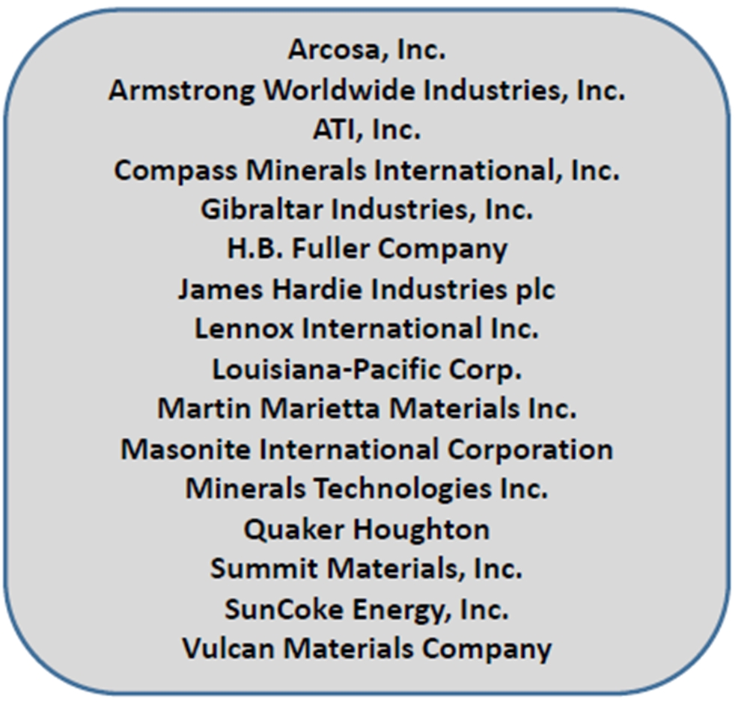
can Materials Company

We are aware that institutional shareholder advisors, such as Institutional Shareholder Services, Glass Lewis and others, utilize methodologies to determine “peer groups” that may differ from our process. We believe that the methodologies they use may result in a peer group that does not provide a close “fit” for Eagle. For example, if the institutional shareholder advisor relies upon GICS codes to identify potential peers, the resulting peer group would include many companies whose operations we view as sufficiently dissimilar to ours as to make comparisons significantly less meaningful. Additionally, if the sole financial metric used by an institutional shareholder advisor to construct a peer group is revenue, the resulting peer group can create a poor fit for two reasons. First, we conduct a portion of our cement operations through the 50% owned Texas Lehigh joint venture. Because of applicable accounting rules we are unable to include the revenue of this joint venture in our revenue line item—we instead account for that entity in a separate line item valuing the equity interest in an unconsolidated joint venture. Second, in our industry, with large up-front capital projects, we believe that cash flow and operating earnings are as or more important than revenues when evaluating peers.
For these reasons and in light of the peer analysis described above, we believe that the compensation peer group identified by our Compensation Committee for fiscal 2023 provides a more appropriate and meaningful basis for assessing our executive compensation.
Primary Elements of Executive Compensation
The primary elements of our executive compensation program are the following:
 | • | Base salary
 | • | Annual incentive bonus
 | • | Long-term incentive compensation
Base Salary
Salaries of the Named Executive Officers are reviewed annually as well as at the time of a promotion or significant change in responsibilities. Considerations that may influence the salary level for a Named Executive Officer include individual performance, the Named Executive Officer’s skills or experience, the Meridian compensation study, our operating performance and the nature and responsibilities of the position. The fiscal 2023 base salaries for the Named Executive Officers were set in May 2022 as follows:
_______________________________
Eagle Materials Inc. * 2023 PROXY STATEMENT 33

Name |  | Base  Salary |  |  |  | Percent  Increase from Prior Year
Michael R. Haack |  | $ | 1,000,000 |  |  |  | 11.1
D. Craig Kesler |  | $ | 515,036 |  |  |  | 3.0
Robert S. Stewart |  | $ | 494,833 |  |  |  | 3.0
Steven L. Wentzel |  | $ | 350,100 |  |  |  | 3.0
Mr. Newby’s base salary was set at $392,268 in connection with his promotion to Executive Vice President, General Counsel and Secretary on June 3, 2022.
Annual Incentive Bonus
The Compensation Committee is responsible for approving the annual incentive bonus for our CEO and the other Named Executive Officers. Annual incentive bonuses paid to our Named Executive Officers for fiscal 2023 (other than Mr. Wentzel) were made under the Eagle Materials Inc. Salaried Incentive Compensation Program for Fiscal Year 2023 (the “Eagle Annual Incentive Program”). The Eagle Annual Incentive Program and the Company’s other incentive programs for fiscal 2023 were structured to create financial incentives and rewards that are directly related to corporate performance and the participating Named Executive Officer’s individual performance during the fiscal year.
The Compensation Committee believes these programs are consistent with our pay-for-performance compensation philosophy in that they place a significant portion of the executive’s compensation “at risk.” Generally, under these programs, a significant portion of the executive’s total compensation is dependent upon the performance of the Company as well as the individual’s performance. The Company’s annual incentive bonus programs also reflect the Committee’s philosophy of aligning the interests of our executives with those of the stockholders. These programs create this alignment by providing that an officer’s annual bonus potential varies directly with our operating earnings (Eagle program) or EBITDA (divisional programs). In addition, individual performance and achievement of goals (as discussed in more detail below under “Approving the Annual Incentive Bonus”) may affect the actual incentive bonus amount through the exercise of “negative discretion.” The Committee believes that operating earnings or EBITDA is an appropriate metric for annual incentive bonuses because it is tied closely to operations, can be directly impacted by the efforts of the pool participants, and is a measure that our stockholders have indicated they track and value.
Eagle Annual Incentive Program
For fiscal 2023, Messrs. Haack, Kesler, Stewart and Newby were participants in the Eagle Annual Incentive Program. Under this program, during the first quarter of the fiscal year, a percentage of our operating earnings is designated by the Compensation Committee as a pool for bonuses, and each participating Named Executive Officer is assigned a share of such pool, representing the executive’s maximum bonus opportunity. At the end of the fiscal year, the size of the pool is determined, based on the amount of operating earnings generated during such fiscal year, and annual incentive bonuses are paid to each participating executive in the form of a lump sum cash payment reflecting each executive’s share of the pool, subject to the exercise of “negative discretion” by the Compensation Committee to reduce (but not increase) the amount of the cash payment based on the executive’s individual performance during the fiscal year. The amount of the annual incentive bonus paid to an executive is based on the level of our operating earnings, the share of the pool designated for such executive, and an assessment of such executive’s individual performance.
The Eagle Annual Incentive Program for Fiscal 2023 was adopted by the Compensation Committee in May 2022 and it mirrored the structure of the fiscal 2022 program. The program was to be funded with 1.2% of the Company’s operating earnings for fiscal 2023, the same percentage used in the prior year.
The bonus pool itself is not subject to a separate cap or maximum; it is merely a function of multiplying the pre-determined percentage by our operating earnings for the applicable fiscal year. However, our 2013 Incentive Plan does provide an absolute cap on cash that any employee may receive in any fiscal year under such programs ($5 million). In setting the percentage of operating earnings which would fund the pool for the Eagle Annual Incentive Program, the Compensation Committee considered several factors, including our compensation philosophy that a significant portion of the executive’s compensation should be “at risk” and subject to the Company’s success (level of operating earnings), as well as the anticipated operating earnings for fiscal 2023.

In allocating each Named Executive Officer’s opportunity under the pool, the Compensation Committee considered the amount of annual incentive bonus compensation opportunities of executives in other companies who fulfill similar roles as illustrated in the compensation study prepared by Meridian, the share of the pool historically allocated to officers in such roles by the Company, the recommendation of Mr. Haack for each participant (other than himself), as well as the Compensation Committee’s assessment of the
_______________________________
Eagle Materials Inc. * 2023 PROXY STATEMENT 34

executive’s importance and contribution to the organization, the executive’s importance in driving the achievement of Company goals and profitability, the executive’s level of responsibility, and the anticipated operating earnings for fiscal 2023. The Compensation Committee set the bonus potential for the Named Executive Officers as follows:
Name |  | Annual  Incentive Bonus  Potential  (% of Pool)
Michael R. Haack |  |  | 28.0
D. Craig Kesler |  |  | 17.5
Robert S. Stewart |  |  | 15.0
Matt Newby |  |  | 6.5

Also at the beginning of fiscal 2023, the Compensation Committee worked with Mr. Haack to develop individual annual incentive goal categories by plan and position throughout the Company, including with respect to the Named Executive Officers (other than himself). For participants in the Eagle Annual Incentive Program, the participants’ individual performance against the goals would be evaluated by the Committee in the exercise of “negative discretion” to reduce (but not increase) the amount of the portion of the pool that would be paid to the participant at the end of the fiscal year.
This pool amount was not quantifiable until the end of fiscal 2023, at which time the Compensation Committee determined that the aggregate amount available for the Eagle Annual Incentive Program pool for fiscal 2023 was $7,485,172 (a maximum of $5,015,066 of which could be paid out to Named Executive Officers). For comparison purposes, the equivalent pool amount in fiscal 2022 was $6,172,484 (a maximum of $5,339,199 of which could be paid out to Named Executive Officers).
Divisional Annual Incentive Program
For certain employees who do not participate in the Eagle Annual Incentive Program, the Company maintains divisional annual incentive plans, which the Committee believes better tie such employees’ annual incentive compensation to metrics that they can directly influence than a Company-wide program. Under these programs, a percentage of a division’s EBITDA is allocated to the bonus pool and each participating employee is assigned a share of the pool, representing the employee’s maximum bonus opportunity. At the end of the fiscal year, the size of the pool is determined and annual bonuses are paid to participating employees in the form of a lump sum cash payment in accordance with their shares of the pool, subject to the exercise of negative discretion by our CEO (or, in the case of bonuses paid to Named Executive Officers, the Compensation Committee) based on the employee’s individual performance during the fiscal year.
For fiscal 2023, Mr. Wentzel participated in a Divisional Annual Incentive Bonus Program—the Eagle Materials Inc. American Gypsum Company Salaried Incentive Compensation Program for Fiscal Year 2023. Under this program, the bonus pool equaled 2.0% of the EBITDA of American Gypsum, which is the same percentage the Compensation Committee has set for the past several years. In deciding to keep the percentage of EBITDA used to fund this bonus pool the same as the prior year, the Compensation Committee considered several factors, including our compensation philosophy that a significant portion of the executive’s compensation should be “at risk” and subject to the Company’s success (level of earnings).

The divisional bonus pools are not subject to a separate cap or maximum, but are merely a function of multiplying the pre-determined percentage by the applicable operating earnings for the applicable fiscal year; however, our 2013 Incentive Plan does provide an absolute cap on cash that any employee may receive in any fiscal year under such programs ($5 million). The aggregate amounts available for the American Gypsum program for fiscal 2023 was $7,561,204, which was not quantifiable until the end of fiscal 2023 and includes amounts available for payment to officers and employees other than the Named Executive Officers. For comparison purposes, the equivalent amount in fiscal 2022 was $5,719,545.
In May 2022, the Compensation Committee set the annual incentive bonus potential for Mr. Wentzel under the American Gypsum program. In determining Mr. Wentzel’s allocation of the pool, the Compensation Committee considered the recommendation of Mr. Haack, the amount of annual incentive bonus compensation payable to executives in other companies who fulfill similar roles as illustrated in the compensation study prepared by Meridian, the portion of the pool historically allocated to his position and the Compensation Committee’s assessment of his importance and contribution to his division’s performance, his importance as an officer within his division in driving the achievement of divisional goals and profitability and his level of responsibility. The Compensation Committee set Mr. Wentzel’s incentive bonus potential at 12.5% of his divisional bonus pool, subject to a cap of $675,000 set by the Committee.
Special Situation Program
In the first quarter of fiscal 2023 (May 2022), the Compensation Committee approved the Eagle Materials Inc. Special Situation Program for Fiscal Year 2023 (the “SSP”), which is a special annual incentive program intended to recognize outstanding individual
_______________________________
Eagle Materials Inc. * 2023 PROXY STATEMENT 35

performance during the fiscal year. The SSP also provides flexibility to reward performance when special circumstances arise in which our CEO determines that an individual has performed well but not been adequately compensated pursuant to other components of compensation, including instances where an individual’s compensation has been adversely affected by unexpected changes in market conditions such as a cyclical downturn or in recognition of transactions and events not contemplated at the time the Compensation Committee set compensation for the applicable year.
SSP awards are made by our CEO, except that awards to senior executive officers require Compensation Committee approval (and our CEO does not have a role in the determination of any SSP award to himself). Awards under the SSP are not predetermined for any individuals at the beginning of the fiscal year. All full-time employees of the Company or any of our subsidiaries are eligible to receive awards under this program. At the beginning of fiscal 2023, the Compensation Committee determined that 0.20% of the Company’s EBITDA for the ensuing fiscal year would fund the SSP, along with the portions of the Eagle and divisional incentive compensation plans and divisional long-term cash compensation plans not paid out. In setting the percentage of EBITDA which would fund the SSP, the Compensation Committee considered several factors, including the anticipated EBITDA for fiscal 2023. All of our Named Executive Officers are eligible to participate in the SSP.
Approving the Annual Incentive Bonus
In May 2023, the Compensation Committee approved the incentive bonus pool for fiscal 2023 for the Company. In addition, at the end of fiscal 2023, Mr. Haack provided performance evaluations of each Named Executive Officer (other than himself) to the Compensation Committee, which evaluations included an assessment of the achievement of their individual goals and objectives, along with his recommendation for the annual incentive bonus for each such Named Executive Officer. With respect to Mr. Haack, the Compensation Committee performed its own evaluation of his performance and the extent to which the goals and objectives established for him for fiscal 2023 had been achieved.
Mr. Haack
At the end of fiscal 2023, the Compensation Committee conducted its performance evaluation of Mr. Haack after receiving input from the entire Board. Mr. Haack also provided information used by the Compensation Committee to evaluate the achievement of his goals and objectives for fiscal 2023 under the Eagle Annual Incentive Program. Based on this evaluation, which included both quantitative as well as discretionary factors, the Compensation Committee believes Mr. Haack performed at a high level during fiscal 2023 and his goals and objectives were substantially met. The Committee’s evaluation resulted in Mr. Haack receiving 96% of his bonus potential for fiscal 2023. The Compensation Committee approved an annual incentive bonus for Mr. Haack under the Eagle Annual Incentive Program of $2,012,014. In making this determination, the Compensation Committee used its judgment to determine the appropriate award level after consideration of several factors, including his achievement of his goals related to the following areas (among others) over the past fiscal year; half of Mr. Haack’s bonus related to factors advancing the Company’s ESG priorities.
 | • | overall financial performance versus plan, achieving record profitability levels;
 | • | leadership on ESG initiatives, including the publication of the Company’s updated Environmental and Social Disclosure Report and the ongoing development and implementation of strategies to reduce greenhouse gas emissions (e.g., continued development of Portland Limestone Cement product and increased use of alternative fuels);
 | • | integration of acquired businesses;
 | • | development and implementation of M&A strategies to optimize and grow the Company’s asset portfolio;
 | • | promotion of a safety performance culture and achieving record safety results; and
 | • | results achieved at the Company’s operating units, including record wallboard production and sales.
Mr. Kesler
At the end of fiscal 2023, Mr. Haack reviewed Mr. Kesler’s performance. Based in part on this review, the Compensation Committee determined that Mr. Kesler had substantially met his goals and awarded Mr. Kesler 96% of his incentive bonus potential, approving an annual incentive bonus for Mr. Kesler under the Eagle Annual Incentive Program of $1,257,509. In making this determination, the Compensation Committee used its judgment to determine the appropriate award level after consideration of several factors, including the input of Mr. Haack regarding Mr. Kesler’s performance and his achievement of his goals related to his areas of responsibility, including: Mr. Kesler’s work on cyber security assessment and improvements, capital management, and the integration of acquired businesses into the Company’s financial and IT systems.
_______________________________
Eagle Materials Inc. * 2023 PROXY STATEMENT 36

Mr. Stewart
At the end of fiscal 2023, Mr. Haack reviewed Mr. Stewart’s performance. Based in part on this review, the Compensation Committee determined that Mr. Stewart had substantially met his goals and awarded Mr. Stewart 95% of his incentive bonus potential, approving an annual incentive bonus for Mr. Stewart under the Eagle Annual Incentive Program of $1,066,637. In making this determination, the Compensation Committee used its judgment to determine the appropriate award level after consideration of several factors, including his achievement of his goals related to his areas of responsibility, the input of Mr. Haack regarding Mr. Stewart’s performance, and the following areas (among others) over the past fiscal year: Mr. Stewart’s work on the Company’s revised Environmental & Social Report, succession planning and talent and organizational development (including with respect to diversity), and his involvement in the Company’s strategic budgeting process.

Mr. Newby
At the end of fiscal 2023, Mr. Haack reviewed the performance of Mr. Newby. Based in part on this review, the Compensation Committee determined that Mr. Newby had substantially met his goals and awarded Mr. Newby 95% of his incentive bonus potential, approving an annual incentive bonus for Mr. Newby under the Eagle Annual Incentive Program of $462,209. In making this determination, the Compensation Committee used its judgment to determine the appropriate award level after consideration of several factors, including his achievement of his goals related to his areas of responsibility, the input of Mr. Haack regarding the performance of Mr. Newby, and the following areas (among others) over the past fiscal year: Mr. Newby’s work on the Company’s process for negotiating and entering into material contracts, legal support of acquisitions, and oversight of the Company’s employee hotline.
Mr. Wentzel
At the end of fiscal 2023, Mr. Haack reviewed the performance of Mr. Wentzel. Based in part on this review, the Compensation Committee determined that Mr. Wentzel had met his goals and awarded Mr. Wentzel 100% of his incentive bonus potential (as capped by the Committee), approving an annual incentive bonus for Mr. Wentzel under the Eagle Materials Inc. American Gypsum Company Salaried Incentive Compensation Program for Fiscal Year 2023 of $675,000. In making this determination, the Compensation Committee used its judgment to determine the appropriate award level after consideration of several factors, including his achievement of his goals related to his areas of responsibility, the input of Mr. Haack regarding the performance of Mr. Wentzel, and the following areas (among others) over the past fiscal year: Mr. Wentzel’s promotion of a safety performance culture, management of his business unit’s increase in production capacity, engineering project management to increase flexibility and capacity at plants, and succession planning and management.
Long-Term Incentive Compensation
Consistent with the Compensation Committee’s philosophy of linking compensation to performance, 50% of our long-term incentive compensation program for fiscal 2023 has been structured to tie executives’ ability to earn equity awards to the achievement of specific Company performance levels. To enhance retention of key employees, once earned, the performance awards contain a further time-vesting component. The remaining 50% of our long-term compensation program has been structured as purely time-vesting, which the Compensation Committee believes, based on the input of Meridian, is in-line with the practice of our peers and enhances the retention of key employees. A more detailed description of the fiscal 2023 awards is found below.
Value-Adjusted Burn Rate
The Compensation Committee strives to be a good steward of the equity available for award under our 2013 Incentive Plan. Our three-year value-adjusted average burn rate (a measure of historical dilution as calculated by ISS) is well below our industry norms. The Company’s three-year average value-adjusted burn rate (which is based on the number of options granted in each fiscal year times a Black-Scholes value plus the number of shares granted in such fiscal year times the stock price, divided by the weighted-average common shares outstanding for such fiscal year times the stock price) is 0.45%. The 2023 benchmark of this measure for our industry published by ISS is 1.33%.
Grant Practice
All of the Named Executive Officers participate in our long-term incentive compensation program. In fiscal 2023, the Compensation Committee approved equity grants as described below. The date on which an equity award is granted is the date specified in the resolutions of the Compensation Committee authorizing the grant. The grant date must fall on or after the date on which the resolutions are adopted by the Committee. As provided in the 2013 Incentive Plan, for stock options, the exercise price is the closing price of our Common Stock on the grant date, as reported by the NYSE.

_______________________________
Eagle Materials Inc. * 2023 PROXY STATEMENT 37

Fiscal 2023 Grants
In structuring the long-term incentive program for fiscal 2023, the Compensation Committee worked with Mr. Haack to establish a mix of performance-based and time-vesting awards. Consistent with prior years, the performance metric selected was return on equity (“ROE”), which represents our earnings as a percentage of our stockholders’ equity, a performance metric that our stockholders have told us they find meaningful and that the Committee views as a measure of the Company’s prudent deployment of capital.
Target award amounts were allocated equally (based on target grant date fair values as described below) between performance-vesting and time-vesting awards, and the Committee allocated such awards between restricted stock and stock options based in part on the stated preference of the recipient. With respect to performance-based equity awards, the Committee determined a target award value that would be received upon the achievement of a strong ROE (15.0%), with up to 120% of the target value earned if exceptional ROE (20.0%) were achieved and 80% of the target value earned if acceptable ROE (10.0%) were achieved. None of the performance-based equity awards would be earned if the return on equity were below this acceptable level. Both performance-based and time-vesting equity awards would vest over a four-year period to enhance the retention of these key employees.
Effective May 19, 2022, the Compensation Committee approved equity awards under the 2013 Incentive Plan to a group of key employees, including the Named Executive Officers, in alignment with the above structure. As part of the compensation study delivered to the Compensation Committee in May 2022, Meridian had provided information regarding long-term compensation as well as total direct compensation paid to the compensation peer group. In determining the value of the equity to be granted, the Compensation Committee took into consideration the Meridian compensation study, the input of Mr. Haack, the Compensation Committee’s assessment of the executive’s importance and contribution to the organization, and the executive’s level of responsibility. The target grant date fair value was allocated 50% to performance-based equity (with a Company ROE financial metric) and 50% to time-vesting equity. In general, recipients of equity awards had their target grant date fair value allocated between restricted stock and stock options as determined by the Compensation Committee after taking into consideration the stated preference of the recipient.
The following table shows the stock options and restricted stock granted to each of the Company’s Named Executive Officers (other than Mr. Graass) effective May 19, 2022:
Name |  | Target Value of Equity Awards(1) |  |  |  | Target Number of  Performance  Vesting  Stock Options |  |  |  | Target Shares of  Performance  Vesting  Restricted Stock |  |  |  | Number of  Time Vesting  Stock Options |  |  |  | Shares of  Time Vesting  Restricted  Stock
Michael R. Haack |  | $ | 4,500,000 |  |  |  | 11,589 |  |  |  | 13,370 |  |  |  | 11,589 |  |  |  | 13,370
D. Craig Kesler |  |  | 1,000,000 |  |  |  | 2,576 |  |  |  | 2,972 |  |  |  | 2,576 |  |  |  | 2,972
Robert S. Stewart |  |  | 900,000 |  |  |  | — |  |  |  | 3,566 |  |  |  | — |  |  |  | 3,566
Matt Newby |  |  | 700,000 |  |  |  | — |  |  |  | 2,773 |  |  |  | — |  |  |  | 2,773
Steven L. Wentzel |  |  | 600,000 |  |  |  | — |  |  |  | 2,377 |  |  |  | — |  |  |  | 2,377
______________________
 | (1) | Grant date fair value of the award computed in accordance with FASB ASC Topic 718. See Summary Compensation Table on page 44 of this Proxy Statement. Half of the target value is allocated to performance-based awards and half of the target value is allocated to time-vesting awards.

The Committee believes that the structure of the fiscal 2023 long-term compensation program is consistent with the Compensation Committee’s philosophy of linking compensation to our performance.
Performance-Based Equity Awards
These awards are comprised of shares of restricted stock and stock options which are earned based upon the achievement by the Company of a certain level of average ROE for the fiscal year ended March 31, 2023, as detailed below:
Return on Equity for FYE 3/31/23 |  | Percent of Target Earned
> 20.0% |  |  | 120 | %
> 15.0% |  |  | 100 | %
> 10.0% |  |  | 80 | %
< 10.0% |  |  | 0 | %
The exact percentage of shares earned is calculated based on straight-line interpolation between the points specified above with fractional points rounded to the nearest tenth of a percent. The earned performance-based equity was to become fully vested one-fourth promptly after the certification date and one-fourth on March 31 for each of the following three years (in each case assuming continued service through such dates).
_______________________________
Eagle Materials Inc. * 2023 PROXY STATEMENT 38

The terms and conditions of the performance-based equity are substantially the same as prior performance-based awards, except that the performance period is as described above. Any performance-based equity that was not earned at the end of fiscal 2023 was to be forfeited. In accordance with the terms of the 2013 Incentive Plan, the exercise price of the stock options is the closing price of the Company’s Common Stock on the date of grant, May 19, 2022 ($126.22).

In May 2023, the Compensation Committee certified that the Company’s 32.2% average ROE for the fiscal year ended March 31, 2023 satisfied the Company’s performance goal such that 120% of the target number of shares/options was earned. In calculating the average ROE, in accordance with the award agreement, the Committee excluded the impact of certain extraordinary items not related to operating performance, including downward adjustment from the gain from the sale of non-core businesses.
Time-Vesting Equity Awards
These awards comprise shares of restricted stock and stock options which vest ratably over four years on March 31, 2023; March 31, 2024; March 31, 2025; and March 31, 2026 (in each case assuming continued service through such dates). The Compensation Committee believes that including time-vesting equity as part of long-term compensation is consistent with competitive pay practices, supports the Company’s philosophy that a significant portion of an executive’s pay should be at risk, enhances the retention of key employees, while at the same time creating a strong incentive for management to operate the business in a manner that creates additional value for stockholders.
The terms and conditions of the time-vesting equity are substantially the same as prior time-vesting awards. As in the case of prior equity awards, the time-vesting equity will also vest upon a change in control of the Company. See “Change in Control Benefits” below. In accordance with the terms of the 2013 Incentive Plan, the exercise price of the stock options is the closing price of the Company’s Common Stock on the date of grant, May 19, 2022 ($126.22).
Other Elements of Executive Compensation
Retirement Plan
Our Named Executive Officers, along with substantially all salaried and hourly employees of the Company and our subsidiaries are covered under our Retirement Plan, a qualified defined contribution plan under sections 401(a) and 401(k) of the Internal Revenue Code of 1986 (the “Code”).
Salaried participants, including our Named Executive Officers, covered under our Retirement Plan may elect to make pre-tax contributions and/or after-tax Roth 401(k) contributions of up to 70% of their base salary subject to the limit under Code Section 402(g) ($20,500 for calendar year 2022 and $22,500 for calendar year 2023), employee after-tax contributions of up to 10% of base salary and, if the participant is at least age 50, pre-tax “catch-up contributions” up to the statutory limit under Code Section 414(v) ($6,500 for calendar year 2022 and $7,500 for calendar year 2023). In addition, our Retirement Plan provides for a discretionary employer profit sharing contribution for our salaried employees, including our Named Executive Officers, that is a percentage of base salary for the year.

Participants are fully vested to the extent of their pre-tax, after-tax Roth 401(k), and after-tax contributions. Our salaried participants become vested in the employer profit sharing contribution over a four-year period (i.e., 25% per year beginning with the first year of service). All Named Executive Officers have been employed by the Company or our affiliates long enough to be fully vested. Participants are entitled to direct the investment of contributions made to the Retirement Plan on their behalf in various investment funds, including up to 15% in an Eagle Common Stock fund. Upon a participant’s termination of employment, disability or death, such amounts may remain in the Company plan or they are payable in the form of a lump sum, installments or direct rollover to an eligible retirement plan, as elected by the participant. At the participant’s election, amounts invested in the Common Stock fund are distributable in shares of our Common Stock.
Employer profit sharing contributions made to the Retirement Plan on behalf of our Named Executive Officers in fiscal 2023 are reflected under the “All Other Compensation” column in the Summary Compensation Table located on page 44_ of this Proxy Statement. A list of the investment funds provided under the Retirement Plan is provided in the footnotes to the Nonqualified Deferred Compensation Table located on page 50 of this Proxy Statement.
_______________________________
Eagle Materials Inc. * 2023 PROXY STATEMENT 39

SERP
In fiscal 1995, the Board approved our Supplemental Executive Retirement Program, which we will refer to as our “SERP,” for certain employees participating in the Retirement Plan. Internal Revenue Code Section 401(a)(17) limits the amount of annual compensation ($305,000 for calendar year 2022 and $330,000 for calendar year 2023) that may be considered in determining our contribution to the Retirement Plan for the account of an eligible participant.
The SERP was established to eliminate the adverse treatment that higher-salaried employees receive as a result of such limit by making a contribution for each participant in an amount substantially equal to the additional employer profit sharing contribution that he or she would have received under the Retirement Plan had 100% of his or her base salary been eligible for a profit-sharing contribution. As in the case of the Retirement Plan, annual incentive bonuses paid to participants are not included when determining the amount of contributions to the SERP. The Compensation Committee believes that the SERP therefore allows us to confer the full intended benefit of the employer profit sharing contribution under the Retirement Plan without the arbitrary limitation of the Internal Revenue Code rules noted above.
Contributions accrued under the SERP for the benefit of the higher-salaried employees vest under the same terms and conditions as under the Retirement Plan and may be invested by the participant in several of the same investment options as offered under the Retirement Plan. Benefits under the SERP are payable upon the participant’s termination of employment in a lump sum or installments as elected by the participant in accordance with the terms of the SERP. As with the Retirement Plan, all Named Executive Officers have been employed by the Company or our affiliates long enough to be fully vested.
Employer contributions under the SERP to our Named Executive Officers in fiscal 2023 are reflected under the “All Other Compensation” column in the Summary Compensation Table located on page 44 of this Proxy Statement. A list of the investment funds provided under the Retirement Plan is provided in the footnotes to the Nonqualified Deferred Compensation Table located on page 50 of this Proxy Statement.
Salary Continuation Plan
The Named Executive Officers, along with other officers and key employees, are participants in our Salary Continuation Plan (the “SCP”). Under this plan, in the event of the death of a participating employee, we will pay such employee’s beneficiaries one full year of base salary in the first year following death and 50% of base salary each year thereafter until the date such employee would have reached normal Social Security retirement age, subject to a maximum amount of $1.5 million. Payments are made to the employee’s beneficiary on a semi-monthly basis.

The purpose of the plan is to provide some financial security for the families of the participating employees, which assists the Company in attracting and retaining key employees. Benefit amounts under the plan are intended to provide a basic level of support for beneficiaries. To cover these potential obligations, we pay the premiums on life insurance policies covering each participating employee. Such policies are owned by the Company and proceeds from such policies would be initially paid to the Company.
Premiums paid on policies covering our Named Executive Officers in fiscal 2023 are reflected under the “All Other Compensation” column in the Summary Compensation Table located on page 44 of this Proxy Statement. Amounts potentially payable to the beneficiaries of our Named Executive Officers pursuant to the SCP are described in “Potential Payments Upon Termination or Change in Control” beginning on page 51 of this Proxy Statement.
Change in Control Benefits
To better ensure the retention of our employees in the event of a potentially disruptive corporate transaction, we have provided our employees, including our Named Executive Officers, with certain change in control protections. We believe that such protections, which are consistent with the practices of our peer companies, are in the best interest of our stockholders because they enable our executive leadership team to fully focus on the benefits of a corporate transaction for stockholders, rather than the potential adverse consequences of the transaction on their careers and compensation.
Change in Control Continuity Agreements
To better ensure the retention of our executive leadership team in the event of a potentially disruptive corporate transaction, the Board has approved change in control continuity agreements with Messrs. Haack, Kesler, Stewart and Newby. The change in control continuity agreements provide that, in the event of a change in control during the term, a two-year protection period will commence during which the relevant executive will be entitled to compensation and benefits on terms that are generally no less favorable than those that applied prior to the change in control.
_______________________________
Eagle Materials Inc. * 2023 PROXY STATEMENT 40

In the event of an executive’s involuntary termination of employment without cause or resignation for good reason during the two-year protection period, subject to the execution of a release of claims, he would be entitled to (a) cash severance equal to the product of (i) a severance multiple of 3 (for Mr. Haack), 2.5 (for Mr. Kesler) or 2 (for Messrs. Stewart and Newby), multiplied by (ii) the sum of his annual base salary and target annual bonus; (b) a prorated annual bonus for the year of termination; (c) a payment in lieu of employer retirement savings plan contributions that he would have received had his employment continued for 18 months (for Mr. Haack), 15 months (for Mr. Kesler) or 12 months (for Messrs. Stewart and Newby) post-termination; (d) a payment equal to the premium for continued participation in health insurance plans for 18 months (for Mr. Haack), 15 months (for Mr. Kesler) or 12 months (for Messrs. Stewart and Newby) post-termination; and (e) outplacement benefits of up to $30,000.
The change in control continuity agreements subject the executives to a perpetual confidentiality covenant and noncompetition covenants for 18 months (for Mr. Haack), 15 months (for Mr. Kesler) or 12 months (for Messrs. Stewart and Newby) post-termination. If any payments or benefits under the change in control continuity agreements would be subject to Sections 280G and 4999 of the Internal Revenue Code, such payments or benefits would be reduced to the extent that such reduction would place the executive in a better after-tax position. The initial term of the change in control continuity agreements is three years from the effective date of June 20, 2019 (for Messrs. Haack, Kesler and Stewart) and May 31, 2022 (for Mr. Newby), subject in each case to automatic renewal for an additional year on each anniversary of the effective date.

All of our change in control continuity agreements have a “double-trigger” termination right (requiring both a change in control and a qualifying termination of employment in order to receive the change in control severance payments), and they do not apply the severance multiple to long-term incentive award values or have tax gross-ups.
Under our change in control continuity agreements a “change in control” is defined generally as (i) the acquisition by any person or entity of 35% or more of our outstanding Common Stock or the voting power of outstanding securities entitled to vote in the election of directors; (ii) a change in the composition of our Board such that the current members of the Board cease to constitute a majority of the Board; (iii) the consummation of a merger, asset disposition, share exchange or similar transaction, unless (1) more than 50% of the stock following such transaction is owned by persons or entities who were stockholders of the Company prior to such transaction, (2) following such transaction, no person or entity owns 35% or more of the common stock of the entity resulting from such transaction, and (3) at least a majority of the members of the resulting corporation’s board of directors were members of our Board; or (iv) our stockholders approve a complete liquidation or dissolution of the Company
See “Potential Payments Upon Termination or Change in Control” beginning on page 51 of this Proxy Statement.
Equity Awards
Awards granted in fiscal 2023 under our 2013 Incentive Plan are subject to accelerated vesting upon the occurrence of a “change in control” as defined in the applicable award agreement if they are not assumed or replaced with equivalent awards in connection with such change in control. Under the award agreements or incentive program documents, a “change in control” is defined generally as:
 | (i) | the acquisition by any person or entity of 50% or more of the outstanding shares of any single class of our Common Stock or 40% or more of outstanding shares of all classes of our Common Stock;
 | (ii) | a change in the composition of our Board such that the current members of the Board cease to constitute a majority of the Board; or
 | (iii) | the consummation of a merger, dissolution, asset disposition, consolidation or share exchange, unless (a) more than 50% of the stock following such transaction is owned by persons or entities who were stockholders of the Company prior to such transaction, (b) following such transaction, no person or entity owns 40% or more of the common stock of the corporation resulting from such transaction, and (c) at least a majority of the members of the resulting corporation’s board of directors were members of our Board.
If a change in control occurs, any unvested outstanding stock options, restricted stock, or restricted stock units would generally become immediately fully vested, and, in the case of stock options, exercisable or, in the case of restricted stock or RSUs, payable, unless the transaction resulting in the change in control provides that the award is to be replaced with an award of equivalent shares of the surviving parent corporation. See “Potential Payments Upon Termination or Change in Control” beginning on page 51 of this Proxy Statement.
We believe the provision of these change in control benefits is a valuable executive talent retention incentive and is consistent with the objectives of our overall executive compensation program.
_______________________________
Eagle Materials Inc. * 2023 PROXY STATEMENT 41

No Discriminatory Perquisites, Post-retirement Welfare Or Tax Gross-Ups
The Company does not provide discriminatory perquisites or post-retirement welfare benefits to the Named Executive Officers. During employment, the Named Executive Officers participate in the broad-based employee health insurance plans available to employees of the Company generally. Further, the Company does not provide for gross-ups of excise taxes under Section 4999 of the Code to any of the Named Executive Officers.

Other Compensation Policies and Practices
Stock Ownership Guidelines
In order to align the interests of the Named Executive Officers with our stockholders, and to promote a long-term focus for the officers, the Board of Directors has adopted executive stock ownership guidelines for the Company’s executive officers. The ownership goal for each Named Executive Officer is expressed as a dollar amount equal to a multiple of base salary. The CEO’s goal is higher than the other executive officers (as detailed below).
Name |  | Multiple of  Salary  Ownership  Guidelines
Michael R. Haack |  | 5X
D. Craig Kesler |  | 3X
Robert S. Stewart |  | 3X
Matt Newby |  | 3X
Steven L. Wentzel |  | 3X
The goal is met when the officer’s current share value meets or exceeds the goal. The current share value is calculated in one of three ways: (i) the sum of the grant date fair value of current shares held by the officer; (ii) the current shares valued at the current market price; or (iii) the current shares valued at an average stock price (the average of the prior three management equity incentive grant prices).
Until an officer has achieved the goal, he or she is required to retain all net shares received from the Company.
Once an officer has achieved the goal, he or she may sell shares of Common Stock to the extent the value of post-sale share holdings (valued at the greater of current price and average price) exceeds the goal.

Types of ownership counted toward the goal include the following:
 | • | Direct holdings;
 | • | Shares represented by earned restricted stock or RSUs;
 | • | Stock holdings in our Retirement Plan; and
 | • | Indirect holdings, such as shares owned by a family member residing in the same household.

The Compensation Committee reviews compliance with the ownership guidelines on an annual basis. Newly elected officers have five years to meet the applicable ownership requirement. As of the record date for the 2023 annual meeting, all Named Executive Officers are in compliance with the guidelines.
Recoupment (Clawback) Policy
We have adopted a recoupment (clawback) policy. We can recoup incentive-based compensation (whether cash or equity) from executive officers if there is an accounting restatement of our financial statements due to the material noncompliance of the Company with any financial reporting requirement under the securities laws. The policy applies to compensation received by any current or former executive officer during the three-year period preceding the restatement.
No Hedging
Under our insider trading policy, all of our directors and employees (including our Named Executive Officers) are prohibited from speculating in our securities or engaging in transactions designed to hedge their ownership interests.
Consideration of the Tax Deductibility of Compensation
Section 162(m) of the Internal Revenue Code generally disallows a tax deduction for public corporations for compensation over $1,000,000 paid in any fiscal year to the corporation’s chief executive officer and certain other executive officers. Despite this fact, the Compensation Committee intends to continue to implement compensation programs that it believes are competitive and in the best
_______________________________
Eagle Materials Inc. * 2023 PROXY STATEMENT 42

interests of the Company and its stockholders. Accordingly, the Committee may approve compensatory arrangements that provide for non-deductible payments or benefits when it determines that such arrangements are consistent with the Company's business needs and in the best interest of the Company and its stockholders.
Compensation Risk
Although a significant portion of potential compensation to our executive officers is performance-based, we do not believe that our compensation policies, principles, objectives and practices are structured to promote inappropriate risk taking by our executives. We believe that the focus of our overall compensation program encourages management to take a balanced approach that focuses on increasing and sustaining our profitability. See “Board Leadership Structure and Role in Risk Oversight — Risk Assessment in Compensation Programs” on page 21 of this Proxy Statement.
Fiscal 2024 Compensation Developments
Following a comprehensive review of the Company’s compensation programs during the course of fiscal 2023 and taking into consideration stockholder feedback, in May 2023, the Compensation Committee modified several aspects of the Company’s compensation programs for fiscal 2024.
Annual Incentive Compensation. As we disclosed in our Form 8-K filed with the SEC on May 23, 2023, on May 17, 2023, the Compensation Committee approved the Eagle Materials Inc. Salaried Incentive Compensation Program for Fiscal Year 2024, which is consistent with the fiscal 2023 Eagle Annual Incentive Program described above, except that (as described below) the fiscal 2024 program (i) provides for threshold financial performance against budget and (ii) contains an individual cap on bonus payments. If the Company’s operating earnings for fiscal 2024 are less than 50% of budget, no funds will be available for the corporate bonus pool. None of the participants in the program (including Messrs. Haack, Kesler and Newby) will be able to receive a bonus payment in excess of three times (3X) such participant’s annual base salary. Similar to the fiscal 2023 Eagle Annual Incentive Program, the pool will be funded with 1.2% of the Company’s operating earnings for fiscal 2024. The pool will be available to pay annual bonuses to participating officers, subject to reduction based on individual performance in fiscal 2024 and the other limitations noted above. The percentage of the fiscal 2024 bonus pool available for payment of the annual incentive bonus to the Named Executive Officers participating in the pool was set as follows: Mr. Haack, 28.0%; Mr. Kesler, 13.5%; and Mr. Newby, 7.5%.
Long-Term Incentive Compensation. As we disclosed in our Form 8-K filed with the SEC on May 26, 2023, effective May 23, 2023, the Compensation Committee approved long-term incentive equity awards under the 2013 Incentive Plan to a group of the Company’s officers, including some of its Named Executive Officers. The awards are similar to the fiscal 2023 awards described above, except (i) the performance awards are subject to multiple performance periods described below and (ii) the time-vesting awards will vest ratably over the three fiscal year-ends following the date of grant (assuming continued service by the relevant officer). In order for the performance-vesting restricted stock to be earned, the Company must achieve performance vesting criteria based on the Company’s average ROE measured at the end of fiscal 2024, 2025 and 2026. Twenty-five percent of the target performance shares will be subject to a one-year performance period, 25% will be subject to a two-year performance period, and 50% will be subject to a three-year performance period. Any earned restricted stock will vest immediately upon the determination of the achievement of the performance vesting criterion for the relevant performance period, and any unearned restricted stock from such performance period will be forfeited.

_______________________________
Eagle Materials Inc. * 2023 PROXY STATEMENT 43

EXECUTIVE COMPENSATION
Summary Compensation Table
The following table summarizes all fiscal 2021, 2022 and 2023 compensation earned by or paid to our Named Executive Officers, who consist of our Chief Executive Officer, our Chief Financial Officer and the three most highly compensated executive officers (other than the Chief Executive Officer and Chief Financial Officer) who were serving as executive officers at fiscal year-end.

Name and Principal  Position |  | Fiscal  Year  Ended  March  31, |  | Salary(1)  ($) |  |  |  | Stock  Awards(2)  ($) |  |  |  | Option  Awards(3)  ($) |  |  |  | Non-Equity  Incentive  Plan  Compensation(4)  ($) |  |  |  | All Other  Compensation(5)  ($) |  |  |  | Total  ($)
Michael R. Haack |  | 2023 |  | $ | 1,000,000 |  |  | $ | 3,375,000 |  |  | $ | 1,125,000 |  |  | $ | 2,012,014 |  |  | $ | 102,774 |  |  | $ | 7,614,788
President and Chief |  | 2022 |  |  | 900,000 |  |  |  | 4,000,000 |  |  |  | — |  |  |  | 1,641,881 |  |  |  | 93,869 |  |  |  | 6,635,750
Executive Officer |  | 2021 |  |  | 824,000 |  |  |  | 1,750,000 |  |  |  | 1,750,000 |  |  |  | 1,350,000 |  |  |  | 87,074 |  |  |  | 5,761,074
D. Craig Kesler |  | 2023 |  |  | 515,036 |  |  |  | 750,000 |  |  |  | 250,000 |  |  |  | 1,257,509 |  |  |  | 57,063 |  |  |  | 2,829,608
Executive Vice |  | 2022 |  |  | 500,035 |  |  |  | 1,000,000 |  |  |  | — |  |  |  | 1,260,730 |  |  |  | 55,938 |  |  |  | 2,816,703
President – Finance and |  | 2021 |  |  | 500,035 |  |  |  | 500,000 |  |  |  | 500,000 |  |  |  | 1,036,352 |  |  |  | 54,902 |  |  |  | 2,591,289
Administration & CFO
Robert S. Stewart |  | 2023 |  |  | 494,833 |  |  |  | 900,000 |  |  |  | — |  |  |  | 1,066,637 |  |  |  | 49,783 |  |  |  | 2,511,253
Executive Vice |  | 2022 |  |  | 480,420 |  |  |  | 900,000 |  |  |  | — |  |  |  | 1,084,814 |  |  |  | 48,702 |  |  |  | 2,513,936
President – Strategy, |  | 2021 |  |  | 480,420 |  |  |  | 900,000 |  |  |  | — |  |  |  | 891,744 |  |  |  | 47,807 |  |  |  | 2,319,971
Corporate Development and
Communications
Matt Newby (6) |  | 2023 |  |  | 392,268 |  |  |  | 700,000 |  |  |  | — |  |  |  | 462,209 |  |  |  | 41,398 |  |  |  | 1,595,875
Executive Vice President
General Counsel and
Secretary
Steven L. Wentzel (7) |  | 2023 |  |  | 350,100 |  |  |  | 600,000 |  |  |  | — |  |  |  | 675,000 |  |  |  | 37,694 |  |  |  | 1,662,794
President - American |  | 2022 |  |  | 339,900 |  |  |  | 600,000 |  |  |  | — |  |  |  | 672,047 |  |  |  | 36,862 |  |  |  | 1,648,809
Gypsum Company LLC |  | 2021 |  |  | 330,000 |  |  |  | 600,000 |  |  |  | — |  |  |  | 606,038 |  |  |  | 34,125 |  |  |  | 1,570,163
James H. Graass (8) |  | 2023 |  |  | 102,053 |  |  |  | 1,869,806 |  | (9) |  | 33,638 |  | (9) |  | — |  |  |  | — |  |  |  | 2,005,497
Retired Executive Vice President |  | 2022 |  |  | 451,000 |  |  |  | 800,000 |  |  |  | — |  |  |  | 1,084,814 |  |  |  | 47,693 |  |  |  | 2,383,507
General Counsel and |  | 2021 |  |  | 451,000 |  |  |  | 800,000 |  |  |  | — |  |  |  | 891,744 |  |  |  | 47,087 |  |  |  | 2,189,831
Secretary

(1) | Includes amounts deferred on a pre-tax or after-tax basis at the election of the executive under our Retirement Plan, which is described in greater detail under “Retirement Plan” on page 39 of this Proxy Statement.
(2) | Except as noted in any footnoted number, the amounts in this column reflect the value of restricted stock awards made to the Named Executive Officer in each of the fiscal years presented and are consistent with the grant date fair value of the award computed in accordance with FASB ASC Topic 718. For assumptions used in determining these values, refer to (a) footnote (L) to the Company’s audited financial statements for the fiscal year ended March 31, 2023 included in the Fiscal 2023 Form 10-K; (b) footnote (L) to the Company’s audited financial statements for the fiscal year ended March 31, 2022 included in the Form 10-K, filed with the SEC on May 20, 2022 (“Fiscal 2022 Form 10-K”); and (c) footnote (L) to the Company’s audited financial statements for the fiscal year ended March 31, 2021 included in the Form 10-K, filed with the SEC on May 21, 2021 (“Fiscal 2021 Form 10-K”). Unless otherwise noted, the amounts in this column assume achievement of less than the highest level of performance conditions, and the following reflects the amounts for this award assuming the highest level of performance conditions (i.e., the maximum amounts payable): Fiscal 2023: Mr. Haack - $3,712,500; Mr. Kesler - $825,000; Mr. Stewart - $990,000; Mr. Newby - $770,000; and Mr. Wentzel - $660,000. Fiscal 2022: Mr. Haack - $4,400,000; Mr. Kesler - $1,100,000; Mr. Stewart - $990,000; Mr. Wentzel - $660,000; and Mr. Graass - $880,000. Fiscal 2021: Mr. Haack - $1,925,000; Mr. Kesler - $550,000; Mr. Stewart - $990,000; Mr. Wentzel - $660,000; and Mr. Graass - $880,000.
(3) | Except as noted in any footnoted number, the amounts in this column reflect the value of option awards made to the Named Executive Officer in each of the fiscal years presented and are consistent with the grant date fair value of the award computed in accordance with
_______________________________
Eagle Materials Inc. * 2023 PROXY STATEMENT 44

FASB ASC Topic 718. For assumptions used in determining these values, refer to (a) footnote (L) to the Company’s audited financial statements for the fiscal year ended March 31, 2023 included in the Fiscal 2023 Form 10-K; (b) footnote (L) to the Company’s audited financial statements for the fiscal year ended March 31, 2022 included in the Fiscal 2022 Form 10-K; and (c) footnote (L) to the Company’s audited financial statements for the fiscal year ended March 31, 2021 included in the Fiscal 2021 Form 10-K. Unless otherwise noted, the amounts in this column assume achievement of less than the highest level of performance conditions, and the following reflects the amounts for this award assuming the highest level of performance conditions (i.e., the maximum amounts payable): Fiscal 2023: Mr. Haack - $1,237,500; and Mr. Kesler - $275,000. Fiscal 2021: Mr. Haack - $1,925,000; and Mr. Kesler - $550,000.
(4) | The amounts in this column represent payments to the Named Executive Officer under the applicable annual incentive compensation program for the applicable fiscal year.
(5) | The amounts shown in this column represent: (a) Company profit sharing contributions to the account of the Named Executive Officer under our Retirement Plan (the Retirement Plan is described in greater detail under “Retirement Plan” on page 39 of this Proxy Statement); (b) Company contributions to the account of the Named Executive Officer under our SERP (the SERP is described in greater detail under “SERP” on page 40 of this Proxy Statement); (c) premium costs to the Company of life insurance policies obtained by the Company in connection with our SCP (the SCP is described in greater detail under “Salary Continuation Plan” on page 40 of this Proxy Statement); and (d) wellness awards. The table below provides further details of the amounts reflected in the All Other Compensation column:

Name |  | Fiscal  Year  Ended  March 31, |  | Profit  Sharing Plan  Contribution  ($) |  |  |  | SERP  Contribution  ($) |  |  |  | Insurance  Premiums  under Salary  Continuation  Plan  ($) |  |  |  | Wellness  Award  ($) |  |  |  | Service  Award  ($) |  |  |  | Total of  All Other  Compensation  ($)
Michael R. Haack |  | 2023 |  | $ | 30,500 |  |  | $ | 67,000 |  |  | $ | 5,274 |  |  | $ | - |  |  | $ | - |  |  | $ | 102,774
 |  | 2022 |  |  | 29,000 |  |  |  | 59,100 |  |  |  | 5,274 |  |  |  | 495 |  |  |  | - |  |  |  | 93,869
 |  | 2021 |  |  | 28,500 |  |  |  | 53,300 |  |  |  | 5,274 |  |  |  | - |  |  |  | - |  |  |  | 87,074
D. Craig Kesler |  | 2023 |  |  | 30,500 |  |  |  | 20,629 |  |  |  | 5,274 |  |  |  | 660 |  |  |  | - |  |  |  | 57,063
 |  | 2022 |  |  | 29,000 |  |  |  | 21,004 |  |  |  | 5,274 |  |  |  | 660 |  |  |  | - |  |  |  | 55,938
 |  | 2021 |  |  | 28,500 |  |  |  | 21,128 |  |  |  | 5,274 |  |  |  | - |  |  |  | - |  |  |  | 54,902
 |  |  |  |  |  |  |  |  |  |  |  |  |  |  |  |  |  |  |  |  |  |  |  |  | -
Robert S. Stewart |  | 2023 |  |  | 30,500 |  |  |  | 18,623 |  |  |  | - |  |  |  | 660 |  |  |  | - |  |  |  | 49,783
 |  | 2022 |  |  | 29,000 |  |  |  | 19,042 |  |  |  | - |  |  |  | 660 |  |  |  | - |  |  |  | 48,702
 |  | 2021 |  |  | 28,500 |  |  |  | 19,307 |  |  |  | - |  |  |  | - |  |  |  | - |  |  |  | 47,807
Matt Newby |  | 2023 |  |  | 30,500 |  |  |  | 5,684 |  |  |  | 3,974 |  |  |  | 529 |  |  |  | 711 |  |  |  | 41,398
Steven L. Wentzel |  | 2023 |  |  | 30,500 |  |  |  | 4,255 |  |  |  | 2,279 |  |  |  | 660 |  |  |  | - |  |  |  | 37,694
 |  | 2022 |  |  | 29,000 |  |  |  | 4,743 |  |  |  | 2,459 |  |  |  | 660 |  |  |  | - |  |  |  | 36,862
 |  | 2021 |  |  | 28,500 |  |  |  | 3,075 |  |  |  | 2,285 |  |  |  | 265 |  |  |  | - |  |  |  | 34,125

(6) | Mr. Newby was not a Named Executive Officer in fiscal year 2022 or 2021. In accordance with SEC disclosure requirements, his compensation disclosure is provided only for the fiscal year in which he served as a Named Executive Officer.
(7) | Mr. Wentzel retired effective June 1, 2023.
(8) | Mr. Graass retired effective June 3, 2022.
(9) | These amounts do not relate to new equity awards to Mr. Graass—rather, they represent the fair value of the retirement-related acceleration of the vesting of Mr. Graass’s outstanding earned restricted stock awards, as well as the additional charge related to the extension of the exercisability of an outstanding stock option award in connection with his retirement.
_______________________________
Eagle Materials Inc. * 2023 PROXY STATEMENT 45

Grants of Plan-Based Awards
The following table sets forth the grants of plan-based awards made during fiscal 2023 to the Named Executive Officers.

 |  |  |  | Estimated Future Payouts  Under Non-Equity Incentive  Plan Awards |  |  |  |  |  |  |  |  |  |  |  | Estimated Future Payouts  Under Equity Incentive Plan  Awards |  |  |  |  |  |  |  |  |  |  |  | Exercise  or Base  Price of  Option |  |  |  | Grant Date  Fair Value  of Stock
Name |  | Grant  Date |  | Threshold  ($) |  |  |  | Target  ($) |  |  |  | Maximum  ($) |  |  |  | Threshold  (#) |  |  |  | Target  (#) |  |  |  | Maximum  (#) |  |  |  | Awards  ($/sh) |  |  |  | and Option  Awards(1)
Michael R. Haack |  | 5/17/22 |  |  | — |  |  | $ | 2,095,848 |  | (2) |  | — |  |  |  | — |  |  |  | — |  |  |  | — |  |  |  | — |  |  |  | —
 |  | 5/19/22 |  |  | — |  |  |  | — |  |  |  | — |  |  |  | — |  |  |  | — |  |  |  | 13,370 |  | (3) |  | — |  |  | $ | 1,687,500
 |  | 5/19/22 |  |  | — |  |  |  | — |  |  |  | — |  |  |  | — |  |  |  | 13,370 |  | (4) |  | 16,044 |  | (4) |  | — |  |  |  | 1,687,500
 |  | 5/19/22 |  |  | — |  |  |  | — |  |  |  | — |  |  |  | — |  |  |  | — |  |  |  | 11,589 |  | (3) |  | 126.22 |  |  |  | 562,500
 |  | 5/19/22 |  |  | — |  |  |  | — |  |  |  | — |  |  |  | — |  |  |  | 11,589 |  | (4) |  | 13,907 |  | (4) |  | 126.22 |  |  |  | 562,500
D. Craig Kesler |  | 5/17/22 |  |  | — |  |  |  | 1,309,905 |  | (2) |  | — |  |  |  | — |  |  |  | — |  |  |  | — |  |  |  | — |  |  |  | —
 |  | 5/19/22 |  |  | — |  |  |  | — |  |  |  | — |  |  |  | — |  |  |  | — |  |  |  | 2,972 |  | (3) |  | — |  |  |  | 375,000
 |  | 5/19/22 |  |  | — |  |  |  | — |  |  |  | — |  |  |  | — |  |  |  | 2,972 |  | (4) |  | 3,566 |  | (4) |  | — |  |  |  | 375,000
 |  | 5/19/22 |  |  | — |  |  |  | — |  |  |  | — |  |  |  | — |  |  |  | — |  |  |  | 2,576 |  | (3) |  | 126.22 |  |  |  | 125,000
 |  | 5/19/22 |  |  | — |  |  |  | — |  |  |  | — |  |  |  | — |  |  |  | 2,576 |  | (4) |  | 3,091 |  | (4) |  | 126.22 |  |  |  | 125,000
Robert S. Stewart |  | 5/17/22 |  |  | — |  |  |  | 1,122,776 |  | (2) |  | — |  |  |  | — |  |  |  | — |  |  |  | — |  |  |  | — |  |  |  | —
 |  | 5/19/22 |  |  | — |  |  |  | — |  |  |  | — |  |  |  | — |  |  |  | — |  |  |  | 3,566 |  | (3) |  | — |  |  |  | 450,000
 |  | 5/19/22 |  |  | — |  |  |  | — |  |  |  | — |  |  |  | — |  |  |  | 3,566 |  | (4) |  | 4,279 |  | (4) |  | — |  |  |  | 450,000
Matt Newby |  | 5/17/22 |  |  | — |  |  |  | 486,536 |  | (2) |  |  |  |  |  | — |  |  |  | — |  |  |  | — |  |  |  | — |  |  |  | —
 |  | 5/19/22 |  |  | — |  |  |  | — |  |  |  | — |  |  |  | — |  |  |  | — |  |  |  | 2,773 |  | (3) |  | — |  |  |  | 350,000
 |  | 5/19/22 |  |  | — |  |  |  | — |  |  |  | — |  |  |  | — |  |  |  | 2,773 |  | (4) |  | 3,328 |  | (4) |  | — |  |  |  | 350,000
Steven L. Wentzel |  | 5/17/22 |  |  | — |  |  |  | 675,000 |  | (2) |  | — |  |  |  | — |  |  |  | — |  |  |  | — |  |  |  | — |  |  |  | —
 |  | 5/19/22 |  |  | — |  |  |  | — |  |  |  | — |  |  |  | — |  |  |  | — |  |  |  | 2,377 |  | (3) |  | — |  |  |  | 300,000
 |  | 5/19/22 |  |  | — |  |  |  | — |  |  |  | — |  |  |  | — |  |  |  | 2,377 |  | (4) |  | 2,853 |  | (4) |  | — |  |  |  | 300,000

(1) | The amounts included in this column reflect the grant date fair value of the award computed in accordance with FASB ASC Topic 718. Assumptions used in the calculation of these amounts are included in footnote (L) to the Company’s audited financial statements for the fiscal year ended March 31, 2023 included in the Fiscal 2023 Form 10-K.
(2) | These amounts represent the maximum annual incentive payments potentially payable to the Named Executive Officers pursuant to the Eagle Annual Incentive Program or the Divisional Annual Incentive Bonus Programs, as applicable, for fiscal 2023. There are no thresholds or maximums for these awards—they are merely a function of multiplying the pre-determined percentage by the operating earnings for the fiscal year; provided, however, our 2013 Incentive Plan does provide an absolute cap on cash that any employee may receive in any fiscal year under such programs ($5 million). The actual pay-outs to the Named Executive Officers were as follows: Mr. Haack - $2,012,014; Mr. Kesler - $1,257,509; Mr. Stewart - $1,066,637; Mr. Newby - $462,209; and Mr. Wentzel - $675,000. These incentive programs are described in greater detail under “Annual Incentive Bonus” beginning on page 34 of this Proxy Statement.
(3) | These amounts represent grants of time-vesting restricted stock made on May 19, 2022 under our 2013 Incentive Plan. One-fourth of the restricted stock vested on March 31, 2023, and restrictions on the remaining restricted stock will lapse ratably on March 31 of 2024, 2025 and 2026. These restricted stock grants are described in greater detail under “Long-Term Incentive Compensation—Fiscal 2023 Grants” beginning on page 38 of this Proxy Statement.
(4) | These amounts represent grants of performance-based restricted stock made on May 19, 2022 under our 2013 Incentive Plan. The vesting of the restricted stock was subject to performance vesting criteria. On May 8, 2023, the Compensation Committee determined that 120% of the target award had been earned. One-fourth of the earned restricted stock vested on May 17, 2023, and restrictions on the remaining earned restricted shares will lapse on March 31 of 2024, 2025 and 2026. These restricted stock grants are described in greater detail under “Long-Term Incentive Compensation—Fiscal 2023 Grants” beginning on page 38 of this Proxy Statement.

_______________________________
Eagle Materials Inc. * 2023 PROXY STATEMENT 46

Outstanding Equity Awards at Fiscal Year-End
The following table summarizes stock-based compensation awards outstanding at the end of fiscal 2023 for each of the Named Executive Officers.

 |  | Option Awards |  |  |  |  |  |  |  |  |  |  |  |  |  |  |  |  |  |  |  | Stock Awards
Name |  | Number of  Securities  Underlying  Unexercised  Options  Exercisable  (#) |  |  |  | Number of  Securities  Underlying  Unexercised  Options  Unexercisable  (#) |  |  |  |  | Equity  Incentive  Plan  Awards:  Number of  Securities  Underlying  Unexercised  Unearned  Options  (#) |  |  |  | Option  Exercise  Price  ($) |  |  |  | Option  Expiration  Date |  |  | Number of  Shares or  Units of  Stock That  Have Not  Vested  (#) |  |  |  |  | Market  Value of  Shares or  Units of  Stock  That  Have Not  Vested  ($)(1) |  |  |  | Equity  Incentive  Plan  Awards:  Number of  Unearned  Shares,  Units  or Other  Rights That  Have Not  Vested  (#) |  | Equity  Incentive  Plan  Awards:  Market or  Payout  Value of  Unearned  Shares,  Units  or Other  Rights  That  Have Not  Vested  ($)
Michael R. Haack |  |  | 8,162 |  |  |  | — |  |  |  |  | — |  |  | $ | 100.88 |  |  | 05/18/2027 |  |  |  | 4,359 |  | (6) |  | $ | 639,683
 |  |  | 8,084 |  |  |  | — |  |  |  |  | — |  |  |  | 106.24 |  |  | 05/17/2028 |  |  |  | 3,633 |  | (7) |  |  | 533,143
 |  |  | 27,937 |  |  |  | — |  |  |  |  | — |  |  |  | 91.58 |  |  | 05/16/2029 |  |  |  | 8,618 |  | (8) |  |  | 1,264,692
 |  |  | 26,490 |  |  |  | — |  |  |  |  | — |  |  |  | 91.58 |  |  | 05/16/2029 |  |  |  | 7,181 |  | (9) |  |  | 1,053,812
 |  |  | 23,774 |  |  |  | 11,887 |  | (2) |  |  | — |  |  |  | 60.21 |  |  | 05/19/2030 |  |  |  | 16,044 |  | (10) |  |  | 2,354,457
 |  |  | 9,906 |  |  |  | 9,906 |  | (3) |  |  | — |  |  |  | 60.21 |  |  | 05/19/2030 |  |  |  | 10,027 |  | (11) |  |  | 1,471,462
 |  |  | — |  |  |  | 13,907 |  | (4) |  |  | — |  |  |  | 126.22 |  |  | 05/19/2032
 |  |  | 2,898 |  |  |  | 8,691 |  | (5) |  |  | — |  |  |  | 126.22 |  |  | 05/19/2032
D. Craig Kesler |  |  | 7,120 |  |  |  | — |  |  |  |  | — |  |  |  | 106.24 |  |  | 05/17/2028 |  |  |  | 11,667 |  | (12) |  |  | 1,712,132
 |  |  | 6,614 |  |  |  | — |  |  |  |  | — |  |  |  | 106.24 |  |  | 05/17/2028 |  |  |  | 1,245 |  | (6) |  |  | 182,704
 |  |  | 9,646 |  |  |  | — |  |  |  |  | — |  |  |  | 91.58 |  |  | 05/16/2029 |  |  |  | 1,038 |  | (7) |  |  | 152,327
 |  |  | 9,135 |  |  |  | — |  |  |  |  | — |  |  |  | 91.58 |  |  | 05/16/2029 |  |  |  | 2,154 |  | (8) |  |  | 316,100
 |  |  | 10,190 |  |  |  | 3,396 |  | (2) |  |  | — |  |  |  | 60.21 |  |  | 05/19/2030 |  |  |  | 1,795 |  | (9) |  |  | 263,416
 |  |  | 8,492 |  |  |  | 2,830 |  | (3) |  |  | — |  |  |  | 60.21 |  |  | 05/19/2030 |  |  |  | 3,566 |  | (10) |  |  | 523,311
 |  |  | — |  |  |  | 3,091 |  | (4) |  |  | — |  |  |  | 126.22 |  |  | 05/19/2032 |  |  |  | 2,229 |  | (11) |  |  | 327,106
 |  |  | 644 |  |  |  | 1,932 |  | (5) |  |  | — |  |  |  | 126.22 |  |  | 05/19/2032
Robert S. Stewart |  |  |  |  |  |  |  |  |  |  |  |  |  |  |  |  |  |  |  |  |  |  | 2,242 |  | (6) |  |  | 329,014
 |  |  |  |  |  |  |  |  |  |  |  |  |  |  |  |  |  |  |  |  |  |  | 1,868 |  | (7) |  |  | 274,129
 |  |  |  |  |  |  |  |  |  |  |  |  |  |  |  |  |  |  |  |  |  |  | 1,938 |  | (8) |  |  | 284,402
 |  |  |  |  |  |  |  |  |  |  |  |  |  |  |  |  |  |  |  |  |  |  | 1,616 |  | (9) |  |  | 237,148
 |  |  |  |  |  |  |  |  |  |  |  |  |  |  |  |  |  |  |  |  |  |  | 4,279 |  | (10) |  |  | 627,943
 |  |  |  |  |  |  |  |  |  |  |  |  |  |  |  |  |  |  |  |  |  |  | 2,674 |  | (11) |  |  | 392,410
Matt Newby |  |  | 4,246 |  |  |  | — |  |  |  |  | — |  |  |  | 75.69 |  |  | 05/20/2026 |  |  |  | 747 |  | (6) |  |  | 109,622
 |  |  | 3,008 |  |  |  | — |  |  |  |  | — |  |  |  | 100.88 |  |  | 05/18/2027 |  |  |  | 623 |  | (7) |  |  | 91,425
 |  |  | 2,605 |  |  |  | — |  |  |  |  | — |  |  |  | 100.88 |  |  | 05/18/2027 |  |  |  | 862 |  | (8) |  |  | 126,499
 |  |  | 3,165 |  |  |  | — |  |  |  |  | — |  |  |  | 106.24 |  |  | 05/17/2028 |  |  |  | 718 |  | (9) |  |  | 105,367
 |  |  | 2,940 |  |  |  | — |  |  |  |  | — |  |  |  | 106.24 |  |  | 05/17/2028 |  |  |  | 3,328 |  | (10) |  |  | 488,384
 |  |  | 3,859 |  |  |  | — |  |  |  |  | — |  |  |  | 91.58 |  |  | 05/16/2029 |  |  |  | 2,079 |  | (11) |  |  | 305,093
 |  |  | 3,654 |  |  |  | — |  |  |  |  | — |  |  |  | 91.58 |  |  | 05/16/2029
 |  |  | 2,039 |  |  |  | 679 |  | (2) |  |  | — |  |  |  | 60.21 |  |  | 05/19/2030
 |  |  | 1,699 |  |  |  | 566 |  | (3) |  |  | — |  |  |  | 60.21 |  |  | 05/19/2030

_______________________________
Eagle Materials Inc. * 2023 PROXY STATEMENT 47

 |  | Option Awards |  |  |  |  |  |  |  |  |  |  |  |  |  |  | Stock Awards
Name |  | Number of  Securities  Underlying  Unexercised  Options  Exercisable  (#) |  |  |  | Number of  Securities  Underlying  Unexercised  Options  Unexercisable  (#) |  |  |  | Equity  Incentive  Plan  Awards:  Number of  Securities  Underlying  Unexercised  Unearned  Options  (#) |  | Option  Exercise  Price  ($) |  | Option  Expiration  Date |  |  | Number of  Shares or  Units of  Stock That  Have Not  Vested  (#) |  |  |  |  | Market  Value of  Shares  or Units  of Stock  That  Have Not  Vested  ($)(1) |  |  |  | Equity  Incentive  Plan  Awards:  Number of  Unearned  Shares,  Units  or Other  Rights That  Have Not  Vested  (#) |  | Equity  Incentive  Plan  Awards:  Market or  Payout  Value of  Unearned  Shares,  Units  or Other  Rights  That  Have Not  Vested  ($)(1)
Steven L. Wentzel |  |  | 2,039 |  |  |  | — |  |  |  |  |  |  | 05/16/2029 |  |  |  | 1,495 |  | (6) |  | $ | 219,391
 |  |  | 1,699 |  |  |  | — |  |  |  |  |  |  | 05/16/2029 |  |  |  | 1,245 |  | (7) |  |  | 182,704
 |  |  |  |  |  |  |  |  |  |  |  |  |  |  |  |  |  | 1,292 |  | (8) |  |  | 189,601
 |  |  |  |  |  |  |  |  |  |  |  |  |  |  |  |  |  | 1,077 |  | (9) |  |  | 158,050
 |  |  |  |  |  |  |  |  |  |  |  |  |  |  |  |  |  | 2,853 |  | (10) |  |  | 418,678
 |  |  |  |  |  |  |  |  |  |  |  |  |  |  |  |  |  | 1,782 |  | (11) |  |  | 261,509

(1) | Based on the closing price per share of Common Stock on the NYSE on March 31, 2023 ($146.75).
(2) | Represents performance-based stock options granted on May 19, 2020 under our 2013 Incentive Plan. The remaining earned stock options will vest on March 31, 2024.
(3) | Represents time-vesting stock options granted on May 1, 2020 under our 2013 Incentive Plan. The remaining stock options will vest on March 31, 2024.
(4) | Represents performance-based stock options granted on May 19, 2022 under our 2013 Incentive Plan. The Compensation Committee determined in May 2023 (i.e., after the end of fiscal 2023) that 120% of the target award was earned. One-fourth of the earned stock options became vested on May 8, 2023, and the remaining earned stock options will vest on March 31 of 2024, 2025 and 2026.
(5) | Represents time-vesting stock options granted on May 19, 2022 under our 2013 Incentive Plan. The remaining stock options will vest ratably on March 31 of 2024, 2025 and 2026.
(6) | Represents performance-based restricted stock granted on May 19, 2020 under our 2013 Incentive Plan. Restrictions on the remaining earned shares will lapse on March 31, 2024.
(7) | Represents time-vesting restricted stock granted on May 19, 2020 under our 2013 Incentive Plan. Restrictions will lapse on the remaining shares on March 31, 2024.
(8) | Represents performance-based restricted stock granted on May 19, 2021 under our 2013 Incentive Plan. Restrictions on the remaining earned shares will lapse ratably on March 31 of 2024 and 2025.
(9) | Represents time-vesting restricted stock granted on May 19, 2021 under our 2013 Incentive Plan. Restrictions will lapse ratably on March 31 of 2024 and 2025.
(10) | Represents performance-based restricted stock granted on May 19, 2022 under our 2013 Incentive Plan. The Compensation Committee determined in May 2023 (i.e., after the end of fiscal 2023) that 120% of the target award was earned. One-fourth of the earned restricted shares was paid to the Named Executive Officer on May 17, 2023, and restrictions will lapse ratably on the remaining earned restricted shares on March 31 of 2024, 2025 and 2026.
(11) | Represents time-vesting restricted stock granted on May 19, 2022 under our 2013 Incentive Plan. Restrictions on the first one-fourth lapsed on March 31, 2023. Restrictions on the remaining shares will lapse ratably on March 31 of 2024, 2025 and 2026.
(12) | Represents restricted stock granted on May 18, 2010 under our 2013 Incentive Plan. Restrictions will lapse upon the Named Executive Officer meeting the requirements of retirement, as defined in the award agreement.

_______________________________
Eagle Materials Inc. * 2023 PROXY STATEMENT 48

Option Exercises and Stock Vested
The following table sets forth information regarding the exercise of stock options and the vesting of restricted stock during fiscal 2023 for each of our Named Executive Officers.

 |  | Option Awards |  |  |  |  |  |  |  | Stock Awards
Name |  | Number of  Shares  Acquired on  Exercise  (#) |  |  |  | Value Realized  on Exercise  ($) |  |  |  | Number of  Shares Acquired  on Vesting(1)  (#) |  |  |  | Value Realized  on Vesting(2)  ($)
Michael R. Haack |  |  | 18,608 |  |  | $ | 1,172,747 |  |  |  | 31,974 |  |  | $ | 4,469,953
D. Craig Kesler |  |  | — |  |  |  | — |  |  |  | 7,482 |  |  |  | 1,058,626
Robert S. Stewart |  |  | — |  |  |  | — |  |  |  | 10,275 |  |  |  | 1,465,286
Matt Newby |  |  | — |  |  |  | — |  |  |  | 3,846 |  |  |  | 546,939
Steven L. Wentzel |  |  | 4,680 |  |  |  | 242,649 |  |  |  | 5,940 |  |  |  | 845,146
James H. Graass |  |  | 2,856 |  |  |  | 141,247 |  |  |  | 15,155 |  |  |  | 2,016,203

(1) | All of the amounts in this column represent shares of Common Stock received by the Named Executive Officer in connection with the lapsing of restrictions on restricted stock previously granted to the Named Executive Officers.
(2) | The amount in this column represents the dollar amount realized by the Named Executive Officer valued at the time of the vesting of such shares.

_______________________________
Eagle Materials Inc. * 2023 PROXY STATEMENT 49

Nonqualified Deferred Compensation
In FY 2023

Name |  | Executive  Contributions in Last  FY  ($) |  |  |  | Registrant  Contributions  in Last  FY(1)  ($) |  |  |  | Aggregate  Earnings  in  Last FY(2)  ($) |  |  |  | Aggregate  Withdrawals/  Distributions  ($) |  |  |  | Aggregate  Balance  at  Last FYE(3)  ($)
Michael R. Haack |  |  | — |  |  | $ | 67,001 |  |  | $ | (22,018 | ) |  |  | — |  |  | $ | 433,826
D. Craig Kesler |  |  | — |  |  |  | 20,629 |  |  |  | (21,305 | ) |  |  | — |  |  |  | 277,143
Robert S. Stewart |  |  | — |  |  |  | 18,623 |  |  |  | (10,804 | ) |  |  | — |  |  |  | 238,126
Matt Newby |  |  | — |  |  |  | 5,684 |  |  |  | 9 |  |  |  | — |  |  |  | 5,692
Steven L. Wentzel |  |  | — |  |  |  | 4,255 |  |  |  | (12,913 | ) |  |  |  |  |  |  | 243,675
James H. Graass |  |  | — |  |  |  | — |  |  |  | (13,512 | ) |  | $ | 459,589 |  |  |  | —

(1) | The amounts in this column represent contributions made by the Company for the account of the Named Executive Officers during fiscal 2023 under our SERP. The SERP is an unfunded, non-qualified plan for certain executives of the Company. Under the SERP, the Company makes contributions to the account of the executive in an amount substantially equal to the additional contributions he would have received under the Retirement Plan had 100% of his annual salary been eligible for a profit-sharing contribution. The SERP is described in greater detail under “SERP” on page 40 of this Proxy Statement. The amounts in this column are reflected in the “All Other Compensation” column of the Summary Compensation Table located on page 44.

(2) | The Company also maintains the Eagle Materials Inc. Deferred Compensation Plan. Under this plan, eligible executives were allowed to defer the receipt of a portion of their salary or annual bonus for fiscal 2001, up to 75% of such amounts. For fiscal years after fiscal 2001, the Deferred Compensation Plan was closed to additional employee deferrals. Amounts under the plan are payable at a date certain or upon the participant’s termination of employment, disability or death in the form of a lump sum or installments as elected pursuant to the terms of the plan. Such amounts are not subject to the six-month delay applicable to key employees under Internal Revenue Code Section 409A. The earnings in this column reflect earnings or losses on balances in the Named Executive Officer’s SERP account and Deferred Compensation Plan account. A Named Executive Officer may designate how his account balances are to be invested by selecting among the investment options available under our Retirement Plan, with the exception of the Common Stock fund. Because these earnings are not “above market,” they are not included in the Summary Compensation Table on page 44 of this Proxy Statement. The table below shows the investment options available under our Retirement Plan (other than the Common Stock fund) and the annual rate of return for the 12-month period ended March 31, 2023, as reported to us by the administrator of the plan.
Fund |  | Rate of  Return
Harbor Capital Appreciation Ret |  |  | (14.53 | )%
Northern Trust S&P 500 Index |  |  | (7.74 | %)
Northern Trust Ext Equity Mkt Idx |  |  | (14.13 | %)
AS SPL Small Cap Value R6 |  |  | (7.02 | %)
PIF Small Cap Growth R6 |  |  | (10.96 | %)
Northern Trust ACWI Ex-US Index |  |  | (4.55 | %)
Vanguard Target Ret 2020 |  |  | (5.22 | %)
Vanguard Target Ret 2025 |  |  | (5.79 | %)
Vanguard Target Ret 2030 |  |  | (6.14 | %)
Vanguard Target Ret 2035 |  |  | (6.29 | %)
Vanguard Target Ret 2040 |  |  | (6.50 | %)
Vanguard Target Ret 2045 |  |  | (6.67 | %)
Vanguard Target Ret 2050 |  |  | (6.70 | %)
Vanguard Target Ret 2055 |  |  | (6.68 | %)
Vanguard Target Ret 2060 |  |  | (6.65 | %)
Vanguard Target Ret 2065 |  |  | (6.62 | %)
Vanguard Target Ret Inc |  |  | (4.47 | )%
Northern Trust Aggreg Bond Index |  |  | (4.73 | )%
METWEST Tot Rtn BD P |  |  | (5.79 | )%
Fidelity Govt MMkt |  |  | 2.34 | %
(3) | The amounts in this column represent the sum of: (i) the balance in the Named Executive Officer’s account under the SERP; and (ii) the balance in the Named Executive Officer’s account under the Company’s Deferred Compensation Plan.

_______________________________
Eagle Materials Inc. * 2023 PROXY STATEMENT 50

POTENTIAL PAYMENTS UPON TERMINATION OR CHANGE IN CONTROL

The following is a summary of the potential payments payable to the Named Executive Officers upon termination of employment or a change in control of the Company under current compensation programs. Specifically, compensation payable to each Named Executive Officer upon voluntary termination, involuntary termination or in the event of death or disability and change in control is discussed below. The amounts shown in the tables below assume that such termination was effective as of March 31, 2023, and therefore do not necessarily reflect the actual amounts which would be paid out to the executives (or their beneficiaries) upon their termination. Due to the number of factors that affect the nature and amount of any benefits provided upon the events discussed below, any actual amounts paid or distributed may be different. Factors that could affect these amounts include the timing during the year of any such event, the price of our Common Stock and the executive’s age.
Change in Control Continuity Agreements
The Company has entered into change in control continuity agreements with Messrs. Haack, Kesler, Stewart and Newby. All of our change in control continuity agreements have a “double-trigger” termination right (requiring both a change in control and a qualifying termination of employment in order to receive the change in control severance payments), and they do not apply the severance multiple to long-term incentive award values or have tax gross-ups. A more detailed description of these agreements is set forth under “Change in Control Continuity Agreements” on page 40 of this Proxy Statement.
In the event of the executive’s involuntary termination of employment without cause or resignation for good reason within
the two-year protection period following a change in control, he would be entitled to cash severance equal to a multiple of the sum of his annual base salary and target annual bonus. Additionally, he would be entitled to a prorated annual bonus for the year of termination, employer retirement savings plan contributions that he would have received had his employment continued for a period of time, the premium for continued participation in health insurance plans for a period of time, and outplacement benefits of up to $30,000.
The table below reflects an estimate of the severance payments that would be made to our Named Executive Officers who have entered into change in control continuity agreements—calculated as if they were terminated without cause or resigned for good reason as of March 31, 2023 following a change in control:

Name |  | Severance  Multiple |  |  |  | Base Salary  ($) |  |  |  | Target  Annual  Bonus  ($) |  |  |  | Retirement Plan  Contribution  ($) |  |  |  | Health  Insurance  Premium  ($) |  |  |  | Outplacement  Benefits  (maximum)  ($) |  |  |  | Total  ($)
Michael R. Haack |  |  | 3.0 |  |  | $ | 1,000,000 |  |  | $ | 2,095,848 |  |  | $ | 146,252 |  |  | $ | 36,000 |  |  | $ | 30,000 |  |  | $ | 9,499,796
D. Craig Kesler |  |  | 2.5 |  |  |  | 515,036 |  |  |  | 1,309,905 |  |  |  | 63,911 |  |  |  | 30,000 |  |  |  | 30,000 |  |  |  | 4,686,264
Robert S. Stewart |  |  | 2.0 |  |  |  | 494,833 |  |  |  | 1,122,776 |  |  |  | 49,123 |  |  |  | 24,000 |  |  |  | 30,000 |  |  |  | 3,338,341
Matt Newby |  |  | 2.0 |  |  |  | 392,268 |  |  |  | 486,536 |  |  |  | 36,184 |  |  |  | 24,000 |  |  |  | 30,000 |  |  |  | 1,847,792

_______________________________
Eagle Materials Inc. * 2023 PROXY STATEMENT 51

Payments Made Upon Any Termination
Deferred Compensation. The amounts shown in the table below do not include distribution of plan balances under our Deferred Compensation Plan or SERP. These balances are shown in the Nonqualified Deferred Compensation in FY 2023 Table on page 50 of this Proxy Statement.
Death and Disability. A termination of employment due to death or disability does not entitle the Named Executive Officer to any payments that are not available to salaried employees generally, except for benefits payable to the beneficiaries of the Named Executive Officers in the event of termination due to death under our Salary Continuation Plan. A description of our Salary Continuation Plan is set forth under “Salary Continuation Plan” on page 40 of this Proxy Statement.
Accrued Pay and Retirement Plan Benefits. The amounts shown in the table below do not include payments and benefits to the extent they are provided on a non-discriminatory basis to salaried employees generally upon termination of employment or relate to equity grants that have already vested. These include:
 | • | accrued salary pay through the date of termination;
 | • | non-equity incentive compensation earned and payable prior to the date of termination;
 | • | option grants received under the 2013 Incentive Plan which have already vested and are exercisable prior to the date of termination (subject to the terms of the applicable Nonqualified Stock Option Agreement);
 | • | restricted stock grants or restricted stock unit grants received under the 2013 Incentive Plan which have already vested prior to the date of termination (subject to the terms of the applicable Restricted Stock or Restricted Stock Unit Agreement); and
 | • | unused accrued vacation pay.

Type of Payment |  | Involuntary  Termination  or  Voluntary  Termination  (non-  Change in  Control)  ($) |  |  |  | Death or  Disability  ($) |  |  |  | Change in  Control(1)  ($)
Michael R. Haack
Long-Term Incentives
Stock Options
Unexercisable and Accelerated Awards(2) |  |  | — |  |  | $ | - |  |  | $ | 2,349,903
Restricted Stock Awards
Unvested and Accelerated Awards(3) |  |  | — |  |  |  | 7,317,249 |  |  |  | 7,317,249
Benefits
Salary Continuation Plan Payments(4) |  |  | — |  |  |  | 1,500,000 |  |  |  | —
Change in Control Continuity Agreement(5) |  |  | — |  |  |  | — |  |  |  | 9,499,796
HAACK TOTAL |  |  | — |  |  |  | 8,817,249 |  |  |  | 19,166,948
D. Craig Kesler
Long-Term Incentives
Stock Options
Unexercisable and Accelerated Awards(2) |  |  | — |  |  |  | — |  |  |  | 641,920
Restricted Stock Awards
Unvested and Accelerated Awards(3) |  |  | — |  |  |  | 3,477,095 |  |  |  | 3,477,095
Benefits
Salary Continuation Plan Payments(4) |  |  | — |  |  |  | 1,500,000 |  |  |  | —
Change in Control Continuity Agreement(5) |  |  | — |  |  |  | — |  |  |  | 4,686,264
KESLER TOTAL |  |  | — |  |  |  | 4,977,095 |  |  |  | 8,805,278
_______________________________
Eagle Materials Inc. * 2023 PROXY STATEMENT 52

Type of Payment |  | Involuntary  Termination  or  Voluntary  Termination  (non-  Change in  Control)  ($) |  |  |  | Death or  Disability  ($) |  |  |  | Change in  Control(1)  ($)
Robert S. Stewart
Long-Term Incentives
Stock Options
Unexercisable and Accelerated Awards(2) |  |  | — |  |  | $ | - |  |  | $ | -
Restricted Stock Awards
Unvested and Accelerated Awards(3) |  |  | — |  |  |  | 2,145,045 |  |  |  | 2,145,045
Benefits
Salary Continuation Plan Payments(4) |  |  | — |  |  |  | — |  |  |  | —
Change in Control Continuity Agreement(5) |  |  | — |  |  |  | — |  |  |  | 3,338,341
STEWART TOTAL |  |  | — |  |  |  | 2,145,045 |  |  |  | 5,483,386
Matt Newby
Long-Term Incentives
Stock Options
Unexercisable and Accelerated Awards(2) |  |  | — |  |  |  | — |  |  |  | —
Restricted Stock Awards
Unvested and Accelerated Awards(3)(6) |  |  | — |  |  |  | 1,226,390 |  |  |  | 1,226,390
Benefits
Salary Continuation Plan Payments(4) |  |  | — |  |  |  | 1,500,000 |  |  |  | —
Change in Control Continuity Agreement(5) |  |  | — |  |  |  | — |  |  |  | 1,847,792
NEWBY TOTAL |  |  | — |  |  |  | 2,726,390 |  |  |  | 3,074,182
Steven L. Wentzel
Long-Term Incentives
Stock Options
Unexercisable and Accelerated Awards(2) |  |  | — |  |  |  | — |  |  |  | —
Restricted Stock Awards
Unvested and Accelerated Awards(3) |  |  | — |  |  |  | 1,429,932 |  |  |  | 1,429,932
Benefits
Salary Continuation Plan Payments(4) |  |  | — |  |  |  | 700,200 |  |  |  | —
WENTZEL TOTAL |  |  | — |  |  |  | 2,130,132 |  |  |  | 1,429,932
AGGREGATE TOTAL FOR NAMED  EXECUTIVE OFFICERS |  |  | — |  |  |  | 20,795,910 |  |  |  | 37,959,725

(1) | The definitions of “Change in Control” are described under “Change in Control Benefits” beginning on page 40 of this Proxy Statement.
(2) | Represents the dollar value of the unexercisable stock options that are accelerated because of a change in control based on the amount, if any, that the closing price of our Common Stock on March 31, 2023 ($146.75) exceeds the exercise price of the stock option.
(3) | Represents the dollar value of the restricted stock for which restrictions will lapse upon death, disability or a change in control based on the closing price of our Common Stock on March 31, 2023 ($146.75).
(4) | Under the terms of our SCP, in the event of a Named Executive Officer’s death while employed by the Company, such Named Executive Officer’s beneficiaries would receive the following payments, which would be paid from the proceeds of a life insurance policy purchased by the Company covering such Named Executive Officer (calculated based on fiscal 2023 salaries):
 | a. | Haack – $1,000,000 over the year following death, plus $500,000 per year thereafter until the beneficiaries have received a total of $1,500,000 in payments.
 | b. | Kesler – $515,036 over the year following death, plus $257,518 per year thereafter until the beneficiaries have received a total of $1,500,000 in payments.
 | c. | Newby – $392,268 over the year following death, plus $196,134 per year thereafter until the beneficiaries have received a total of $1,500,000 in payments.
 | d. | Wentzel – $350,100 over the year following death, plus $175,050 per year thereafter until the year Mr. Wentzel would have reached 66.
(5) | See the “Change in Control Continuity Agreements” section above for a description of the components of these potential payments.

_______________________________
Eagle Materials Inc. * 2023 PROXY STATEMENT 53

CEO PAY RATIO

Pursuant to a mandate of the Dodd-Frank Wall Street Reform and Consumer Protection Act, the Securities and Exchange Commission (the “SEC”) has adopted Item 402(u) of Regulation S-K requiring annual disclosure of a reasonable estimate of the ratio of the total annual compensation of our chief executive officer to the total annual compensation of the employee of the Company or one of its subsidiaries who is determined to have the median compensation of all employees of the Company and its subsidiaries, collectively (excluding the CEO). The rule also requires annual disclosure of such median employee’s total compensation for the applicable fiscal year and the CEO’s total compensation for the applicable fiscal year, in each case as determined in accordance with the rules governing the presentation of total compensation of the Named Executive Officers in the Summary Compensation Table presented on page 44 of this Proxy Statement. Our CEO is Mr. Haack.
To identify the median-compensated employee for fiscal 2023, we examined the total gross compensation data for fiscal 2023. Based on this data, we determined the median-compensated employee. We then calculated such employee’s total fiscal 2023 compensation in accordance with the rules governing the presentation of the total compensation of the Named Executive Officers in the Summary Compensation Table.
Based on this methodology, the fiscal 2023 total annual compensation for the median-compensated employee was $77,118. As reported on page 44 of this Proxy Statement, the fiscal 2023 total annual compensation of our CEO, Mr. Haack, was $7,614,788. The ratio of the CEO’s total compensation to the median-compensated employee’s total compensation of approximately 99:1.
This pay ratio is a reasonable estimate calculated in a manner consistent with SEC rules based on our payroll and employment records and the methodology described above
_______________________________
Eagle Materials Inc. * 2023 PROXY STATEMENT 54

PAY VERSUS PERFORMANCE
As required by Item 402(v) of Regulation S-K, we are providing the following information about the relationship between executive compensation for our principal executive officer (“PEO”) and non-PEO Named Executive Officers and the financial performance of the Company. The table below addresses compensation actually paid (“CAP”) to the PEO and the non-PEO Named Executive Officers, which is a concept developed by the SEC for purposes of this tabular disclosure and does not imply that the covered executives actually received payments or value equal to the CAP during the applicable fiscal year. Although the Compensation Committee focuses on pay relative to performance in its executive compensation decisions, it has not historically utilized CAP as a key measure in implementing its pay-for-performance philosophy. For further information concerning the Company’s pay-for-performance philosophy and how the Company aligns executive compensation with the Company’s performance, refer to “Compensation Discussion and Analysis” beginning on page 28 of this Proxy Statement.
The Company has selected Return on Equity as the company-selected financial performance measure presented in the table below. Although the Company uses numerous financial and non-financial performance measures for the purpose of evaluating performance for the Company’s compensation programs, the Company has determined that Return on Equity is the financial performance measure that represents the most important performance measure (that is not otherwise required to be disclosed in the table) used by the Company to link compensation actually paid to the Company’s Named Executive Officers for the most recently completed fiscal year.

 |  |  |  |  |  |  |  |  |  | Average Summary Compensation Table Total |  |  |  | Average Compensation |  |  |  | Value of Initial Fixed $100 Investment Based On:
Fiscal Year Ended March 31, |  | Summary Compensation Table Total for PEO (1) |  |  |  | Compensation Actually Paid to PEO (2) |  |  |  | Compensation for Non-PEO Named Executive Officers (3) |  |  |  | Actually Paid to Non-PEO Named Executive Officers (4) |  |  |  | Total Shareholder Return (5) |  |  |  | Peer Group Total Shareholder Return (5) |  |  |  | Net Income (dollars in thousands) (6) |  |  |  | Return on Equity (7)
2023 |  | $ | 7,614,788 |  |  | $ | 10,936,146 |  |  | $ | 2,121,005 |  |  | $ | 2,342,020 |  |  | $ | 255.39 |  |  | $ | 190.86 |  |  | $ | 461,540 |  |  |  | 32.2 | %
2022 |  |  | 6,635,750 |  |  |  | 6,645,203 |  |  |  | 2,340,739 |  |  |  | 2,311,876 |  |  |  | 221.62 |  |  |  | 200.39 |  |  |  | 374,247 |  |  |  | 24.6 | %
2021 |  |  | 5,761,074 |  |  |  | 17,679,107 |  |  |  | 2,167,814 |  |  |  | 5,014,372 |  |  |  | 230.42 |  |  |  | 194.28 |  |  |  | 339,444 |  |  |  | 20.0 | %

(1) | Mr. Haack has been our PEO for all three fiscal years included in this table. The dollar amounts reported in this column are the amounts of total compensation reported for Mr. Haack for each corresponding year in the “Total” column of the Summary Compensation Table. Refer to the Summary Compensation Table on page 44 of this Proxy Statement.
(2) | The dollar amounts reported in this column represent the amount of the CAP for Mr. Haack, as computed in accordance with Item 402(v)(2)(iii) of Regulation S-K. Mr. Haack did not participate during these fiscal years in any defined benefit or actuarial benefit plans of the type that would be required to be reported in the Summary Compensation Table. In accordance with the requirements of Item 402(v) of Regulation S-K, the following adjustments were made to Mr. Haack’s total compensation for each year to determine CAP:
Fiscal Year Ended March 31, |  | Reported Summary Compensation Table Total for PEO |  |  |  | Reported Value of Equity Awards (a) |  |  |  | Equity Award Adjustments (b) |  |  |  | Compensation Actually Paid to PEO
2023 |  | $ | 7,614,788 |  |  | $ | (4,500,000 | ) |  | $ | 7,821,358 |  |  | $ | 10,936,146
2022 |  |  | 6,635,750 |  |  |  | (4,000,000 | ) |  |  | 4,009,453 |  |  |  | 6,645,203
2021 |  |  | 5,761,074 |  |  |  | (3,500,000 | ) |  |  | 15,418,033 |  |  |  | 17,679,107

(a) | This column deducts the total of the amounts reported in the “Stock Awards” and “Option Awards” columns in the Summary Compensation Table for the applicable year.
(b) | This column reflects the following adjustments in respect of stock awards and option awards for the covered fiscal year: (i) add the year-end fair value of any equity awards granted during the applicable year that are outstanding and unvested as of the end of the year; (ii) add the amount of change as of the end of the covered fiscal year (from the end of the prior fiscal year) in fair value (whether positive or negative) of any awards granted in prior years that are outstanding and unvested as of the end of the applicable year; (iii) add, for awards that are granted and vest in the same applicable year, the fair value as of the vesting date; (iv) add, for awards granted in prior years that vest in the covered fiscal year, the amount equal to the change as of the vesting date (from the end of the prior fiscal year) in fair value (whether positive or negative); (v) subtract, for awards granted in prior years that are determined to fail to meet the applicable vesting conditions during the covered fiscal year, the amount equal to the fair value at the end of the prior fiscal year; and (vi) add the dollar value of any dividends or other earnings paid on stock or option awards in the covered fiscal year prior to the vesting date that are not otherwise reflected in the fair value of such award or included in any other component of total compensation for the applicable year. The valuation assumptions used to calculate fair values did not materially differ from those disclosed at the time of grant. The amounts deducted or added in calculating the equity award adjustments are as follows:
_______________________________
Eagle Materials Inc. * 2023 PROXY STATEMENT 55

Fiscal Year Ended March 31, |  | Year End Fair Value of Current Year Equity Awards that are Outstanding and Unvested |  |  |  | Year over Year Change in Fair Value of Prior Year Equity Awards that are Outstanding and Unvested |  |  |  | Fair Value as of Vesting Date of Current Year Equity Awards that Vested in the Current Year |  |  |  | Vesting Date Fair Value of Equity Awards Granted in Prior Years that Vested in the Current Year |  |  |  | Fair Value at End of the Prior Year of Equity Awards that Failed to Meet Vesting Conditions in the Current Year |  |  |  | Value of Dividends or other Earnings Paid on Stock or Option Awards not Otherwise Reflected in Fair Value or Total Compensation |  |  |  | Total Equity Award Adjustments
2023 |  | $ | 5,577,881 |  |  | $ | 851,265 |  |  | $ | 483,832 |  |  | $ | 836,406 |  |  | $ | - |  |  | $ | 71,974 |  |  | $ | 7,821,358
2022 |  |  | 3,595,107 |  |  |  | (230,786 | ) |  |  | 469,703 |  |  |  | 139,562 |  |  |  | - |  |  |  | 35,867 |  |  |  | 4,009,453
2021 |  |  | 10,258,679 |  |  |  | 2,348,248 |  |  |  | 1,311,816 |  |  |  | 1,621,794 |  |  |  | (126,911 | ) |  |  | 4,407 |  |  |  | 15,418,033

(3) | Our non-PEO Named Executive Officers in the fiscal years reported in this table are as follows: Fiscal 2023 includes Messrs. Kesler, Stewart, Newby, Wentzel and Graass; fiscal 2022 includes Messrs. Kesler, Stewart, Wentzel and Graass; and fiscal 2021 includes Messrs. Kesler, Stewart, Wentzel and Graass. The dollar amounts reported in this column represent the average of the amounts reported for the non-PEO Named Executive Officers as a group in the “Total” column of the Summary Compensation Table in each applicable year’s proxy statement.
(4) | The dollar amounts reported in this column represent the average amount of CAP for the non-PEO Named Executive Officers as a group, as computed in accordance with Item 402(v) of Regulation S-K. The non-PEO Named Executive Officers did not participate during these fiscal years in any defined benefit or actuarial benefit plans of the type that would be required to be reported in the Summary Compensation Table. In accordance with the requirements of Item 402(v) of Regulation S-K, the following adjustments were made to average total compensation for the non-PEO Named Executive Officers as a group for each year to determine the compensation actually paid, using the same methodology described above in footnote (2):
Fiscal Year Ended March 31, |  | Average Reported Summary Compensation Table Total for Non-PEO Named Executive Officers |  |  |  | Average Reported Value of Equity Awards |  |  |  | Average Equity Award Adjustments (a) |  |  |  | Average Compensation Actually Paid to Non-PEO Named Executive Officers
2023 |  | $ | 2,121,005 |  |  | $ | (1,020,689 | ) |  | $ | 1,241,703 |  |  | $ | 2,342,020
2022 |  |  | 2,340,739 |  |  |  | (825,000 | ) |  |  | 796,137 |  |  |  | 2,311,876
2021 |  |  | 2,167,814 |  |  |  | (825,000 | ) |  |  | 3,671,558 |  |  |  | 5,014,372

(a) | The amounts deducted or added in calculating the equity award adjustments are as follows:

Fiscal Year Ended March 31, |  | Year End Fair Value of Current Year Equity Awards that are Outstanding and Unvested |  |  |  | Year over Year Change in Fair Value of Prior Year Equity Awards that are Outstanding and Unvested |  |  |  | Fair Value as of Vesting Date of Current Year Equity Awards that Vested in the Current Year |  |  |  | Vesting Date Fair Value of Equity Awards Granted in Prior Years that Vested in the Current Year |  |  |  | Fair Value at End of the Prior Year of Equity Awards that Failed to Meet Vesting Conditions in the Current Year |  |  |  | Value of Dividends or other Earnings Paid on Stock or Option Awards not Otherwise Reflected in Fair Value or Total Compensation |  |  |  | Total Equity Award Adjustments
2023 |  | $ | 746,770 |  |  | $ | 193,674 |  |  | $ | 91,300 |  |  | $ | 191,963 |  |  | $ | - |  |  | $ | 17,996 |  |  | $ | 1,241,703
2022 |  |  | 741,536 |  |  |  | (75,378 | ) |  |  | 96,923 |  |  |  | 17,738 |  |  |  | - |  |  |  | 15,318 |  |  |  | 796,137
2021 |  |  | 1,986,465 |  |  |  | 855,472 |  |  |  | 251,781 |  |  |  | 611,815 |  |  |  | (36,464 | ) |  |  | 2,489 |  |  |  | 3,671,558

(5) | Each year reflects what the cumulative $100 investment would be, including the reinvestment of dividends, if such amount were invested on March 31, 2020. The peer group used for this purpose is the following published industry index: Dow Jones US Building Materials & Fixtures.
(6) | The dollar amounts reported represent the amount of net income reflected in the Company’s audited financial statements for the applicable year.
(7) | Return on Equity for a given fiscal year is defined as the net earnings of the Company for such fiscal year; divided by the Company’s average stockholders’ equity for such fiscal year (which is defined for any period to mean the Company’s total stockholders’ equity as of the beginning of such period plus the Company’s total stockholders’ equity at the end of such period; divided by 2). In calculating the average Return on Equity, the impact of certain extraordinary items not related to operating performance, including downward adjustment for the gain from the sale of non-core businesses, are excluded.

__________________________
_______________________________
Eagle Materials Inc. * 2023 PROXY STATEMENT 56

Financial Performance Measures
As described in greater detail in “Compensation Discussion and Analysis,” the Company’s executive compensation program reflects a pay-for-performance philosophy. The metrics that the Company uses for both our long-term and short-term incentive awards are selected based on an objective of incentivizing our Named Executive Officers to increase the value of our enterprise for our shareholders. The most important financial performance measures used by the Company to link executive compensation actually paid to the Company’s Named Executive Officers, for the most recently completed fiscal year, to the Company’s performance are as follows:
•Return on Equity
•Operating Earnings
•EBIT
•EBITDA

Relationship Between CAP and Performance
As noted above, the Company utilizes several performance measures to align executive compensation with Company performance. Not all of these Company measures, however, are presented in the Pay versus Performance table, which covers only total shareholder return, net income and return on equity. The tables below compare CAP to the three performance measures covered by the Pay versus Performance table. Although the Compensation Committee focuses on pay relative to performance in its executive compensation decisions, it has not historically utilized CAP as a key measure in implementing its pay-for-performance philosophy.
Compensation Actually Paid versus Return on Equity
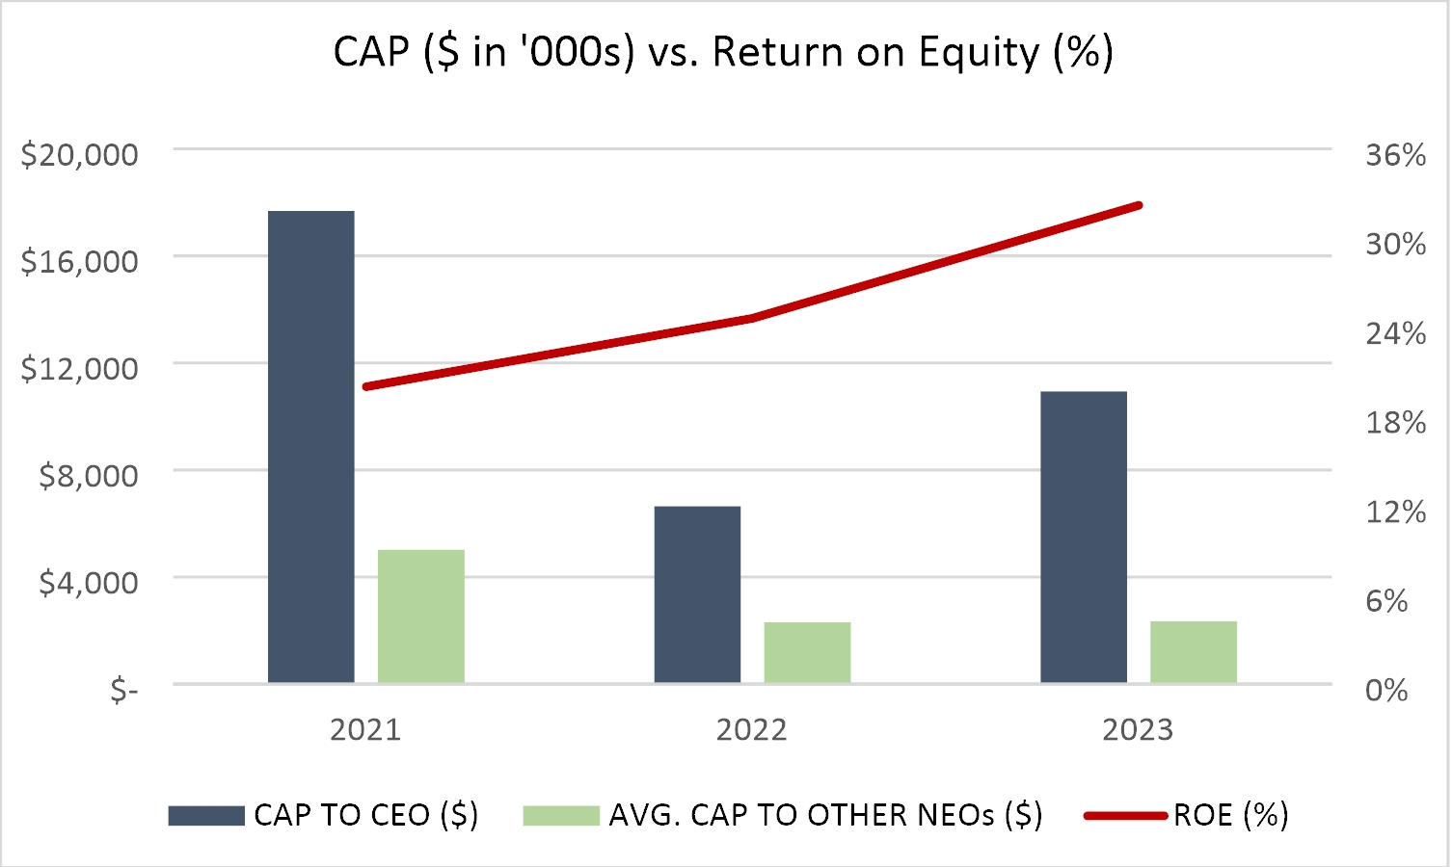

_______________________________
Eagle Materials Inc. * 2023 PROXY STATEMENT 57

Compensation Actually Paid versus Net Income
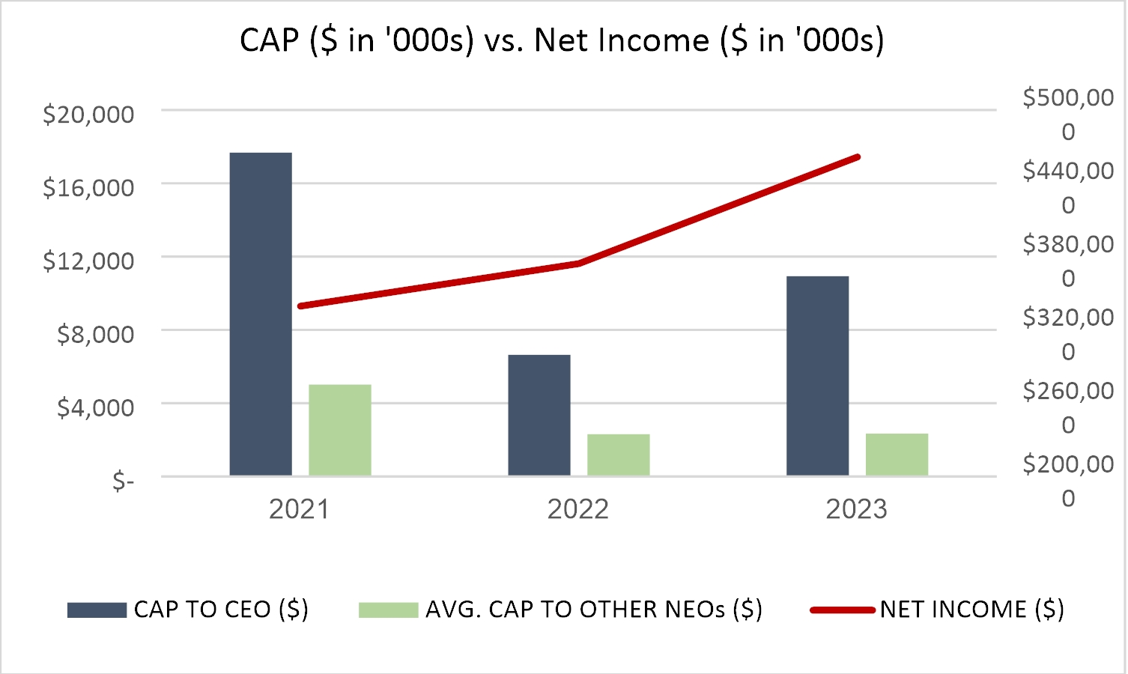

Compensation Actually Paid versus Total Shareholder Return
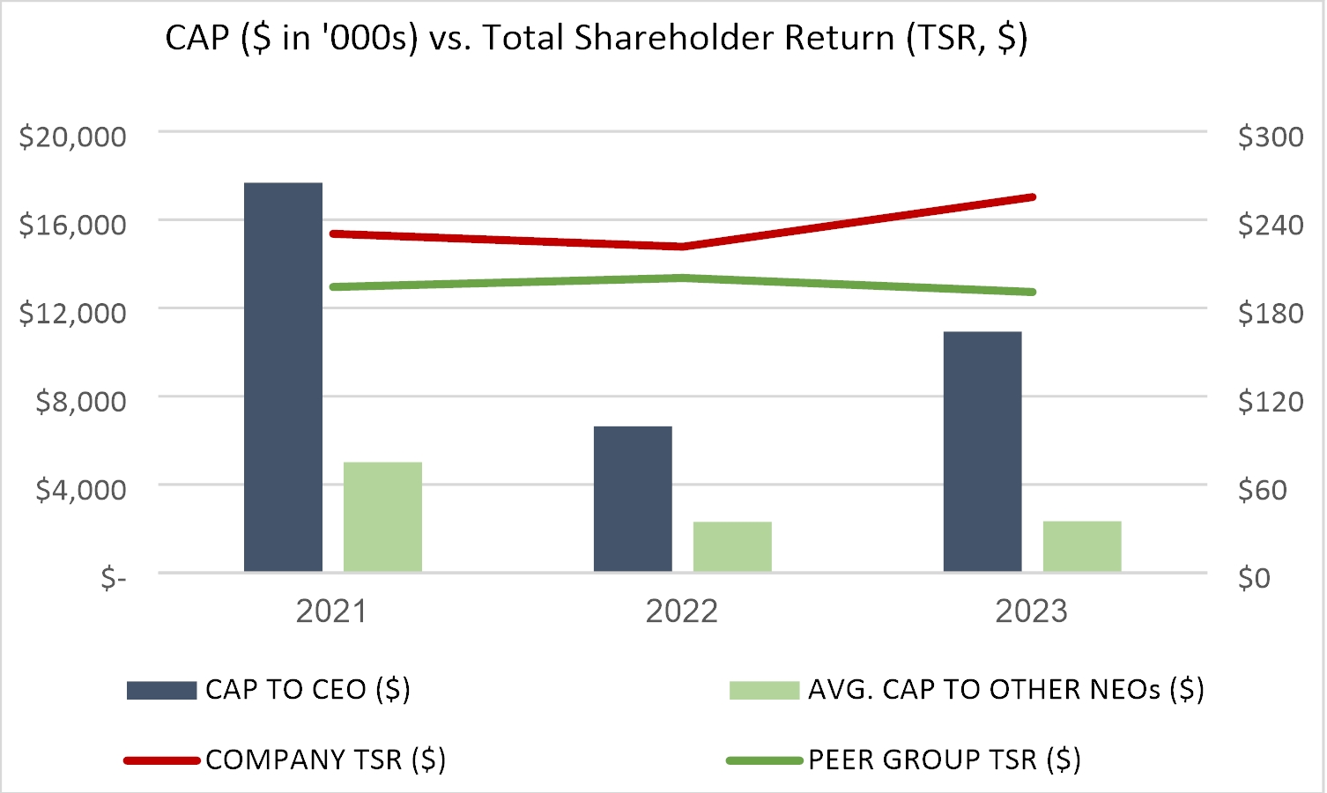

_______________________________
Eagle Materials Inc. * 2023 PROXY STATEMENT 58

STOCK OWNERSHIP

Management

We encourage stock ownership by our directors, officers and employees to align their interests with your interests as stockholders. The following table shows the beneficial ownership of our Common Stock, as of the record date for the annual meeting (June 6, 2023) by: (a) each person who has been a director or executive officer of the Company since April 1, 2022 and (b) by all such directors and executive officers of the Company as a group (20 persons). Except as otherwise indicated, all shares are owned directly, and the owner of such shares has the sole voting and investment power with respect thereto.

Amount and Nature of Beneficial Ownership (1)
 |  | Number of  Shares  Beneficially  Owned(2) |  |  |  | Percentage  of Common  Stock
F. William Barnett(3) |  |  | 15,671 |  |  |  | *
Richard Beckwitt |  |  | 21,504 |  |  |  | *
Ed H. Bowman(3) |  |  | 12,313 |  |  |  | *
Margot L. Carter |  |  | 8,163 |  |  |  | *
Eric Cribbs |  |  | 24,924 |  |  |  | *
George J. Damiris |  |  | 6,336 |  |  |  | *
William R. Devlin |  |  | 30,258 |  |  |  | *
Martin M. Ellen |  |  | 9,694 |  |  |  | *
James H. Graass(4) |  |  | 15,959 |  |  |  | *
Mauro Gregorio |  |  | 3,347 |  |  |  | *
Michael R. Haack |  |  | 191,964 |  |  |  | *
D. Craig Kesler(5) |  |  | 108,865 |  |  |  | *
Matt Newby |  |  | 44,788 |  |  |  | *
Michael R. Nicolais(6) |  |  | 68,134 |  |  |  | *
David B. Powers(7) |  |  | 27,009 |  |  |  | *
Mary P. Ricciardello |  |  | 11,431 |  |  |  | *
Richard R. Stewart(8) |  |  | 13,389 |  |  |  | *
Robert S. Stewart |  |  | 13,547 |  |  |  | *
Tony Thompson |  |  | 15,086 |  |  |  | *
Steven L. Wentzel(9) |  |  | 22,302 |  |  |  | *
All current directors, nominees and executive officers as a group  (20 persons) |  |  | 664,684 |  |  |  | 1.7 | %

* | Less than 1%
(1) | For purposes of this table, “beneficial ownership” is determined in accordance with Rule 13d-3 under the Exchange Act, pursuant to which a person is deemed to have “beneficial ownership” of shares of our stock that the person has the right to acquire within 60 days. For purposes of computing the percentage of outstanding shares of Common Stock held by each person or group of persons named in the table, any shares that such person or persons have the right to acquire within 60 days are deemed to be outstanding, but are not deemed to be outstanding for the purpose of computing the percentage ownership of any other persons.
(2) | Amounts include the following shares of Common Stock that may be acquired upon exercise of stock options awarded under our 2013 Incentive Plan: Mr. Beckwitt – 2,070 shares; Mr. Cribbs – 8,570 shares; Mr. Devlin – 3,313 shares; Mr. Haack – 82,735 shares; Mr. Kesler – 38,880 shares; Mr. Newby – 22,969 shares; Mr. Nicolais – 18,669 shares; Ms. Ricciardello – 4,747 shares; Mr. Thompson – 638 shares; Mr. Wentzel – 2,582 shares and all directors and executive officers of the Company as a group (20 persons) – 185,173 shares. In addition, this table includes shares of Common Stock that are held for the account of participants as of June 6, 2023, pursuant to the Common Stock fund of the Retirement Plan, as follows: Mr. Devlin – 1,947 shares; Mr. Kesler – 2,215 shares; and all directors and executive officers of the Company as a group (20 persons) – 4,162 shares. These amounts do not include the RSUs previously granted to the non-employee directors (including dividend equivalent units accrued since the date of grant) disclosed in the table on page 20 of this Proxy Statement.
(3) | Messrs. Barnett and Bowman retired as directors effective August 5, 2022. Their beneficial ownership reflected above is based on their last filed Form 4.
(4) | Mr. Graass retired from the Company on June 3, 2022. His beneficial ownership reflected above is based on his last filed Form 4 and includes 543 shares of Common Stock held in Mr. Grass’s IRA.
(5) | Includes 160 shares of Common Stock held in Mr. Kesler’s IRA.
_______________________________
Eagle Materials Inc. * 2023 PROXY STATEMENT 59

(6) | Includes (a) 1,386 shares of Common Stock owned by the wife of Mr. Nicolais; (b) 1,550 shares of Common Stock held by the profit sharing plan of the employer of Mr. Nicolais; and (c) 3,500 shares of Common Stock held in an IRA owned by Mr. Nicolais.
(7) | Includes 23,662 shares of Common Stock owned by a spousal trust.
(8) | Includes 4,003 shares of Common Stock owned by Stewart Family Trust.
(9) | Mr. Wentzel retired from the Company on June 1, 2023.
_______________________________
Eagle Materials Inc. * 2023 PROXY STATEMENT 60

Certain Beneficial Owners
The table below provides information regarding the only persons we know of who are the beneficial owners of more than five percent of our Common Stock. The number of shares of Common Stock shown in the table as beneficially owned by each person as of the most recent practicable date, which is generally the date as of which information is provided in the most recent beneficial ownership report filed by such person with the SEC. The percentage of our Common Stock shown in the table as owned by each person is calculated in accordance with applicable SEC rules based on the number of outstanding shares of Common Stock as of June 6, 2023, the record date for our annual meeting of stockholders.
Name and Address of Beneficial Owner |  | Number of  Shares  Beneficially  Owned |  |  |  | Percentage of  Common  Stock
The Vanguard Group (1)
100 Vanguard Blvd. |  |  | 3,994,328 |  |  |  | 11.2 | %
Malvern, PA 19355
BlackRock, Inc. (2)
55 East 52nd Street |  |  | 3,294,293 |  |  |  | 9.3 | %
New York, NY 10055
FMR LLC (3)
245 Summer Street |  |  | 2,306,493 |  |  |  | 6.5 | %
Boston, MA 02210

(1) | Based solely on the information contained in a Schedule 13G/A filed with the SEC on February 9, 2023. Of the shares reported in the Schedule 13G/A, The Vanguard Group has (i) shared voting power with respect to 15,975 shares; (ii) sole dispositive power with respect to 3,941,643 shares; and (iii) shared dispositive power with respect to 52,685 shares.
(2) | Based solely on the information contained in a Schedule 13G/A filed with the SEC on January 25, 2023. Of the shares reported in the Schedule 13G/A, BlackRock, Inc. has sole voting power with respect to 3,224,051 shares and sole dispositive power with respect to 3,294,293 shares.
(3) | Based solely on the information contained in a Schedule 13G/A filed with the SEC on February 9, 2023. Of the shares reported in the Schedule 13G/A, FMR LLC has sole voting power with respect to 2,305,248 shares and sole dispositive power with respect to 2,306,493 shares.

_______________________________
Eagle Materials Inc. * 2023 PROXY STATEMENT 61

Related Party Transactions
Our code of conduct adopted by the Board, which we refer to as “The Eagle Way,” includes provisions addressing conflicts of interest which arise when a director, officer, or employee has an interest in a transaction in which the Company is a participant. The Eagle Way defines a conflict of interest as an activity, investment or association that interferes or might appear to interfere with the judgment or objectivity of an officer or employee in performing his or her job in the best interests of the Company and our shareholders.
Under The Eagle Way, officers or employees are encouraged to consult with their supervisors regarding any matter that may involve a conflict of interest. In addition, The Eagle Way requires that prior approval of the supervisor of an officer or employee, the president of the Eagle business unit in which such officer or employee is employed, and the Company’s general counsel before: (1) obtaining an ownership interest in, or position with, an Eagle supplier, contractor, customer or competitor, subject to certain exceptions relating to the ownership of publicly traded securities; (2) employing any relatives where there is either a direct or indirect reporting relationship or a substantial amount of interaction between the relatives on the job; or (3) establishing a business relationship between Eagle and a company in which the officer or employee or his or her relative has an ownership interest or holds a position.
In addition to the above policies included in The Eagle Way, we have implemented certain informal processes in connection with transactions with related persons. For example, the Company’s legal staff is primarily responsible for the development of processes to obtain information from the directors and executive officers with respect to related person transactions and for determining, based on the facts and circumstances, whether the related person has a direct or indirect material interest in the transaction. In addition, all of our employees, executive officers and directors are required to disclose any conflicts of interest in an annual certification reviewed by our Legal Department. After disclosure, some conflicts of interest may be resolved through implementing appropriate controls for our protection. Depending on the identity of the officer or employee involved in a transaction creating a potential conflict of interest, the conflict of interest may be resolved by the Company’s legal staff or may be referred to the Audit Committee. Where an appropriately disclosed conflict of interest is minor and not likely to adversely impact us, we may consent to the activity. Such consent may be subject to appropriate controls intended to ensure that transaction as implemented is not adverse to the Company. In other cases where appropriate controls are not feasible, the person involved will be requested not to enter into, or to discontinue, the relevant transaction or relationship. If a potential conflict arises concerning a director or officer of the Company, the potential conflict is disclosed to the Chair of the Audit Committee of the Board for review and disposition. As required under SEC rules, transactions that are determined to be directly or indirectly material to the Company or a related person are disclosed in the annual proxy statement.
Delinquent Section 16(a) Reports
Section 16(a) of the Exchange Act requires the Company’s directors and executive officers, and persons who beneficially own more than 10% of a registered class of the Company’s equity securities, to file initial reports of ownership, reports of changes in ownership and annual reports of ownership with the SEC and the NYSE. These persons are required by SEC regulations to furnish the Company with copies of all Section 16(a) forms that they file with the SEC.
Based solely on our review of the copies of such forms we received with respect to fiscal 2023 or written representations from certain reporting persons, the Company believes that its directors and executive officers, and persons who beneficially own more than 10% of a registered class of the Company’s equity securities, have complied with all filing requirements of Section 16(a) for fiscal 2023 applicable to such persons, except for one late Form 4 filing by Mr. Cribbs.

_______________________________
Eagle Materials Inc. * 2023 PROXY STATEMENT 62

Employee, Officer and Director Hedging
Under our insider trading policy, the Company’s directors, officers and employees are prohibited from engaging in speculative transactions in the Company’s securities. The transactions specifically addressed in the policy are:
 | • | publicly traded options (examples include puts, calls and other derivative securities involving Company securities, on an exchange or in any other organized market);
 | • | short sales (which evidence an expectation on the part of the seller that the securities will decline in value and signal to the market a lack of confidence in the Company’s short-term prospects); and
 | • | hedging transactions (examples include zero-cost collars and forward sale contracts, which allow a holder to lock in much of the value of his or her stock holdings, often in exchange for all or part of the potential upside appreciation in the stock—creating a potential mis-alignment with the objectives of the Company’s other stockholders).
Code of Conduct
The Company’s code of conduct, The Eagle Way, applies to all of the Company’s employees, including the Company’s officers. The Eagle Way also applies to the Board of Directors. The Company’s code of conduct is designed to deter wrongdoing and to promote:
 | • | honest and ethical conduct, including the ethical handling of actual or apparent conflicts of interest between personal and professional relationships;
 | • | compliance with applicable governmental laws, rules and regulations;
 | • | the prompt internal reporting of violations of the code of conduct to an appropriate person or persons identified in the code of conduct; and
 | • | accountability for adherence to the code of conduct.
All of the Company’s employees and directors are required to certify to the Company, on an annual basis, that they have complied with the Company’s code of conduct without exception or, if they have not so complied, to list the exceptions. The Company has posted the text of its code of conduct on its Internet website at www.eaglematerials.com (click on “Investor Relations”, then on “Corporate Governance”, then on “The Eagle Way” under the heading “Code of Ethics”). Additionally, the Company will provide without charge a copy of the code of conduct to any person upon written request to our Secretary at our principal executive office.

_______________________________
Eagle Materials Inc. * 2023 PROXY STATEMENT 63

PROPOSAL NO. 2: ADVISORY VOTE ON COMPENSATION
OF OUR NAMED EXECUTIVE OFFICERS

We are seeking your advisory vote approving the compensation paid to our Named Executive Officers as disclosed in this Proxy Statement. We believe the structure of our executive compensation programs promotes our business objectives, aligns executives’ interests with those of stockholders and serves to motivate, attract and retain executive talent.
We urge stockholders to read our “Compensation Discussion and Analysis” beginning on page 28 of this Proxy Statement, which describes in more detail how our executive compensation policies and programs operate. We are seeking stockholder approval of the following advisory resolution:

RESOLVED, that the compensation paid to the Company’s Named Executive Officers, as disclosed pursuant to the compensation disclosure rules of the Securities and Exchange Commission, including the Compensation Discussion and Analysis, the compensation tables and the related material disclosed in this Proxy Statement, is hereby approved by the stockholders of the Company on an advisory basis.

Although the vote on this proposal is advisory and nonbinding, the Compensation Committee and the Board will review the results of the vote and consider them when making future determinations regarding our executive compensation programs. The affirmative vote of a majority of the votes cast by shares entitled to vote thereon is required for the approval of the foregoing resolution. Abstentions and broker non-votes are not counted as votes cast, and therefore do not affect the approval of the resolution.
Recommendation of the Board
Our Board of Directors recommends that holders of Common Stock vote FOR the non-binding advisory resolution approving the compensation paid to our Named Executive Officers.

_______________________________
Eagle Materials Inc. * 2023 PROXY STATEMENT 64

PROPOSAL NO. 3: ADVISORY VOTE REGARDING FREQUENCY OF FUTURE ADVISORY VOTES ON THE COMPENSATION OF OUR NAMED EXECUTIVE OFFICERS

We are required to provide a non-binding, advisory vote on the compensation of our Named Executive Officers at least once every three years. In this proposal, we are asking stockholders to provide their view on whether future advisory votes on the compensation of our Named Executive Officers should occur every three years, every two years or every year. We last held such an advisory vote at our annual meeting held in 2017. At that meeting, more votes were cast in favor of “one year” than were cast in favor of any of the other alternatives.
The Board of Directors intends to carefully consider the shareholder vote on this proposal, but does not make any recommendation, as there are advantages and disadvantages on more frequent or less frequent votes. Stockholders will be able to specify one of four choices for this proposal on the proxy card: three years, two years, one year or abstain. Although the vote on this proposal is advisory and non-binding, the Compensation Committee and the Board will review the results of the vote and consider them when making its determination regarding the frequency of future votes. The frequency receiving the greatest number of votes will be considered the frequency recommended by our stockholders, even if that alternative does not receive a majority of the votes cast. Because the Board is not making a recommendation on its preferred alternative under this proposal, shares will not be voted on this proposal unless stockholders indicate their preference among the alternatives presented. Abstentions and broker non-votes are not counted as votes cast, and therefore do not affect the outcome of the vote.
Recommendation of the Board
Our Board of Directors does not make a recommendation regarding the frequency of future advisory votes on the compensation of our Named Executive Officers.

_______________________________
Eagle Materials Inc. * 2023 PROXY STATEMENT 65

PROPOSAL NO. 4: APPROVAL OF THE 2023 PLAN

Overview
Awards based on our Common Stock are a major part of long-term compensation for our key employees and non-employee directors. We believe such awards help us to attract and retain the talented members of our management team. As noted in the “Compensation Discussion and Analysis” beginning on page 28, for many years we have recognized that structuring long-term equity incentive awards to executives helps to align their financial interests with the interests of our stockholders. Our current Incentive Plan (the 2013 Incentive Plan) affords our Compensation Committee flexibility to determine the type of compensatory awards that provide appropriate incentives and encourage stock ownership among key employees and non-employee directors. Our current Incentive Plan expires in August 2023.
In order to ensure that shares of our Common Stock continue to be available for use by the Compensation Committee in making awards in the form of stock options, restricted stock, stock units and other stock-based awards, our Board of Directors has, subject to stockholder approval, approved our 2023 Equity Incentive Plan (the “2023 Plan”). We refer to the existing Incentive Plan as the “2013 Incentive Plan.” The Board is presenting the 2023 Plan to the stockholders at the 2023 Annual Meeting because this is the last regularly scheduled stockholder meeting before the 2013 Incentive Plan expires in August 2023.
A summary of the principal provisions of the 2023 Plan are set forth below. The full text of the 2023 Plan is annexed to this Proxy Statement as Appendix A. The following summary is qualified in its entirety by reference to Appendix A. Approval of the 2023 Plan requires the favorable vote of a majority of the shares present in person or represented by proxy at the meeting. No awards may be granted under the 2023 Plan after the tenth anniversary of the date on which the stockholders approve the 2023 Plan.
Stockholder-Friendly Features of the 2023 Plan
The following features of the 2023 Plan are designed to reinforce alignment between the equity compensation arrangements awarded pursuant to the 2023 Plan and our stockholders’ interests:
•No discounting of stock options or stock appreciation rights (“SARs”);
•No reloading, repricing or replacement of underwater stock options or SARs without stockholder approval;
•One-year minimum vesting requirement, subject to certain exceptions set forth in the 2023 Plan;
•No payments of dividends or dividend equivalents may be paid with respect to an award prior to the vesting of such award (and no dividend equivalents will be paid on stock options or SARs);
•Annual non-employee director compensation limit
•No Liberal Share Recycling for options or SARs. Shares retained by or delivered to the Company to pay the exercise price of a stock option, shares delivered to or withheld by the Company to pay withholding taxes related to a stock option or SAR, and unissued shares resulting from the settlement of SARs in stock will all count against the shares reserved and issuable under the 2023 Plan; and
•No liberal definition of “change in control.”
Purposes of the 2023 Plan
Equity-based compensation is a significant component of our compensation program and the 2023 Plan is intended to serve the following purposes:
•Align the interests of the Company’s stockholders and recipients of awards under the 2023 Plan by increasing the proprietary interest of such recipients in the Company’s growth and success;
•Advance the interests of the Company by attracting and retaining officers, other employees, non-employee directors, consultants, independent contractors and agents; and
•Motivate such persons to act in the long-term best interests of the Company and its stockholders.
_______________________________
Eagle Materials Inc. * 2023 PROXY STATEMENT 66

Factors Considered by the Board in Approving the 2023 Plan
In setting the proposed number of shares reserved and issuable under the 2023 Plan, the Compensation Committee and the Board considered a number of factors, including the following:
 | • | The Company’s three-year average burn rate. Our three-year average burn rate was 0.54% for fiscal year 2021 through fiscal year 2023 and our one-year burn rate for fiscal year 2023 was 0.45%. We define burn rate as the total number of full value shares (i.e., restricted stock awards, restricted stock units and performance stock units) and the total number of stock options granted to participants over one fiscal year expressed as a percent of the fully diluted weighted average common shares outstanding. We average our burn rate over three fiscal years to determine our three-year average burn rate. We believe our historical burn rates are reasonable for a company of our size in our industry.
 | • | Duration that shares available for issuance under the 2023 Plan are expected to last. Based on the requested number of shares to be reserved under the 2023 Plan and on our three-year average burn rate, we expect that the share reserve will cover awards for approximately five years. We believe the expected life of the share reserve is reasonable and will ensure sufficient funding for equity awards for a number of years.
 | • | Expected potential dilution. The potential dilution under our 2013 Incentive Plan was 1.8%. The 2023 Plan will increase potential dilution by 4.0 percentage points. Therefore, as of the record date, the total potential dilution with the shares requested for the 2023 Plan would approximate 5.8% in total. We define total potential dilution as the sum of the total number of (i) outstanding full value share grants, (ii) outstanding stock options and (iii) shares of common stock available for future grants under the 2023 Plan, expressed as a percentage of the fully diluted common shares outstanding. We believe that the expected potential dilution that will result from the 2023 Plan is reasonable for a Company of our size in our industry.
 | • | Other considerations. In approving the number of shares reserved for issuance under the 2023 Plan, the Compensation Committee and Board of Directors also considered our long-term incentive pay strategy of emphasizing equity grants to executives and directors to align their interests to those of our shareholders, our director compensation and also reviewed an analysis of equity grant practices for our industry peer group provided by our independent compensation consultant.
Information on Equity Compensation Plans as of June 1, 2023
The information included in this Proxy Statement and our 2022 Annual Report is updated by the following information regarding all existing equity compensation plans as of June 1, 2023 (except as noted otherwise):
Total number of stock options outstanding(1) | 353,360
Weighted-average exercise price of stock options outstanding | $91.24
Weighted-average remaining term of stock options outstanding | 6.21
Total number of full value awards outstanding (includes restricted stock, restricted stock units and performance stock units)(2) | 286,177
Total number of shares remaining available for future grant under the 2013 Incentive Plan (3) | 3,208,709
Total number of shares of common stock outstanding as of the Record Date | 35,516,173
______________________
 | (1) | Includes performance-based stock options outstanding, reflecting performance at the target performance level. No SARs were outstanding as of June 1, 2023.
 | (2) | The number of shares of outstanding restricted stock with performance-based vesting conditions (PSUs) assumes performance at the target performance level.
 | (3) | The 2013 Incentive Plan is our only active employee equity incentive plan. The number of shares remaining available for future grant under the 2013 Incentive Plan reflects PSUs at the target payout. We will not grant any shares under the 2013 Incentive Plan between June 1, 2023 and the Effective Date.
_______________________________
Eagle Materials Inc. * 2023 PROXY STATEMENT 67

Summary of the 2023 Plan
The following description of the 2023 Plan is qualified in its entirety by reference to the plan document, a copy of which is annexed to this Proxy Statement as Appendix A and incorporated into this Proxy Statement by reference.
Administration
The 2023 Plan will be administered by the Compensation Committee, a subcommittee thereof, or such other committee designated by the Board, in each case consisting of two or more members of the Board. Each member of the Compensation Committee is intended to be (i) a “non-employee director” within the meaning of Rule 16b-3 under the Exchange Act and (ii) “independent” within the meaning of the rules of the New York Stock Exchange. For the sake of brevity, references in this description to the Compensation Committee will relate to any of the foregoing as and when applicable.
Subject to the express provisions of the 2023 Plan, the Compensation Committee has the authority to select eligible persons to receive awards and determine all of the terms and conditions of each award. All awards are evidenced by an agreement containing such provisions not inconsistent with the 2023 Plan as the Compensation Committee approves. The Compensation Committee also has authority to establish rules and regulations for administering the 2023 Plan and to decide questions of interpretation or application of any provision of the 2023 Plan. The Compensation Committee may, in its discretion, take action such that (i) any outstanding options and SARs become exercisable in part or in full; (ii) all or any portion of a restriction period on any outstanding awards lapse; (iii) all or a portion of any performance period applicable to any outstanding awards lapse; and (iv) any performance measures applicable to any outstanding award be deemed satisfied at the target, maximum or any other level.
The Compensation Committee may delegate some or all of its power and authority under the 2023 Plan to the Board, a subcommittee of the Board, a member of the Board, the Chief Executive Officer or other executive officer of the Company as the Compensation Committee deems appropriate, except that it may not delegate its power and authority to a member of the Board, the Chief Executive Officer or any executive officer with regard to awards to persons subject to Section 16 of the Exchange Act.
Available Shares
Under the 2023 Plan, the number of shares of Common Stock initially available for all awards, other than substitute awards granted in connection with a corporate transaction, will be 1,425,000 shares. This amount is subject to adjustment in the event of any equity restructuring that causes the per share value of shares of Common Stock to change, such as a stock dividend, stock split, spinoff, rights offering or recapitalization through an extraordinary cash dividend. The number of available shares will be reduced by the sum of the aggregate number of shares of Common Stock which become subject to outstanding awards. On June 6, 2023, the closing sales price per share of our Common Stock as reported on the New York Stock Exchange was $166.41.
To the extent that shares of Common Stock subject to an outstanding award granted under the 2023 Plan are not issued or delivered by reason of (i) the expiration, termination, cancellation or forfeiture of such award (excluding shares of Common Stock subject to an option cancelled upon settlement of a related tandem SAR or subject to a tandem SAR cancelled upon exercise of a related option); or (ii) the settlement of an award that can only be settled in cash, then such shares of Common Stock will again be available under the 2023 Plan. Shares of Common Stock subject to an award granted under the 2023 Plan, other than an option or SAR, will again become available for issuance under the 2023 Plan if the shares are delivered to or withheld by the Company to pay the withholding taxes payable with respect to such award. Shares of Common Stock subject to an option or SAR granted under the 2023 Plan will not again be available for issuance under the 2023 Plan if such shares are (i) shares that were not issued or delivered upon the net settlement or net exercise of such option or SAR (including any shares withheld for the payment of taxes) or (ii) shares repurchased by the Company on the open market with the proceeds of an option exercise.
Change in Control
Unless otherwise provided in an award agreement, and without regard to the 2023 Plan’s minimum vesting conditions described below, in the event of a change in control of the Company, and to the extent the acquiring corporation does not assume the outstanding awards under the 2023 Plan or substitute new awards therefor having an equivalent value for such outstanding awards, the Board (as constituted prior to such change in control) shall require that (i) some or all outstanding options and SARs will become exercisable in full or in part; (ii) the restriction period applicable to some or all outstanding restricted stock, restricted stock units and other stock-based awards (“other stock awards” and collectively with restricted stock awards and restricted stock unit awards, “Stock Awards”) will lapse in full or in part; (iii) the performance period applicable to some or all outstanding awards will lapse in full or in part; and (iv) the performance measures
_______________________________
Eagle Materials Inc. * 2023 PROXY STATEMENT 68

applicable to some or all outstanding awards will be deemed to be satisfied at the greater of target level performance or actual performance (measured as of the date that immediately precedes the date of such change in control).
Unless otherwise provided in an award agreement, and without regard to the 2023 Plan’s minimum vesting conditions described below, in the event of a change in control of the Company, and to the extent the acquiring corporation assumes the outstanding awards under the 2023 Plan or substitutes new awards therefor having an equivalent value for such outstanding awards, such assumed awards or substitute new awards shall not become exercisable, the restriction period or performance period for such awards shall not lapse, and the performance measures shall be not deemed satisfied, in each case solely as a result of the occurrence of a change in control; provided that the Board (as constituted prior to such change in control) shall require that if the acquiring corporation terminates a participant’s employment or service without cause upon or within two (2) years after such change in control , (i) the participant’s outstanding options and SARs shall become exercisable in full or in part, (ii) the restriction period applicable to the participant’s outstanding Stock Awards shall lapse in full or in part, (iii) the performance period applicable to the participant’s outstanding awards shall lapse in full or in part, and (iv) the performance measures applicable to some or all outstanding awards shall be deemed to be satisfied at the greater of target level performance or actual performance (measured as of the date that immediately precedes the date of such change in control).
Under the terms of the 2023 Plan, a change in control is generally defined as (i) certain acquisitions of 35% or more of either (x) the Company’s outstanding Common Stock or (y) the Company’s then outstanding securities eligible to vote for the election of our Board; (ii) a change in our Board in certain instances resulting in the incumbent directors ceasing to constitute at least a majority of our Board; (iii) the consummation of certain reorganizations, mergers, statutory share exchanges, consolidations, or similar corporate transactions involving the Company or any of its subsidiaries or sale or other disposition of all or substantially all of the assets of the Company, or the acquisition of assets or securities of another entity by the Company or any of its subsidiaries; or (iv) stockholder approval of a complete liquidation or dissolution of the Company.
With respect to any award that constitutes “deferred compensation” subject to Section 409A of the Internal Revenue Code of 1986 (the “Code”) and that is payable on account of a change in control (including any installments or stream of payments that are accelerated on account of a change in control), the transaction or event described in clause (i), (ii), (iii) or (iv) of the preceding paragraph also constitutes a “change in control event,” as defined in Treasury Regulation §1.409A-3(i)(5) if required in order for the payment to comply with Section 409A of the Code (i.e., if such event also constitutes a “change in the ownership”, “change in effective control”, and/or a “change in the ownership of a substantial portion of assets” of the Company as those terms are defined under Treasury Regulation §1.409A-3(i)(5)), but only to the extent necessary to establish a time or form of payment that complies with Section 409A of the Code, without altering the definition of “change in control” for purposes of determining whether a participant’s rights to such award become vested or otherwise unconditional upon the change in control.
No Repricing or Reloading
The Compensation Committee may not, without the approval of stockholders, (i) reduce the purchase price or base price of any previously granted stock option or SAR; (ii) cancel any previously granted stock option or SAR in exchange for another stock option or SAR with a lower purchase price or base price; (iii) cancel any previously granted stock option or SAR in exchange for cash or another award if the purchase price of such stock option or the base price of such SAR exceeds the fair market value of a share of Common Stock on the date of such cancellation, in each case, other than in connection with a change in control or pursuant to the 2023 Plan’s adjustment provisions; or (iv) include provisions with respect to any stock option or SAR that “reloads” such stock option or SAR on exercise.
Minimum Vesting Conditions
Subject to the proviso and the following sentence below, awards granted under the 2023 Plan will vest no earlier than the first anniversary of the date on which the award is granted; provided, that the following awards will not be subject to the foregoing minimum vesting requirement: (i) any substitute awards granted in connection with awards that are assumed, converted or substituted pursuant to a merger, acquisition or similar transaction entered into by the Company or any of its subsidiaries; (ii) shares delivered in lieu of fully vested cash obligations; (iii) awards to non-employee directors that vest on earlier of the one-year anniversary of the date of grant and the next annual meeting of stockholders, which is at least 50 weeks after the immediately preceding year’s annual meeting; and (iv) additional awards the Compensation Committee may grant, up to a maximum of five percent (5%) of the available share reserve authorized for issuance under the 2023 Plan (subject to the 2023 Plan’s adjustment provisions). The foregoing restriction does not apply to the Compensation Committee’s discretion to provide for accelerated exercisability or vesting of any award.
Non-Transferability
Awards may not be transferred by a participant, except by will, the laws of descent and distribution or pursuant to any beneficiary designation procedures established by the Company or, to the extent expressly permitted by the award agreement, to the participant’s
_______________________________
Eagle Materials Inc. * 2023 PROXY STATEMENT 69

family members, a trust or entity established by the participant for estate planning purposes or a charitable organization designated by the participant or pursuant to a domestic relations order, in each case, without consideration.
Clawback of Awards
The awards granted under the 2023 Plan and any cash payment or shares of Common Stock delivered pursuant to an award are subject to forfeiture, recovery by the Company or other action pursuant to the applicable award agreement or the clawback or recoupment policy of the Company, as amended from time to time, including without limitation, any amendments to such policy that the Company may be required to maintain under the Dodd-Frank Wall Street Reform and Consumer Protection Act and implementing rules and regulations thereunder, or as otherwise required by law.
Effective Date, Termination and Amendment
The 2023 Plan will become effective as of the date of stockholder approval and will terminate as of the first annual stockholder meeting to occur on or after the tenth (10th) anniversary of the date of such stockholder approval, unless earlier terminated by the Board. The Board may amend the 2023 Plan at any time, subject to any requirement of stockholder approval required by applicable law, rule or regulation, including any rule of the New York Stock Exchange, and provided that no amendment may be made that seeks to modify the non-employee director compensation limit or the prohibition on repricing of stock options and SARs without stockholder approval under the 2023 Plan or that materially impairs the rights of a holder of an outstanding award without the consent of such holder. No additional awards will be granted under the 2013 Incentive Plan after the 2023 Plan becomes effective.
Eligibility
Participants in the 2023 Plan will consist of such officers, other employees, non-employee directors, consultants, independent contractors and agents of the Company and its subsidiaries (and such persons who are expected to become any of the foregoing) as selected by the Compensation Committee. As of June 6, 2023, approximately 2,400 employees and nine non-employee directors would be eligible to participate in the 2023 Plan.
The aggregate grant date fair value of awards made under this Plan to any non-employee director, when combined with the cash compensation provided to such non-employee director, during any fiscal year of the Company for such non-employee director’s services as a non-employee director, shall not exceed $1,000,000.
Award Types
Under the 2023 Plan, the Company may grant:
•Non-qualified stock options;
•Incentive stock options (within the meaning of Section 422 of the Code);
•SARs;
•Stock Awards; and
•Performance awards.
Stock Options and SARs
The 2023 Plan provides for the grant of stock options and SARs. The Compensation Committee will determine the conditions to the exercisability of each option and SAR.
Each option will be exercisable for no more than ten (10) years after its date of grant. If the option is an incentive stock option and the optionee owns greater than ten percent (10%) of the voting power of all shares of capital stock of the Company (a “ten percent holder”), then the option will be exercisable for no more than five (5) years after its date of grant. In its sole discretion, the Compensation Committee may provide, at the time of grant, that the shares to be issued upon an option’s exercise will be in the form of restricted stock or other similar securities, or may reserve the right so to provide after the time of grant. Except in the case of substitute awards granted in connection with a corporate transaction, the exercise price with respect to each share of Common Stock subject to an option will not be less than the fair market value of a share of Common Stock on the date of grant, unless the option is an incentive stock option and the optionee is a ten percent holder, in which case the exercise price will be the price required by the Code. Each option will be automatically exercised as of the
_______________________________
Eagle Materials Inc. * 2023 PROXY STATEMENT 70

end of the last day of the term of such option, if the exercise price with respect to each share of Common Stock subject to the option is less than the fair market value of a share of Common Stock on such date, on a net exercise basis and with tax withholding satisfied by the Company retaining shares from the exercise. In addition, no incentive stock option may be granted later than ten (10) years after the date on which the 2023 Plan was approved by the Board.
Each SAR will be exercisable for no more than ten (10) years after its date of grant. Other than in the case of substitute awards granted in connection with a corporate transaction, the base price with respect to each share of Common Stock under a SAR will not be less than the fair market value of a share of Common Stock on the date of grant, provided that the base price of a SAR granted in tandem with an option (a “tandem SAR”) will be the exercise price of the related option. A SAR entitles the holder to receive upon exercise (subject to withholding taxes) shares of Common Stock (which may be restricted stock) or, to the extent provided in the award agreement, cash or a combination thereof, with an aggregate value equal to the difference between the fair market value of the shares of Common Stock on the exercise date and the base price of the SAR. Each SAR will be automatically exercised as of the end of the last day of the term of such SAR, if the base price with respect to each share of Common Stock under the SAR is less than the fair market value of a share of Common Stock on such date, and with tax withholding satisfied by the Company retaining shares from the exercise.
All of the terms relating to the exercise, cancellation or other disposition of stock options and SARs (i) upon a termination of employment of a participant, whether by reason of disability, retirement, death or any other reason; or (ii) during a paid or unpaid leave of absence, will, in each case, be set forth in the applicable award agreement or as otherwise specified by the Compensation Committee. Notwithstanding anything in the award agreement to the contrary, the holder of an option or SAR will not be entitled to receive dividend equivalents with respect to the shares of Common Stock subject to such option or SAR.
Stock Awards
The 2023 Plan provides for the grant of Stock Awards. The Compensation Committee may grant a Stock Award as a restricted stock award, restricted stock unit award or other stock award. Restricted stock awards and restricted stock unit awards are subject to forfeiture if the holder does not remain continuously in the employment of the Company during the restriction period or if specified performance measures (if any) are not attained during the performance period. Other stock awards may not be subject to any vesting conditions, subject to the 2023 Plan’s minimum vesting conditions described above.
Unless otherwise set forth in a restricted stock award agreement, the holder of shares of restricted stock has rights as a stockholder of the Company, including the right to vote and receive distributions and dividends with respect to shares of restricted stock and to participate in any capital adjustments applicable to all holders of the Company’s Common Stock. Any distributions or dividends with respect to shares subject to a restricted stock award will be deposited by the Company and will be subject to the same the vesting conditions that apply to the underlying award.
The agreement awarding restricted stock units will specify whether such award will (or may) be settled in shares of Common Stock, cash or a combination thereof. Unless otherwise set forth in the applicable award agreement, and subject to the terms and conditions of a restricted stock unit award and the following sentence, the holder will be entitled to receive dividend equivalents. Any dividend equivalents credited with respect to restricted stock units that are subject to vesting conditions will be subject to the same vesting conditions that apply to the underlying award. If determined by the Compensation Committee and to the extent specified in the applicable award agreement, any such dividend equivalents may be eligible to earn interest, or be subject to the deemed reinvestment into additional restricted stock units under such award. Prior to settlement of a restricted stock unit, the holder of a restricted stock unit has no rights as a stockholder of the Company.
The Compensation Committee will determine the terms and conditions of other stock awards, including shares of Common Stock granted as a bonus and not subject to any vesting conditions and shares of Common Stock issued in lieu of obligations of the Company to pay cash under any compensatory plan or arrangement, subject to terms determined by the Compensation Committee. Any distributions, dividends or dividend equivalents with respect to other stock awards that are subject to vesting conditions will be subject to the same vesting conditions as the underlying awards.
Subject to the terms and conditions set forth in the 2023 Plan, all of the terms relating to the satisfaction of performance measures and the termination of a restriction period or performance period relating to a Stock Award, or the forfeiture and cancellation of a Stock Award, or any forfeiture and cancellation of such award (i) upon a termination of employment, whether by reason of disability, retirement,
_______________________________
Eagle Materials Inc. * 2023 PROXY STATEMENT 71

death or any other reason; or (ii) during a paid or unpaid leave of absence, will, in each case, be set forth in the applicable award agreement or as otherwise specified by the Compensation Committee.
Performance Awards
The 2023 Plan also provides for the grant of performance awards. The award agreement relating to a performance award will specify whether such award will (or may) be settled in shares of Common Stock (including shares of restricted stock) or cash or a combination thereof. The award agreement relating to a performance award will provide, in the manner determined by the Compensation Committee, for the vesting of such performance award if the specified performance measures are satisfied or met during the specified performance period and for the forfeiture of such award if the specified performance measures are not satisfied or met during the specified performance period. Any dividends or dividend equivalents with respect to a performance award will be subject to the same vesting and other restrictions as the underlying award. Prior to the settlement of a performance award in shares of Common Stock, the holder of such award has no rights as a stockholder of the Company with respect to such shares. Subject to the terms and conditions set forth in the 2023 Plan, all of the terms relating to the satisfaction of performance measures and the termination of the performance period relating to a performance award, or the forfeiture and cancellation of a performance award, or any forfeiture and cancellation of such award (i) upon a termination of employment, whether by reason of disability, retirement, death or any other reason; or (ii) during a paid or unpaid leave of absence, will, in each case, be set forth in the applicable award agreement or as otherwise specified by the Compensation Committee.
Performance Measures
Under the 2023 Plan, the grant, vesting, exercisability or payment of certain awards, or the receipt of shares of Common Stock subject to certain awards, may be made subject to the satisfaction of performance measures. The performance goals applicable to a particular award will be determined by the Compensation Committee at the time of grant. One or more of the following business criteria for the Company, on a consolidated basis, and/or for specified subsidiaries, business or geographical units or operating areas of the Company (except with respect to the total shareholder return and earnings per share criteria) or on an individual basis, may be used by the Compensation Committee in establishing performance measures under the 2023 Plan: stock price measures (including but not limited to growth measures and total shareholder return); earnings per share (actual or targeted growth); earnings before and after interest and/or taxes, depreciation, and amortization (“EBITDA”); economic value added (“EVA”); net income measures (including but not limited to income after capital costs and income before or after taxes); operating income; cash flow measures; return measures (including but not limited to return on assets, return on capital or invested capital, and return on equity); operating measures (including but not limited to sales volumes, production volumes and production efficiency); expense measures (including but not limited to overhead cost and general and administrative expense); margins; and corporate values measures (including but not limited to ethics compliance, environmental, and safety), any combination of the foregoing, or such other goals as the Compensation Committee may determine whether or not listed herein.
Each such goal may be determined on a pre-tax or post-tax basis or on an absolute or relative basis and may include comparisons based on current internal targets, the past performance of the Company (including the performance of one or more specified subsidiaries, affiliates, business or geographical units or operating areas of the Company, as applicable) or the past or current performance of one or more other companies or market indices (or a combination of such past and current performance). In addition to the above, performance goals may include comparisons relating to capital (including, but not limited to, the cost of capital), stockholders’ equity, shares outstanding, assets or net assets, sales, or any combination thereof. In establishing a performance measure or determining the achievement of a performance measure, the Compensation Committee may provide that achievement of the applicable performance measures may be amended or adjusted to include or exclude components of any performance measure, including, without limitation, foreign exchange gains and losses; asset writedowns; acquisitions and divestitures; change in fiscal year; unbudgeted capital expenditures; special charges such as restructuring or impairment charges; debt refinancing costs; extraordinary or noncash items; unusual, infrequently occurring, nonrecurring or one-time events affecting the Company or its financial statements; or changes in law or accounting principles. Performance measures will be subject to such other special rules and conditions as the Compensation Committee may establish at any time.
Federal Income Tax Consequences
The following is a brief summary of certain United States federal income tax consequences generally arising with respect to awards under the 2023 Plan. This discussion does not address all aspects of the United States federal income tax consequences of participating in the 2023 Plan that may be relevant to participants in light of their personal investment or tax circumstances and does not discuss any state, local or non-United States tax consequences of participating in the 2023 Plan. Each participant is advised to consult his or her particular tax advisor concerning the application of the United States federal income tax laws to such participant’s particular situation, as well as the applicability and effect of any state, local or non-United States tax laws before taking any actions with respect to any awards.
_______________________________
Eagle Materials Inc. * 2023 PROXY STATEMENT 72

Section 162(m) of the Code
Section 162(m) of the Code generally limits to $1 million the amount that a publicly held corporation is allowed each year to deduct for the compensation paid to each of the corporation’s chief executive officer, the corporation’s chief financial officer and certain other current and former executive officers of the corporation.
Stock Options
A participant will not recognize taxable income at the time an option is granted and the Company will not be entitled to a tax deduction at that time. A participant will recognize compensation taxable as ordinary income (and subject to income tax withholding in respect of an employee) upon exercise of a non-qualified stock option equal to the excess of the fair market value of the shares purchased over their exercise price, and the Company will be entitled to a corresponding deduction, subject to the deduction limits under Section 162(m) of the Code. A participant will not recognize income (except for purposes of the alternative minimum tax as applicable) upon exercise of an incentive stock option. If the shares acquired by exercise of an incentive stock option are held for the longer of two (2) years from the date the option was granted and one (1) year from the date it was exercised, any gain or loss arising from a subsequent disposition of those shares will be taxed as long-term capital gain or loss, and the Company will not be entitled to any deduction. If, however, those shares are disposed of within the above-described period, then in the year of that disposition the participant will recognize compensation taxable as ordinary income equal to the excess of the lesser of (i) the amount realized upon that disposition, and (ii) the excess of the fair market value of those shares on the date of exercise over the exercise price, and the Company will be entitled to a corresponding deduction, subject to the deduction limits under Section 162(m) of the Code.
SARs
A participant will not recognize taxable income at the time SARs are granted and the Company will not be entitled to a tax deduction at that time. Upon exercise, the participant will recognize compensation taxable as ordinary income (and subject to income tax withholding in respect of an employee) in an amount equal to the fair market value of any shares delivered and the amount of cash paid by the Company, and the Company will be entitled to a corresponding deduction, subject to the deduction limits under Section 162(m) of the Code.
Stock Awards
A participant will not recognize taxable income at the time restricted stock is granted and the Company will not be entitled to a tax deduction at that time, unless the participant makes an election to be taxed at that time. If such election is made, the participant will recognize compensation taxable as ordinary income (and subject to income tax withholding in respect of an employee) at the time of the grant in an amount equal to the excess of the fair market value for the shares at such time over the amount, if any, paid for those shares. If such election is not made, the participant will recognize compensation taxable as ordinary income (and subject to income tax withholding in respect of an employee) at the time the restrictions constituting a substantial risk of forfeiture lapse in an amount equal to the excess of the fair market value of the shares at such time over the amount, if any, paid for those shares. The amount of ordinary income recognized by making the above-described election or upon the lapse of restrictions constituting a substantial risk of forfeiture is deductible by the Company as compensation expense, subject to the deduction limits under Section 162(m) of the Code.
A participant will not recognize taxable income at the time a restricted stock unit is granted and the Company will not be entitled to a tax deduction at that time. Upon settlement of restricted stock units, the participant will recognize compensation taxable as ordinary income (and subject to income tax withholding in respect of an employee) in an amount equal to the fair market value of any shares delivered and the amount of any cash paid by the Company, and the Company will be entitled to a corresponding deduction, subject to the deduction limits under Section 162(m) of the Code.
A participant who receives shares of Common Stock that are not subject to any restrictions under the 2023 Plan will recognize compensation taxable as ordinary income on the date of grant in an amount equal to the fair market value of such shares on that date, and the Company will be entitled to a corresponding deduction, subject to the deduction limits under Section 162(m) of the Code.
Performance Awards
A participant will not recognize taxable income at the time performance awards are granted and the Company will not be entitled to a tax deduction at that time. Upon settlement of performance awards, the participant will recognize compensation taxable as ordinary income (and subject to income tax withholding in respect of an employee) in an amount equal to the fair market value of any shares delivered and the amount of cash paid by the Company, and the Company will be entitled to a corresponding deduction, subject to the deduction limits under Section 162(m) of the Code.
_______________________________
Eagle Materials Inc. * 2023 PROXY STATEMENT 73

Plan Benefits
If the 2023 Plan is adopted, the benefits to be received by participants cannot be determined at this time because grants are at the discretion of our Compensation Committee. None of the shares authorized by the 2023 Plan have been awarded to any of the directors or employees, and no commitment has been made to award any such shares. The Compensation Committee has authority to authorize future awards under the 2023 Plan from time to time. The value of any future equity awards will ultimately depend on the nature and size of the awards, the future price of our Common Stock and the exercise decisions made by the participants, among other factors, and will be subject to such vesting conditions under the 2023 Plan as the Compensation Committee determines from time to time. For further details on the awards granted during the fiscal year ended March 31, 2023 under the 2013 Incentive Plan, please refer to the executive and director compensation tables beginning on page 44 and 19, respectively, of this Proxy Statement.
For illustrative purposes only, the following equity awards were granted to the Named Executive Officers and other groups of individuals named below under the 2013 Incentive Plan in the fiscal year ended March 31, 2023:
Person or Group of Persons |  | Dollar Value ($)(1) |  |  |  | Number of  Awards Granted Under 2013 Incentive Plan (2)
Michael R. Haack |  | $ | 4,500,000 |  |  |  | 54,910
D. Craig Kesler |  |  | 1,000,000 |  |  |  | 12,205
Robert S. Stewart |  |  | 900,000 |  |  |  | 7,845
Matt Newby |  |  | 700,000 |  |  |  | 6,101
Steven L. Wentzel |  |  | 600,000 |  |  |  | 5,230
Executive Officer Group |  |  | 9,100,000 |  |  |  | 101,198
Non-Employee Director Group |  |  | 2,022,733 |  |  |  | 17,992
Non-Executive Officer Employee Group |  |  | 4,550,000 |  |  |  | 48,661
_____________________  (1) | Does not include cash awards. The amounts in this column reflect the value of option awards and restricted stock awards made to the designated individuals and groups during the fiscal year ended March 31, 2023 and are consistent with the grant date fair value of the award computed in accordance with FASB ASC Topic 718. For assumptions used in determining these values, refer to footnote (L) to the Company’s audited financial statements for the fiscal year ended March 31, 2023 included in the Fiscal 2023 Form 10-K.
(2)Represents grants of stock options and restricted stock (including performance awards) in fiscal 2023.
Equity Compensation Plan Information
The following table shows the number of outstanding options and shares available for future issuance of awards under the Company’s equity compensation plans as of March 31, 2023. Our equity compensation plans have been approved by the Company’s stockholders.
Plan Category |  | Incentive Plan |  | Number of securities to be issued upon exercise of outstanding options, warrants and rights (a) |  |  |  | Weighted average exercise price of outstanding options, warrants and rights (b) |  |  |  | Number of securities remaining for future issuance under equity compensation plans excluding securities reflected in column (a) (c)
Equity compensation plans approved by stockholders |  | 2013 |  |  | 436,969 |  |  | $ | 89.69 |  |  |  | 3,260,305
Equity compensation plans not approved by stockholders |  |  |  |  | — |  |  |  | — |  |  |  | —
 |  |  |  |  | 436,949 |  |  | $ | 89.69 |  |  |  | 3,260,305
Recommendation of the Board
Our Board of Directors unanimously recommends a vote FOR the approval of the 2023 Plan. If the requisite vote of our stockholders is not obtained, our Compensation Committee may continue to make awards out of the 2013 Incentive Plan, but only to the extent of available shares during the remaining term of the 2013 Incentive Plan.

_______________________________
Eagle Materials Inc. * 2023 PROXY STATEMENT 74

PROPOSAL NO. 5: APPROVAL OF EXPECTED
APPOINTMENT OF INDEPENDENT AUDITORS

General
Ernst & Young acted as our independent auditors to audit our books and records for fiscal 2023, and the Audit Committee expects to appoint Ernst & Young as our independent auditors for fiscal year 2024 if its proposal for audit services is satisfactory.
We believe the approval of this expected appointment is good corporate practice because the audit of our books and records is a matter of importance to our stockholders. If our stockholders do not support the expected appointment, our Audit Committee will consider that fact when determining whether or not to retain Ernst & Young, but still may elect to retain them. Even if the expected appointment is approved, the Audit Committee, in its discretion, may elect not to proceed with the appointment. Once it has appointed an auditor, our Audit Committee may elect to change the appointment at any time during the year if it determines that such a change would be in our best interests and the best interests of our stockholders.
Representatives of Ernst & Young are expected to be present for the annual meeting, with the opportunity to make a statement if they choose to do so, and will be available to respond to appropriate questions from our stockholders.
Recommendation of the Board
Our Board of Directors recommends a vote FOR the approval of the expected appointment of Ernst & Young as the Company’s auditors for the fiscal year ending March 31, 2024.

_______________________________
Eagle Materials Inc. * 2023 PROXY STATEMENT 75

RELATIONSHIP WITH INDEPENDENT PUBLIC ACCOUNTANTS

Ernst & Young LLP, which we refer to as Ernst & Young, audited the Company’s financial statements for the fiscal years ended March 31, 2021, 2022 and 2023.
Ernst & Young reports directly to our Audit Committee. The Audit Committee has adopted policies and procedures for pre-approving all audit and permissible non-audit services performed by Ernst & Young. Under these policies, the Audit Committee pre-approves the use of audit and specific permissible audit-related and non-audit services up to certain dollar limits. Other audit and permissible non-audit services that exceed a $50,000 threshold must be pre-approved separately by the Audit Committee, or, for such services that do not exceed $50,000, by a member of the Audit Committee. Any such member must report the pre-approval at the next Audit Committee meeting. In deciding whether or not to pre-approve services, the Audit Committee determines whether each service is permissible under the SEC’s rules, and, if permissible, the potential effect of such services on the independence of Ernst & Young.
The following table sets forth the various fees for services provided to the Company by Ernst & Young in the fiscal years ended March 31, 2023 and 2022, all of which services have been approved by the Audit Committee:

Fiscal Year Ended March 31, |  | Audit Fees (1) |  |  |  | Audit Related  Fees |  |  |  | Tax Fees |  |  |  | All Other  Fees |  |  |  | Total
2023 |  | $ | 2,018,646 |  |  | $ | - |  |  | $ | - |  |  | $ | 2,000 |  |  | $ | 2,020,646
2022 |  |  | 1,736,000 |  |  |  | 59,375 |  |  |  | - |  |  |  | 2,000 |  |  |  | 1,797,375

(1) | Includes fees for the annual audit and quarterly reviews, accounting and financial reporting consultations regarding generally accepted accounting principles.
_______________________________
Eagle Materials Inc. * 2023 PROXY STATEMENT 76

AUDIT COMMITTEE REPORT
To the Board of Directors of Eagle Materials Inc.:
All of the Audit Committee members are independent as defined in the current NYSE listing standards and the applicable rules of the Securities Exchange Act of 1934, and Mr. Ellen is our “audit committee financial expert” within the meaning of the rules of the SEC. The Audit Committee charter sets forth the duties and responsibilities of the Audit Committee. The Audit Committee is primarily responsible for assisting the Board in fulfilling its responsibility to oversee the following: the integrity of our financial statements, our compliance with legal and regulatory requirements, the qualifications and independence and appointment of our independent auditors and the performance of our internal audit function and independent auditors. Management has primary responsibility for the preparation of the financial statements, completeness and accuracy of financial reporting and the overall system of internal control over financial reporting.
We have reviewed and discussed with management and the independent registered public accounting firm, Ernst & Young LLP, as appropriate, (1) the audited financial statements of Eagle Materials Inc. as of and for the fiscal year ended March 31, 2023 and (2) management’s report on internal control over financial reporting and the independent registered accounting firm’s related opinions.
We have discussed with Ernst & Young LLP the required communications specified by auditing standards, together with guidelines established by the SEC and the Sarbanes-Oxley Act, including the matters required to be discussed by Public Company Accounting Oversight Board (“PCAOB”) Auditing Standard No. 1301, Communication with Audit Committees.
We have received and reviewed the written disclosures and the letter from Ernst & Young LLP required by the applicable requirements of the PCAOB concerning independence and have discussed with Ernst & Young LLP their independence. We have also considered whether Ernst & Young LLP’s provision of non-audit services to Eagle Materials Inc. and its affiliates is compatible with Ernst & Young LLP’s independence.
Based on the reviews and discussions referred to above, we recommend to the Board of Directors that the financial statements referred to above be included in the Annual Report of Eagle Materials Inc. on Form 10-K for the fiscal year ended March 31, 2023. This report is furnished by the members of the Audit Committee as of May 19, 2023.
Audit Committee
Martin M. Ellen, Chairman
Mauro Gregorio
Mary P. Ricciardello
Richard R. Stewart
This report of the Audit Committee does not constitute “soliciting material” and should not be deemed “filed” or incorporated by reference into any of the other Company filings under the Securities Act of 1933 or the Securities Exchange Act of 1934, except to the extent the Company specifically requests that the information be treated as soliciting material or specifically incorporates this report by reference therein.

_______________________________
Eagle Materials Inc. * 2023 PROXY STATEMENT 77

OTHER MATTERS WHICH MAY BE PRESENTED FOR ACTION AT THE MEETING

Our Board of Directors does not intend to present for action at this annual meeting any matter other than those specifically set forth in the Notice of Annual Meeting of Stockholders. If any other matter is properly presented for action at the meeting, it is the intention of persons named in the proxy to vote thereon in accordance with their judgment pursuant to the discretionary authority conferred by the proxy.
DELIVERY OF DOCUMENTS TO STOCKHOLDERS
Pursuant to the rules of the SEC, the Company and services that it employs to deliver communications to its stockholders are permitted to deliver to two or more stockholders sharing the same mailing address a single copy of the proxy statement. Upon written or oral request, the Company will deliver a separate copy of the proxy statement to any stockholder at a shared mailing address who wishes to receive separate copies of such documents in the future. Stockholders receiving multiple copies of such documents may likewise request that the Company deliver single copies of such documents in the future. Stockholders may notify the Company of their requests by calling or directing a written request to Eagle Materials Inc., Attention: Matt Newby, Secretary, 5960 Berkshire Ln., Suite 900, Dallas, Texas 75225, (214) 432-2000.
STOCKHOLDER PROPOSALS AND NOMINATIONS FOR THE 2024 ANNUAL MEETING
Next year’s annual meeting of stockholders is scheduled to be held on August 1, 2024. In order to be considered for inclusion in the Company’s proxy material for that meeting, a stockholder proposal must be received at our executive offices, addressed to the attention of the Secretary, not later than February 24, 2024. Any such proposal must also comply with all other applicable requirements of Rule 14a-8 under the Exchange Act.
For any proposal that is not submitted for inclusion in our proxy material for the 2024 Annual Meeting of Stockholders but is instead sought to be presented directly at that meeting, Rule 14a-4(c) under the Exchange Act permits the Company’s management to exercise discretionary voting authority under proxies it solicits unless the Company is notified about the proposal on or before May 5, 2024, subject to the applicable rules of the SEC. Our Bylaws provide that, to be considered at the 2024 Annual Meeting, a stockholder proposal must be submitted in writing and received by our Secretary at the executive offices of the Company during the period beginning on April 5, 2024 and ending May 5, 2024, and must contain the information specified by and otherwise comply with our Bylaws.
Under our Bylaws, nominations for director may be made by a stockholder who is entitled to vote for the election of directors and complies with all of the applicable requirements set forth in our Bylaws. The notice by a stockholder of its intention to nominate directors at the 2024 annual meeting of stockholders must be received at our executive offices, addressed to the attention of the Secretary, during the period beginning on April 5, 2024 and ending on May 5, 2024. Notice of director nominations must satisfy the provisions in our Bylaws relating to director nominations and set forth information required by Rule 14a-19(b) of the Securities Exchange Act of 1934.
Any stockholder wishing to receive a copy of our Bylaws should direct a written request to our Secretary at the Company’s principal executive office.
FORM 10-K
Stockholders entitled to vote at the meeting may obtain a printed copy of the Company’s Annual Report on Form 10-K for the fiscal year ended March 31, 2023, including the financial statements required to be filed with the SEC, without charge, upon written or oral request to Eagle Materials Inc., Attention: Matt Newby, Secretary, 5960 Berkshire Ln., Suite 900, Dallas, Texas 75225, (214) 432-2000.

By Order of the Board of Directors
MATT NEWBY
Executive Vice President,
General Counsel and Secretary
Dallas, Texas
June 23, 2023

_______________________________
Eagle Materials Inc. * 2023 PROXY STATEMENT 78

Appendix A

Eagle Materials Inc.
2023 EQUITY INCENTIVE PLAN

I. | INTRODUCTION
1.1Purposes. The purposes of the Eagle Materials Inc. 2023 Equity Incentive Plan (this “Plan”) are (i) to align the interests of the stockholders of Eagle Materials Inc. (the “Company”) and the recipients of awards under this Plan by increasing the proprietary interest of such recipients in the Company’s growth and success, (ii) to advance the interests of the Company by attracting and retaining officers, other employees, Non-Employee Directors, consultants, independent contractors and agents, and (iii) to motivate such persons to act in the long-term best interests of the Company and its stockholders.
1.2Certain Definitions.
“Agreement” shall mean the written or electronic agreement evidencing an award hereunder between the Company and the recipient of such award.
“Board” shall mean the Board of Directors of the Company.
“Change in Control” shall have the meaning set forth in Section 5.8(b).
“Code” shall mean the Internal Revenue Code of 1986, as amended.
“Committee” shall mean the Compensation Committee of the Board, or a subcommittee thereof, or such other committee designated by the Board, in each case, consisting of two or more members of the Board, each of whom is intended to be (i) a “non-employee director” within the meaning of Rule 16b-3 under the Exchange Act and (ii) “independent” within the meaning of the rules of the New York Stock Exchange or, if the Common Stock is not listed on the New York Stock Exchange, within the meaning of the rules of the principal stock exchange on which the Common Stock is then traded.
“Common Stock” shall mean the common stock, par value $0.01 per share, of the Company, and all rights appurtenant thereto.
“Delay Period” shall have the meaning set forth in Section 5.9(c).
“Exchange Act” shall mean the Securities Exchange Act of 1934, as amended.
“Fair Market Value” shall mean, with respect to a share of Common Stock, the closing transaction price of a share of Common Stock as reported on the New York Stock Exchange on the date as of which such value is being determined or, if the Common Stock is not listed on the New York Stock Exchange, the closing transaction price of a share of Common Stock on the principal national stock exchange on which the Common Stock is traded on the date as of which such value is being determined or, if there shall be no reported transactions for such date, on the next preceding date for which transactions were reported; provided, however, that the Company may in its discretion use the closing transaction price of a share of Common Stock on the day preceding the date as of which such value is being determined to the extent the Company determines such method is more practical for administrative purposes, such as for purposes of tax withholding. If the Common Stock is not listed on a national stock exchange or if Fair Market Value for any date cannot be so determined, Fair Market Value shall be determined by the Committee by whatever means or method as the Committee, in the good faith exercise of its discretion, shall at such time deem appropriate and in compliance with Section 409A of the Code. With respect to any property other than Common Stock, “Fair Market Value” shall mean the market value of such property determined by such methods or procedures as shall be established from time to time by the Committee.
“Free-Standing SAR” shall mean an SAR which is not granted in tandem with, or by reference to, an option, which entitles the holder thereof to receive, upon exercise, shares of Common Stock (which may be Restricted Stock) or cash or a combination thereof, with an aggregate value equal to the excess of the Fair Market Value of one share of Common Stock on the date of exercise over the base price of such SAR, multiplied by the number of such SARs which are exercised.
“Incentive Stock Option” shall mean an option to purchase shares of Common Stock that meets the requirements of Section 422 of the Code, or any successor provision, which is intended by the Committee to constitute an Incentive Stock Option.
_______________________________
Eagle Materials Inc. * 2023 PROXY STATEMENT 79

“Non-Employee Director” shall mean any director of the Company who is not an officer or employee of the Company or any Subsidiary.
“Nonqualified Stock Option” shall mean an option to purchase shares of Common Stock which is not an Incentive Stock Option.
“Other Stock Award” shall mean an award granted pursuant to Section 3.4.
“Performance Award” shall mean a right to receive an amount of shares of Common Stock (which may be Restricted Stock) or cash or a combination thereof, contingent upon the attainment of specified Performance Measures within a specified Performance Period.
“Performance Measures” shall mean the criteria and objectives, established by the Committee, which shall be satisfied or met (i) as a condition to the grant or exercisability of all or a portion of an option or SAR or (ii) during the applicable Restriction Period or Performance Period as a condition to the vesting of the holder’s interest, in the case of a Restricted Stock Award, of the shares of Common Stock subject to such award, or, in the case of a Restricted Stock Unit Award, Other Stock Award or Performance Award, to the holder’s receipt of the shares of Common Stock subject to such award or of payment with respect to such award. One or more of the following business criteria for the Company, on a consolidated basis, and/or for specified subsidiaries, affiliates, business or geographical units or operating areas of the Company (except with respect to the total shareholder return and earnings per share criteria) on an individual basis, may be used by the Committee in establishing Performance Measures under this Plan: stock price measures (including but not limited to growth measures and total shareholder return); earnings per share (actual or targeted growth); earnings before and after interest and/or taxes, depreciation, and amortization (“EBITDA”); economic value added (“EVA”); net income measures (including but not limited to income after capital costs and income before or after taxes); operating income; cash flow measures; return measures (including but not limited to return on assets, return on capital or invested capital, and return on equity); operating measures (including but not limited to sales volumes, production volumes and production efficiency); expense measures (including but not limited to overhead cost and general and administrative expense); margins; and corporate values measures (including but not limited to ethics compliance, environmental, and safety), any combination of the foregoing, or such other goals as the Committee may determine whether or not listed herein. Each such goal may be determined on a pre-tax or post-tax basis or on an absolute or relative basis and may include comparisons based on current internal targets, the past performance of the Company (including the performance of one or more specified subsidiaries, affiliates, business or geographical units or operating areas of the Company, as applicable) or the past or current performance of one or more other companies or market indices (or a combination of such past and current performance). In addition to the ratios specifically enumerated above, performance goals may include comparisons relating to capital (including, but not limited to, the cost of capital), stockholders’ equity, shares outstanding, assets or net assets, sales, or any combination thereof. In establishing a Performance Measure or determining the achievement of a Performance Measure, the Committee may provide that achievement of the applicable Performance Measures may be amended or adjusted to include or exclude components of any Performance Measure, including, without limitation, foreign exchange gains and losses, asset writedowns, acquisitions and divestitures, change in fiscal year, unbudgeted capital expenditures, special charges such as restructuring or impairment charges, debt refinancing costs, extraordinary or noncash items, unusual, infrequently occurring, nonrecurring or one-time events affecting the Company or its financial statements or changes in law or accounting principles. Performance Measures shall be subject to such other special rules and conditions as the Committee may establish at any time.
“Performance Period” shall mean any period designated by the Committee during which (i) the Performance Measures applicable to an award shall be measured and (ii) the conditions to vesting applicable to an award shall remain in effect.
“Prior Plan” shall mean the Eagle Materials Inc. Amended and Restated Incentive Plan, as amended and restated as of August 7, 2013, and as thereafter amended.
“Restricted Stock” shall mean shares of Common Stock which are subject to a Restriction Period and which may, in addition thereto, be subject to the attainment of specified Performance Measures within a specified Performance Period.
“Restricted Stock Award” shall mean an award of Restricted Stock under this Plan.
“Restricted Stock Unit” shall mean a right to receive one share of Common Stock or, in lieu thereof, the Fair Market Value of such share of Common Stock in cash, which shall be contingent upon the expiration of a specified Restriction Period and which may, in addition thereto, be contingent upon the attainment of specified Performance Measures within a specified Performance Period.
“Restricted Stock Unit Award” shall mean an award of Restricted Stock Units under this Plan.
_______________________________
Eagle Materials Inc. * 2023 PROXY STATEMENT 80

“Restriction Period” shall mean any period designated by the Committee during which (i) the Common Stock subject to a Restricted Stock Award may not be sold, transferred, assigned, pledged, hypothecated or otherwise encumbered or disposed of, except as provided in this Plan or the Agreement relating to such award, or (ii) the conditions to vesting applicable to a Restricted Stock Unit Award or Other Stock Award shall remain in effect.
“SAR” shall mean a stock appreciation right which may be a Free-Standing SAR or a Tandem SAR.
“Stock Award” shall mean a Restricted Stock Award, Restricted Stock Unit Award or Other Stock Award.
“Subsidiary” shall mean any corporation, limited liability company, partnership, joint venture or similar entity in which the Company owns, directly or indirectly, an equity interest possessing 50% or more of the combined voting power of the total outstanding equity interests of such entity.
“Substitute Award” shall mean an award granted under this Plan upon the assumption of, or in substitution for, outstanding equity awards previously granted by a company or other entity in connection with a corporate transaction, including a merger, combination, consolidation or acquisition of property or stock; provided, however, that in no event shall the term “Substitute Award” be construed to refer to an award made in connection with the cancellation and repricing of an option or SAR.
“Tandem SAR” shall mean an SAR which is granted in tandem with, or by reference to, an option (including a Nonqualified Stock Option granted prior to the date of grant of the SAR), which entitles the holder thereof to receive, upon exercise of such SAR and surrender for cancellation of all or a portion of such option, shares of Common Stock (which may be Restricted Stock) or, cash or a combination thereof, with an aggregate value equal to the excess of the Fair Market Value of one share of Common Stock on the date of exercise over the base price of such SAR, multiplied by the number of shares of Common Stock subject to such option, or portion thereof, which is surrendered.
“Tax Date” shall have the meaning set forth in Section 5.5.
“Ten Percent Holder” shall have the meaning set forth in Section 2.1(a).
1.3Administration. This Plan shall be administered by the Committee. Any one or a combination of the following awards may be made under this Plan to eligible persons: (i) options to purchase shares of Common Stock in the form of Incentive Stock Options or Nonqualified Stock Options; (ii) SARs in the form of Tandem SARs or Free-Standing SARs; (iii) Stock Awards in the form of Restricted Stock, Restricted Stock Units or Other Stock Awards; and (iv) Performance Awards. The Committee shall, subject to the terms of this Plan, select eligible persons for participation in this Plan and determine the form, amount and timing of each award to such persons and, if applicable, the number of shares of Common Stock subject to an award, the number of SARs, the number of Restricted Stock Units, the dollar value subject to a Performance Award, the purchase price or base price associated with the award, the time and conditions of exercise or settlement of the award, including, as applicable and pursuant to the Agreement evidencing the award, whether such award shall (or may) be settled in shares of Common Stock (which may be Restricted Stock) or cash or a combination thereof, and all other terms and conditions of the award, including, without limitation, the form of the Agreement evidencing the award. The Committee shall, subject to the terms of this Plan, interpret and construe this Plan and any Agreement thereunder and the application thereof, establish rules and regulations it deems necessary or desirable for the administration of this Plan and may impose, incidental to the grant of an award, conditions with respect to the award, such as limiting competitive employment or other activities. All such interpretations, rules, regulations and conditions shall be conclusive and binding on all parties.
The Committee may, in its sole discretion and for any reason at any time, take action such that (i) any or all outstanding options and SARs shall become exercisable in part or in full, (ii) all or a portion of the Restriction Period applicable to any outstanding awards shall lapse, (iii) all or a portion of the Performance Period applicable to any outstanding awards shall lapse and (iv) the Performance Measures (if any) applicable to any outstanding awards shall be deemed to be satisfied at the target, maximum or any other level.
The Committee may delegate some or all of its power and authority hereunder to the Board or, subject to applicable law, to a subcommittee of the Board, a member of the Board, the Chief Executive Officer or such other executive officer of the Company as the Committee deems appropriate; provided, however, that the Committee may not delegate its power and authority to a member of the Board, the Chief Executive Officer or other executive officer of the Company with regard to the selection for participation in this Plan of an officer, director or other person subject to Section 16 of the Exchange Act or decisions concerning the timing, pricing or amount of an award to such an officer, director or other person.
No member of the Board or Committee, and neither the Chief Executive Officer nor any other executive officer to whom the Committee delegates any of its power and authority hereunder, shall be liable for any act, omission, interpretation, construction or determination made in connection with this Plan in good faith, and the members of the Board and the Committee and the Chief Executive
_______________________________
Eagle Materials Inc. * 2023 PROXY STATEMENT 81

Officer or other executive officer shall be entitled to indemnification and reimbursement by the Company in respect of any claim, loss, damage or expense (including attorneys’ fees) arising therefrom to the full extent permitted by law (except as otherwise may be provided in the Company’s Certificate of Incorporation and/or By-Laws) and under any directors’ and officers’ liability insurance that may be in effect from time to time.
1.4Eligibility. Participants in this Plan shall consist of such officers, other employees, Non-Employee Directors, consultants, independent contractors, agents, and persons expected to become officers, other employees, Non-Employee Directors, consultants, independent contractors and agents of the Company and its Subsidiaries as the Committee in its sole discretion may select from time to time. The Committee’s selection of a person to participate in this Plan at any time shall not require the Committee to select such person to participate in this Plan at any other time. Except as provided otherwise in an Agreement, for purposes of this Plan, references to employment by the Company shall also mean employment by a Subsidiary, and references to employment shall include service as a Non-Employee Director, consultant, independent contractor or agent. The Committee shall determine, in its sole discretion, the extent to which a participant shall be considered employed during any periods during which such participant is on a leave of absence.
The aggregate grant date fair value of awards made under this Plan to any Non-Employee Director, when combined with the cash compensation provided to such Non-Employee Director, during any fiscal year of the Company for such Non-Employee Director’s services as a Non-Employee Director, shall not exceed $1,000,000.
1.5Shares Available. Subject to adjustment as provided in Section 5.7 and to all other limits set forth in this Plan, the number of shares of Common Stock that shall initially be available for all awards under this Plan, other than Substitute Awards, shall be 1,425,000 shares. Subject to adjustment as provided in Section 5.7, no more than 1,425,000 shares of Common Stock in the aggregate may be issued under the Plan in connection with Incentive Stock Options. To the extent that shares of Common Stock subject to an outstanding option, SAR, Stock Award or Performance Award granted under the Plan, other than Substitute Awards, are not issued or delivered by reason of (i) the expiration, termination, cancellation or forfeiture of such award (excluding shares subject to an option cancelled upon settlement in shares of a related Tandem SAR or shares subject to a Tandem SAR cancelled upon exercise of a related option) or (ii) the settlement of an award that can only be settled in cash, then such shares of Common Stock shall again be available under this Plan; provided, however, that shares of Common Stock subject to an award under this Plan shall not again be available for issuance under this Plan if such shares are (x) shares that were subject to an option or stock-settled SAR and were not issued or delivered upon the net settlement (including any shares withheld for the payment of taxes) or net exercise of such option or SAR or (y) shares repurchased by the Company on the open market with the proceeds of an option exercise. For the avoidance of doubt, any shares withheld for the payment of any taxes with respect to an award that is not described in clause (x) above shall again be available for issuance under this Plan. At the time this Plan becomes effective pursuant to Section 5.1 below, none of the shares of Common Stock available for future grant under the Prior Plan shall be available for future grants under this Plan or such Prior Plan.
The number of shares of Common Stock available for awards under this Plan shall not be reduced by (i) the number of shares of Common Stock subject to Substitute Awards or (ii) available shares under a stockholder approved plan of a company or other entity which was a party to a corporate transaction with the Company (as appropriately adjusted to reflect such corporate transaction) which become subject to awards granted under this Plan (subject to applicable stock exchange requirements).
Shares of Common Stock to be delivered under this Plan shall be made available from authorized and unissued shares of Common Stock, or authorized and issued shares of Common Stock reacquired and held as treasury shares or otherwise or a combination thereof.
1.6Minimum Vesting Conditions. Awards granted under the Plan shall, subject to Section 1.3 above, vest no earlier than the first anniversary of the date on which the award is granted; provided, that the following awards shall not be subject to the foregoing minimum vesting requirement: any (i) Substitute Awards granted in connection with awards that are assumed, converted or substituted pursuant to a merger, acquisition or similar transaction entered into by the Company or any of its Subsidiaries, (ii) shares delivered in lieu of fully vested cash obligations, (iii) awards to Non-Employee Directors that vest on the earlier of the one-year anniversary of the date of grant and the next annual meeting of stockholders, which is at least 50 weeks after the immediately preceding year’s annual meeting (except with respect to any new Non-Employee Director who joins the Board other than in connection with any such annual meeting), and (iv) any additional awards the Committee may grant, up to a maximum of 5% of the available share reserve authorized for issuance under the Plan pursuant to Section 1.5 (subject to adjustment under Section 5.7).
II. | STOCK OPTIONS AND STOCK APPRECIATION RIGHTS
2.1Stock Options. The Committee may, in its discretion, grant options to purchase shares of Common Stock to such eligible persons as may be selected by the Committee. Each option, or portion thereof, that is not an Incentive Stock Option shall be a Nonqualified Stock Option. The Committee may grant Incentive Stock Options to any employee of the Company, any Subsidiary or any affiliate of the Company, subject to the requirements of Section 422 of the Code. To the extent that the aggregate Fair Market Value (determined as of the date of grant) of shares of Common Stock with respect to which options designated as Incentive Stock Options are exercisable for the first
_______________________________
Eagle Materials Inc. * 2023 PROXY STATEMENT 82

time by a participant during any calendar year (under this Plan or any other plan of the Company, or any parent or Subsidiary) exceeds the amount (currently $100,000) established by the Code, such options shall constitute Nonqualified Stock Options.
Options shall be subject to the following terms and conditions and shall contain such additional terms and conditions, not inconsistent with the terms of this Plan, as the Committee shall deem advisable:
(a)Number of Shares and Purchase Price. The number of shares of Common Stock subject to an option and the purchase price per share of Common Stock purchasable upon exercise of the option shall be determined by the Committee; provided, however, that the purchase price per share of Common Stock purchasable upon exercise of an option shall not be less than 100% of the Fair Market Value of a share of Common Stock on the date of grant of such option; provided further, that if an Incentive Stock Option shall be granted to any person who, at the time such option is granted, owns capital stock possessing more than 10% of the total combined voting power of all classes of capital stock of the Company (or of any parent or Subsidiary) (a “Ten Percent Holder”), the purchase price per share of Common Stock shall not be less than the price (currently 110% of Fair Market Value) required by the Code in order to constitute an Incentive Stock Option.
Notwithstanding the foregoing, in the case of an option that is a Substitute Award, the purchase price per share of the shares subject to such option may be less than 100% of the Fair Market Value per share on the date of grant; provided, that the excess of: (i) the aggregate Fair Market Value (as of the date such Substitute Award is granted) of the shares subject to the Substitute Award, over (ii) the aggregate purchase price thereof does not exceed the excess of: (x) the aggregate fair market value (as of the time immediately preceding the transaction giving rise to the Substitute Award, such fair market value to be determined by the Committee) of the shares of the predecessor company or other entity that were subject to the grant assumed or substituted for by the Company, over (y) the aggregate purchase price of such shares.
(b)Option Period and Exercisability. The period during which an option may be exercised shall be determined by the Committee; provided, however, that no option shall be exercised later than ten (10) years after its date of grant; provided further, that if an Incentive Stock Option shall be granted to a Ten Percent Holder, such option shall not be exercised later than five (5) years after its date of grant. The Committee may, in its discretion, establish Performance Measures which shall be satisfied or met as a condition to the grant of an option or to the exercisability of all or a portion of an option. The Committee shall determine whether an option shall become exercisable in cumulative or non-cumulative installments and in part or in full at any time. An exercisable option, or portion thereof, may be exercised only with respect to whole shares of Common Stock. If an option is exercised for shares of Restricted Stock, a certificate or certificates representing such Restricted Stock shall be issued in accordance with Section 3.2(c), or such shares shall be transferred to the holder in book entry form with restrictions on the shares duly noted, and the holder of such Restricted Stock shall have such rights of a stockholder of the Company as determined pursuant to Section 3.2(d).
(c)Method of Exercise. An option may be exercised (i) by giving written notice to the Company specifying the number of whole shares of Common Stock to be purchased and accompanying such notice with payment therefor in full (or arrangement made for such payment to the Company’s satisfaction) either (A) in cash or cash equivalents (including certified check or bank check or wire transfer of immediately available funds), (B) by tendering previously acquired shares of Common Stock (either actually or by attestation, valued at their then Fair Market Value), (C) with the consent of the Committee, by delivery of other consideration (including, where permitted by law and the Committee, other awards) having a Fair Market Value on the exercise date equal to the total purchase price, (D) by withholding shares of Common Stock otherwise issuable in connection with the exercise of the option, (E) through any other method specified in an Agreement, or (F) any combination of any of the foregoing. The notice of exercise, accompanied by such payment, shall be delivered to the Company at its principal business office or such other office as the Committee may from time to time direct, and shall be in such form, containing such further provisions consistent with the provisions of the Plan, as the Committee may from time to time prescribe. In no event may any option granted hereunder be exercised for a fraction of a share of Common Stock. No adjustment shall be made for ordinary cash dividends or other rights for which the record date is prior to the date as of which the optionee exercises the option and becomes the sole owner of the subject shares of Common Stock. No shares of Common Stock shall be issued and no certificate representing shares of Common Stock shall be delivered until the full purchase price therefor and any withholding taxes thereon, as described in Section 5.5, have been paid (or arrangement made for such payment to the Company’s satisfaction). An option shall be automatically exercised as of the end of the last day of the term of the option, if the option price is less than the Fair Market Value of a share of Common Stock on such date, on a net exercise basis as contemplated by this Section 2.1(c) and with tax withholding satisfied by the Company retaining shares from the exercise as contemplated by Section 5.5. In its sole discretion, the Committee may provide, at the time of grant, that the shares to be issued upon an option’s exercise shall be in the form of Restricted Stock or other similar securities, or may reserve the right so to provide after the time of grant.
2.2Stock Appreciation Rights. The Committee may, in its discretion, grant SARs to such eligible persons as may be selected by the Committee. The Agreement relating to an SAR shall specify whether the SAR is a Tandem SAR or a Free-Standing SAR.
_______________________________
Eagle Materials Inc. * 2023 PROXY STATEMENT 83

SARs shall be subject to the following terms and conditions and shall contain such additional terms and conditions, not inconsistent with the terms of this Plan, as the Committee shall deem advisable:
(a)Number of SARs and Base Price. The number of SARs subject to an award shall be determined by the Committee. Any Tandem SAR related to an Incentive Stock Option shall be granted at the same time that such Incentive Stock Option is granted. The base price of a Tandem SAR shall be the purchase price per share of Common Stock of the related option. The base price of a Free-Standing SAR shall be determined by the Committee; provided, however, that such base price shall not be less than 100% of the Fair Market Value of a share of Common Stock on the date of grant of such SAR (or, if earlier, the date of grant of the option for which the SAR is exchanged or substituted).
Notwithstanding the foregoing, in the case of an SAR that is a Substitute Award, the base price per share of the shares subject to such SAR may be less than 100% of the Fair Market Value per share on the date of grant; provided, that the excess of: (i) the aggregate Fair Market Value (as of the date such Substitute Award is granted) of the shares subject to the Substitute Award, over (ii) the aggregate base price thereof does not exceed the excess of: (x) the aggregate fair market value (as of the time immediately preceding the transaction giving rise to the Substitute Award, such fair market value to be determined by the Committee) of the shares of the predecessor company or other entity that were subject to the grant assumed or substituted for by the Company, over (y) the aggregate base price of such shares.
(b)Exercise Period and Exercisability. The period for the exercise of an SAR shall be determined by the Committee; provided, however, that no SAR shall be exercised later than ten (10) years after its date of grant; provided further, that no Tandem SAR shall be exercised later than the expiration, cancellation, forfeiture or other termination of the related option. The Committee may, in its discretion, establish Performance Measures which shall be satisfied or met as a condition to the grant of an SAR or to the exercisability of all or a portion of an SAR. The Committee shall determine whether an SAR may be exercised in cumulative or non-cumulative installments and in part or in full at any time. An exercisable SAR, or portion thereof, may be exercised, in the case of a Tandem SAR, only with respect to whole shares of Common Stock and, in the case of a Free-Standing SAR, only with respect to a whole number of SARs. If an SAR is exercised for shares of Restricted Stock, a certificate or certificates representing such Restricted Stock shall be issued in accordance with Section 3.2(c), or such shares shall be transferred to the holder in book entry form with restrictions on the shares duly noted, and the holder of such Restricted Stock shall have such rights of a stockholder of the Company as determined pursuant to Section 3.2(d). Prior to the exercise of a stock-settled SAR, the holder of such SAR shall have no rights as a stockholder of the Company with respect to the shares of Common Stock subject to such SAR.
(c)Method of Exercise. A Tandem SAR may be exercised (i) by giving written notice to the Company specifying the number of whole SARs which are being exercised, (ii) by surrendering to the Company any options which are cancelled by reason of the exercise of the Tandem SAR and (iii) by executing such documents as the Company may reasonably request. A Free-Standing SAR may be exercised (A) by giving written notice to the Company specifying the whole number of SARs which are being exercised and (B) by executing such documents as the Company may reasonably request. No shares of Common Stock shall be issued and no certificate representing shares of Common Stock shall be delivered until any withholding taxes thereon, as described in Section 5.5, have been paid (or arrangement made for such payment to the Company’s satisfaction). In its sole discretion, the Committee may provide, at the time of grant, that the shares to be issued upon a Free-Standing SAR’s exercise shall be in the form of Restricted Stock or other similar securities, or may reserve the right so to provide after the time of grant. An SAR shall be automatically exercised as of the end of the last day of the term of the SAR, if the base price is less than the Fair Market Value of a share of Common Stock on such date, and with tax withholding satisfied by the Company retaining shares from the exercise as contemplated by Section 5.5.
2.3Termination of Employment or Service. Subject to the terms and conditions set forth in this Plan, all of the terms relating to the exercise, cancellation or other disposition of an option or SAR (i) upon a termination of employment with or service to the Company of the holder of such option or SAR, as the case may be, whether by reason of disability, retirement, death or any other reason, or (ii) during a paid or unpaid leave of absence, shall be set forth in the applicable Agreement or as otherwise specified by the Committee.
2.4No Repricing or Reloading. The Committee shall not without the approval of the stockholders of the Company, (i) reduce the purchase price or base price of any previously granted option or SAR, (ii) cancel any previously granted option or SAR in exchange for another option or SAR with a lower purchase price or base price, (iii) cancel any previously granted option or SAR in exchange for cash or another award if the purchase price of such option or the base price of such SAR exceeds the Fair Market Value of a share of Common Stock on the date of such cancellation, in each case, other than in connection with a Change in Control or the adjustment provisions set forth in Section 5.7, or (iv) include provisions with respect to any option or SAR that “reloads” such option or SAR on exercise.
2.5No Dividend Equivalents. Notwithstanding anything in an Agreement to the contrary, the holder of an option or SAR shall not be entitled to receive dividend equivalents with respect to the number of shares of Common Stock subject to such option or SAR.
_______________________________
Eagle Materials Inc. * 2023 PROXY STATEMENT 84

III. | STOCK AWARDS
3.1Stock Awards. The Committee may, in its discretion, grant Stock Awards to such eligible persons as may be selected by the Committee. The Agreement relating to a Stock Award shall specify whether the Stock Award is a Restricted Stock Award, a Restricted Stock Unit Award or, in the case of an Other Stock Award, the type of award being granted.
3.2Terms of Restricted Stock Awards. Restricted Stock Awards shall be subject to the following terms and conditions and shall contain such additional terms and conditions, not inconsistent with the terms of this Plan, as the Committee shall deem advisable.
(a)Number of Shares and Other Terms. The number of shares of Common Stock subject to a Restricted Stock Award and the Restriction Period, Performance Period (if any) and Performance Measures (if any) applicable to a Restricted Stock Award shall be determined by the Committee.
(b)Vesting and Forfeiture. The Agreement relating to a Restricted Stock Award shall provide, in the manner determined by the Committee, in its discretion, and subject to the provisions of this Plan, for the vesting of the shares of Common Stock subject to such award (i) if the holder of such award remains continuously in the employment of or service to the Company during the specified Restriction Period and (ii) if specified Performance Measures (if any) are satisfied or met during a specified Performance Period, and for the forfeiture of the shares of Common Stock subject to such award (x) if the holder of such award does not remain continuously in the employment of or service to the Company during the specified Restriction Period or (y) if specified Performance Measures (if any) are not satisfied or met during a specified Performance Period.
(c)Stock Issuance. During the Restriction Period, the shares of Restricted Stock shall be held by a custodian in book entry form with restrictions on such shares duly noted or, alternatively, a certificate or certificates representing a Restricted Stock Award shall be registered in the holder’s name and may bear a legend, in addition to any legend which may be required pursuant to Section 5.6, indicating that the ownership of the shares of Common Stock represented by such certificate is subject to the restrictions, terms and conditions of this Plan and the Agreement relating to the Restricted Stock Award. All such certificates shall be deposited with the Company, together with stock powers or other instruments of assignment (including a power of attorney), each endorsed in blank with a guarantee of signature if deemed necessary or appropriate, which would permit transfer to the Company of all or a portion of the shares of Common Stock subject to the Restricted Stock Award in the event such award is forfeited in whole or in part. Upon termination of any applicable Restriction Period (and the satisfaction or attainment of applicable Performance Measures), subject to the Company’s right to require payment of any taxes in accordance with Section 5.5, the restrictions shall be removed from the requisite number of any shares of Common Stock that are held in book entry form, and all certificates evidencing ownership of the requisite number of shares of Common Stock shall be delivered to the holder of such award.
(d)Rights with Respect to Restricted Stock Awards. Unless otherwise set forth in the Agreement relating to a Restricted Stock Award, and subject to the terms and conditions of a Restricted Stock Award and the following sentence, the holder of such award shall have all rights as a stockholder of the Company, including, but not limited to, voting rights, the right to receive dividends and the right to participate in any capital adjustment applicable to all holders of Common Stock. Any distribution or dividend with respect to shares of Common Stock underlying the Restricted Stock Award, including a regular cash dividend, shall be deposited with the Company and shall be subject to the same vesting conditions that apply to such shares of Common Stock.
3.3Terms of Restricted Stock Unit Awards. Restricted Stock Unit Awards shall be subject to the following terms and conditions and shall contain such additional terms and conditions, not inconsistent with the terms of this Plan, as the Committee shall deem advisable.
(a)Number of Shares and Other Terms. The number of shares of Common Stock subject to a Restricted Stock Unit Award, including the number of shares that are earned upon the attainment of any specified Performance Measures, and the Restriction Period, Performance Period (if any) and Performance Measures (if any) applicable to a Restricted Stock Unit Award shall be determined by the Committee.
(b)Vesting and Forfeiture. The Agreement relating to a Restricted Stock Unit Award shall provide, in the manner determined by the Committee, in its discretion, and subject to the provisions of this Plan, for the vesting of such Restricted Stock Unit Award (i) if the holder of such award remains continuously in the employment of or service to the Company during the specified Restriction Period and (ii) if specified Performance Measures (if any) are satisfied or met during a specified Performance Period, and for the forfeiture of the shares of Common Stock subject to such award (x) if the holder of such award does not remain continuously in the employment of or service to the Company during the specified Restriction Period or (y) if specified Performance Measures (if any) are not satisfied or met during a specified Performance Period.
_______________________________
Eagle Materials Inc. * 2023 PROXY STATEMENT 85

(c)Rights with Respect to Restricted Stock Unit Awards; Settlement. Pursuant to Section 1.3, the Agreement relating to a Restricted Stock Unit Award shall specify whether such award shall (or may) be settled in shares of Common Stock or cash or a combination thereof. Unless otherwise set forth in the Agreement relating to a Restricted Stock Unit Award, and subject to the terms and conditions of a Restricted Stock Unit Award and the following sentence, the holder of such award shall be entitled to receive dividend equivalents. Any dividend equivalents credited with respect to Restricted Stock Units that are subject to vesting conditions shall be subject to the same vesting conditions that apply to the underlying award. Prior to the settlement of a Restricted Stock Unit Award, the holder of such award shall have no rights as a stockholder of the Company with respect to the shares of Common Stock subject to such award. If determined by the Committee and to the extent specified in the Agreement relating to a Restricted Stock Unit Award, any such dividend equivalents may be eligible to earn interest, or be subject to the deemed reinvestment into additional Restricted Stock Units under such award.
3.4Other Stock Awards. Subject to the limitations set forth in the Plan, the Committee is authorized to grant other awards that may be denominated or payable in, valued in whole or in part by reference to, or otherwise based on, or related to, shares of Common Stock, including without limitation shares of Common Stock granted as a bonus and not subject to any vesting conditions, dividend equivalents, deferred stock units, stock purchase rights and shares of Common Stock issued in lieu of obligations of the Company to pay cash under any compensatory plan or arrangement, subject to such terms as shall be determined by the Committee. The Committee shall determine the terms and conditions of such awards, which may include the right to elective deferral thereof, subject to such terms and conditions as the Committee may specify in its discretion. Any distribution, dividend or dividend equivalents with respect to Other Stock Awards that are subject to vesting conditions shall be subject to the same vesting conditions as the underlying awards.
3.5Termination of Employment or Service. Subject to the terms and conditions set forth in this Plan, all of the terms relating to the satisfaction of Performance Measures and the termination of the Restriction Period or Performance Period relating to a Stock Award, or any forfeiture and cancellation of such award (i) upon a termination of employment with or service to the Company of the holder of such award, whether by reason of disability, retirement, death or any other reason, or (ii) during a paid or unpaid leave of absence, shall be set forth in the applicable Agreement or as otherwise specified by the Committee.
IV. | PERFORMANCE AWARDS
4.1Performance Awards. The Committee may, in its discretion, grant Performance Awards to such eligible persons as may be selected by the Committee.
4.2Terms of Performance Awards. Performance Awards shall be subject to the following terms and conditions and shall contain such additional terms and conditions, not inconsistent with the terms of this Plan, as the Committee shall deem advisable.
(a)Value of Performance Awards and Performance Measures. The method of determining the value of the Performance Award and the Performance Measures and Performance Period applicable to a Performance Award shall be determined by the Committee.
(b)Vesting and Forfeiture. The Agreement relating to a Performance Award shall provide, in the manner determined by the Committee, in its discretion, and subject to the provisions of this Plan, for the vesting of such Performance Award if the specified Performance Measures are satisfied or met during the specified Performance Period and for the forfeiture of such award if the specified Performance Measures are not satisfied or met during the specified Performance Period.
(c)Rights with Respect to Performance Awards; Settlement. Pursuant to Section 1.3, the Agreement relating to a Performance Award shall specify whether such award shall (or may) be settled in shares of Common Stock (including shares of Restricted Stock) or cash or a combination thereof. If a Performance Award is settled in shares of Restricted Stock, such shares of Restricted Stock shall be issued to the holder in book entry form or a certificate or certificates representing such Restricted Stock shall be issued in accordance with Section 3.2(c) and the holder of such Restricted Stock shall have such rights as a stockholder of the Company as determined pursuant to Section 3.2(d). Any dividends or dividend equivalents with respect to a Performance Award shall be subject to the same vesting and other restrictions that apply to such Performance Award. Prior to the settlement of a Performance Award in shares of Common Stock, including Restricted Stock, the holder of such award shall have no rights as a stockholder of the Company.
4.3Termination of Employment or Service. Subject to the terms and conditions set forth in this Plan, all of the terms relating to the satisfaction of Performance Measures and the termination of the Performance Period relating to a Performance Award, or any forfeiture and cancellation of such award (i) upon a termination of employment with or service to the Company of the holder of such award, whether by reason of disability, retirement, death or any other reason, or (ii) during a paid or unpaid leave of absence, shall be set forth in the applicable Agreement or as otherwise specified by the Committee.
_______________________________
Eagle Materials Inc. * 2023 PROXY STATEMENT 86

V. | GENERAL
5.1Effective Date and Term of Plan. This Plan shall be submitted to the stockholders of the Company for approval at the Company’s 2023 annual meeting of stockholders on August 3, 2023, and, if approved by the affirmative vote of a majority of the shares of Common Stock present in person or represented by proxy at such annual meeting of stockholders, shall become effective as of the date on which the Plan was approved by stockholders. This Plan shall terminate as of the first annual meeting of the Company’s stockholders to occur on or after the tenth anniversary of its effective date, unless terminated earlier by the Board. Termination of this Plan shall not affect the terms or conditions of any award granted prior to termination. No awards shall be granted under the Prior Plan after this Plan becomes effective.
Awards hereunder may be made at any time prior to the termination of this Plan; provided, that no Incentive Stock Option may be granted later than ten (10) years after the date on which the Plan was approved by the Board. In the event that this Plan is not approved by the stockholders of the Company, this Plan and any awards hereunder shall be void and of no force or effect.
5.2Amendments. The Board may amend this Plan as it shall deem advisable; provided, however, that no amendment to the Plan shall be effective without the approval of the Company’s stockholders if (i) stockholder approval is required by applicable law, rule or regulation, including any rule of the New York Stock Exchange, or any other stock exchange on which the Common Stock is then traded, or (ii) such amendment seeks to modify the Non-Employee Director compensation limit set forth in Section 1.4 or the prohibition on repricing set forth in Section 2.4 hereof; provided further, that no amendment may materially impair the rights of a holder of an outstanding award without the consent of such holder.
5.3Agreement. Each award under this Plan shall be evidenced by an Agreement setting forth the terms and conditions applicable to such award. No award shall be valid until an Agreement is executed by the Company and, to the extent required by the Company, either executed by the recipient or accepted by the recipient by electronic means approved by the Company within the time period specified by the Company. Upon such execution or execution and electronic acceptance, and delivery of the Agreement to the Company, such award shall be effective as of the effective date set forth in the Agreement.
5.4Non-Transferability. No award shall be transferable other than by will, the laws of descent and distribution or pursuant to beneficiary designation procedures approved by the Company or, to the extent expressly permitted in the Agreement relating to such award, to the holder’s family members, a trust or entity established by the holder for estate planning purposes, a charitable organization designated by the holder or pursuant to a domestic relations order, in each case, without consideration. Except to the extent permitted by the foregoing sentence or the Agreement relating to an award, each award may be exercised or settled during the holder’s lifetime only by the holder or the holder’s legal representative or similar person. Except as permitted by the second preceding sentence, no award may be sold, transferred, assigned, pledged, hypothecated, encumbered or otherwise disposed of (whether by operation of law or otherwise) or be subject to execution, attachment or similar process. Upon any attempt to so sell, transfer, assign, pledge, hypothecate, encumber or otherwise dispose of any award, such award and all rights thereunder shall immediately become null and void.
5.5Tax Withholding. The Company shall have the right to require, prior to the issuance or delivery of any shares of Common Stock or the payment of any cash pursuant to an award made hereunder, payment by the holder of such award of any federal, state, local or other taxes which may be required to be withheld or paid in connection with such award. An Agreement may provide that (i) the Company shall withhold whole shares of Common Stock which would otherwise be delivered to a holder, having an aggregate Fair Market Value determined as of the date the obligation to withhold or pay taxes arises in connection with an award (the “Tax Date”), or withhold an amount of cash which would otherwise be payable to a holder, in the amount necessary to satisfy any such obligation or (ii) the holder may satisfy any such obligation by any of the following means: (A) a cash payment to the Company; (B) delivery (either actual delivery or by attestation procedures established by the Company) to the Company of previously owned whole shares of Common Stock having an aggregate Fair Market Value, determined as of the Tax Date, equal to the amount necessary to satisfy any such obligation; (C) authorizing the Company to withhold whole shares of Common Stock which would otherwise be delivered having an aggregate Fair Market Value, determined as of the Tax Date, or withhold an amount of cash which would otherwise be payable to a holder, in either case equal to the amount necessary to satisfy any such obligation; (D) in the case of the exercise of an option, a cash payment by a broker-dealer acceptable to the Company to whom the participant has submitted an irrevocable notice of exercise or (E) any combination of (A), (B) and (C), in each case to the extent set forth in the Agreement relating to the award.
5.6Restrictions on Shares. Each award made hereunder shall be subject to the requirement that if at any time the Company determines that the listing, registration or qualification of the shares of Common Stock subject to such award upon any securities exchange or under any law, or the consent or approval of any governmental body, or the taking of any other action is necessary or desirable as a condition of, or in connection with, the delivery of shares thereunder, such shares shall not be delivered unless such listing, registration, qualification, consent, approval or other action shall have been effected or obtained, free of any conditions not acceptable to the Company. The Company may require that certificates evidencing shares of Common Stock delivered pursuant to any award made hereunder bear a
_______________________________
Eagle Materials Inc. * 2023 PROXY STATEMENT 87

legend indicating that the sale, transfer or other disposition thereof by the holder is prohibited except in compliance with the Securities Act of 1933, as amended, and the rules and regulations thereunder.
5.7Adjustment. In the event of any equity restructuring (within the meaning of Financial Accounting Standards Board Accounting Standards Codification Topic 718, Compensation—Stock Compensation, or any successor or replacement accounting standard) that causes the per share value of shares of Common Stock to change, such as a stock dividend, stock split, spinoff, rights offering or recapitalization through an extraordinary cash dividend, the number and class of securities available, and the individual share limitations for recipients of awards, under this Plan, the terms of each outstanding option and SAR (including the number and class of securities subject to each outstanding option or SAR and the purchase price or base price per share), the terms of each outstanding Stock Award (including the number and class of securities subject thereto), and the terms of each outstanding Performance Award (including the number and class of securities subject thereto) shall be appropriately adjusted by the Committee, such adjustments to be made in the case of outstanding options and SARs in accordance with Section 409A of the Code. In the event of any other change in corporate capitalization, including a merger, consolidation, reorganization, or partial or complete liquidation of the Company, such equitable adjustments described in the foregoing sentence may be made as determined to be appropriate and equitable by the Committee to prevent dilution or enlargement of rights of participants. In either case, the decision of the Committee regarding any such adjustment shall be final, binding and conclusive.
5.8Change in Control.
(a)Subject to the terms of the applicable award Agreements, in the event of a Change in Control:
 | (1) | to the extent the corporation resulting from or succeeding to the business of the Company pursuant to such Change in Control, or a parent corporation thereof, (the “Acquiring Corporation”), shall not assume the outstanding awards under the Plan or substitute new awards therefor having an equivalent value for such outstanding awards, the Board (as constituted prior to such Change in Control), shall require that (i) outstanding options and SARs shall become exercisable in full or in part, (ii) the Restriction Period applicable to outstanding Stock Awards shall lapse in full or in part, (iii) the Performance Period applicable to outstanding awards shall lapse in full or in part, and (iv) the Performance Measures applicable to some or all outstanding awards shall be deemed to be satisfied at the greater of target level performance or actual performance (measured as of the date that immediately precedes the date of such Change in Control); and
 | (2) | to the extent the Acquiring Corporation shall assume the outstanding awards under the Plan or substitute new awards therefor having an equivalent value for such outstanding awards, such assumed awards or substitute new awards shall not become exercisable, the Restriction Period or Performance Period for such awards shall not lapse, and the Performance Measures shall be not deemed satisfied, in each case solely as a result of the occurrence of a Change in Control; provided that the Board (as constituted prior to such Change in Control), shall require that if the Acquiring Corporation terminates a participant’s employment or service without cause upon or within two years after the Change in Control, (i) the participant’s outstanding options and SARs shall become exercisable in full or in part, (ii) the Restriction Period applicable to the participant’s outstanding Stock Awards shall lapse in full or in part, (iii) the Performance Period applicable to the participant’s outstanding awards shall lapse in full or in part, and (iv) the Performance Measures applicable to some or all outstanding awards shall be deemed to be satisfied at the greater of target level performance or actual performance (measured as of the date that immediately precedes the date of such Change in Control).
(b)For purposes of this Plan, a “Change in Control” shall mean:
 | (1) | an acquisition by any individual, entity or group (within the meaning of Section 13(d)(3) or 14(d)(2) of the Exchange Act) (a “Person”) of beneficial ownership (within the meaning of Rule 13d-3 promulgated under the Exchange Act) of 35% or more of either (x) the then outstanding shares of Common Stock of the Company (the “Outstanding Company Common Stock”) or (y) the combined voting power of the then outstanding voting securities of the Company entitled to vote generally in the election of directors (the “Outstanding Company Voting Securities”); provided, however, that for purposes of this subsection (1), the following acquisitions shall not constitute a Change in Control: (A) any acquisition directly from the Company; (B) any acquisition by the Company; (C) any acquisition by any employee benefit plan (or related trust) sponsored or maintained by the Company or any entity controlled by the Company; or (D) any acquisition by any entity pursuant to a transaction that complies with clauses (A), (B) and (C) of subsection (3) of this Section 5.8(b);
 | (2) | a change in the composition of the Board such that the individuals who, as of the date the applicable award is granted, constitute the Board (the “Incumbent Board”) cease for any reason to constitute at least a majority of the Board;
_______________________________
Eagle Materials Inc. * 2023 PROXY STATEMENT 88

provided, however, that, for purposes of this Section 5.8(b), any individual who becomes a member of the Board subsequent to the date on which the applicable award is granted and whose election, or nomination for election by the Company’s stockholders, was approved by a vote of at least a majority of those individuals who are members of the Board and who were also members of the Incumbent Board (or deemed to be such pursuant to this proviso) shall be considered as though such individual were a member of the Incumbent Board; provided further, that any such individual whose initial assumption of office occurs as a result of either an actual or threatened election contest with respect to the election or removal of directors or other actual or threatened solicitation of proxies or consents by or on behalf of a Person other than the Board shall not be considered as a member of the Incumbent Board;
 | (3) | the consummation of a reorganization, merger, statutory share exchange or consolidation or similar transaction involving the Company or any of its subsidiaries or sale or other disposition of all or substantially all of the assets of the Company, or the acquisition of assets or securities of another entity by the Company or any of its subsidiaries (a “Business Combination”), in each case, unless, following such Business Combination: (A) all or substantially all of the individuals and entities who were the beneficial owners, respectively, of the Outstanding Company Common Stock and Outstanding Company Voting Securities immediately prior to such Business Combination beneficially own, directly or indirectly, more than 50% of, respectively, the then outstanding shares of common stock (or, for a noncorporate entity, equivalent securities) and the combined voting power of the then outstanding voting securities entitled to vote generally in the election of directors (or, for a noncorporate entity, equivalent securities), as the case may be, of the entity resulting from such Business Combination (including an entity that, as a result of such transaction, owns the Company or all or substantially all of the Company’s assets either directly or through one or more subsidiaries) in substantially the same proportions as their ownership, immediately prior to such Business Combination of the Outstanding Company Common Stock and Outstanding Company Voting Securities, as the case may be; (B) no Person (excluding any entity resulting from such Business Combination or any employee benefit plan (or related trust) of the Company or such entity resulting from such Business Combination) beneficially owns, directly or indirectly, 35% or more of, respectively, the then outstanding shares of common stock (or, for a noncorporate entity, equivalent securities) of the entity resulting from such Business Combination or the combined voting power of the then outstanding voting securities of such entity except to the extent that such ownership existed prior to the Business Combination; and (C) at least a majority of the members of the board of directors (or, for a noncorporate entity, equivalent body or committee) of the entity resulting from such Business Combination were members of the Incumbent Board at the time of the execution of the initial agreement, or of the action of the Board, providing for such Business Combination; or
 | (4) | the approval by the stockholders of the Company of a complete liquidation or dissolution of the Company;
provided, that with respect to any award that constitutes “deferred compensation” subject to Section 409A of the Code and that is payable on account of a Change in Control (including any installments or stream of payments that are accelerated on account of a Change in Control), the transaction or event described in clause (1), (2), (3) or (4) also constitutes a “change in control event,” as defined in Treasury Regulation §1.409A-3(i)(5) if required in order for the payment not to violate Section 409A of the Code (i.e., if such event also constitutes a “change in the ownership”, “change in effective control”, and/or a “change in the ownership of a substantial portion of assets” of the Company as those terms are defined under Treasury Regulation §1.409A-3(i)(5)), but only to the extent necessary to establish a time or form of payment that complies with Section 409A of the Code, without altering the definition of Change in Control for purposes of determining whether a participant’s rights to such award become vested or otherwise unconditional upon the Change in Control.
5.9Deferrals and Section 409A.
(a)Awards made under this Plan are intended to comply with or be exempt from Section 409A of the Code, and ambiguous provisions, if any, set forth herein or any Agreement shall be construed and interpreted in a manner consistent with such intent. No payment, benefit or consideration shall be substituted for an award if such action would result in the imposition of taxes Section 409A of the Code. Notwithstanding anything in this Plan to the contrary, if any Plan provision or award under this Plan would result in the imposition of an additional tax under Section 409A of the Code, that Plan provision or award shall be reformed, to the extent permissible under Section 409A of the Code, to avoid imposition of the additional tax, and no such action shall be deemed to materially impair the rights of a holder of an outstanding award.
(b)Unless the Committee provides otherwise in an Agreement, each Stock Award or Performance Award (or portion thereof if the award is subject to a vesting schedule) shall be settled no later than the 15th day of the third month after the end of the first calendar year in which the award (or such portion thereof) is no longer subject to a “substantial risk of forfeiture” within the meaning of Section 409A of the Code. Notwithstanding the foregoing, the Committee may determine that the delivery of shares of Common Stock or the payment of cash, or a combination thereof, upon the settlement of all or a portion of any award made hereunder shall be deferred, or the Committee
_______________________________
Eagle Materials Inc. * 2023 PROXY STATEMENT 89

may, in its sole discretion, approve deferral elections made by holders of awards. Deferrals shall be for such periods and upon such terms as the Committee may determine in its sole discretion, subject to the requirements of Section 409A of the Code.
(c)If a holder of an award is determined on the date of the holder’s termination of employment to be a “specified employee” within the meaning of that term under Section 409A(a)(2)(B) of the Code, then, with regard to any payment under this Plan that is considered nonqualified deferred compensation under Section 409A of the Code and which is payable on account of a “separation from service” (within the meaning of Section 409A of the Code), such payment shall be delayed until the earlier of (i) the first business day following the six-month anniversary of the holder’s “separation from service” and (ii) the date of the holder’s death (the “Delay Period”). Upon the expiration of the Delay Period, all payments delayed pursuant to this Section 5.9(c) (whether they would have otherwise been payable in a single lump sum or in installments in the absence of such delay) will be paid in a lump sum, without interest, on the first business day following the expiration of the Delay Period and any remaining payments due under the award will be paid in accordance with the normal payment dates specified for them in the applicable Agreement. For purposes of Section 409A of the Code, each payment made under this Plan or any award shall be treated as a separate payment.
5.10No Right of Participation, Employment or Service. Unless otherwise set forth in an employment agreement, no person shall have any right to participate in this Plan. Neither this Plan nor any award made hereunder shall confer upon any person any right to continued employment by or service with the Company, any Subsidiary or any affiliate of the Company or affect in any manner the right of the Company, any Subsidiary or any affiliate of the Company to terminate the employment or service of any person at any time without liability hereunder.
5.11Rights as Stockholder. No person shall have any right as a stockholder of the Company with respect to any shares of Common Stock or other equity security of the Company which is subject to an award hereunder unless and until such person becomes a stockholder of record with respect to such shares of Common Stock or equity security.
5.12Designation of Beneficiary. To the extent permitted by the Company, a holder of an award may file with the Company a written designation of one or more persons as such holder’s beneficiary or beneficiaries (both primary and contingent) in the event of the holder’s death or incapacity. To the extent an outstanding option or SAR granted hereunder is exercisable, such beneficiary or beneficiaries shall be entitled to exercise such option or SAR pursuant to procedures prescribed by the Company. Each beneficiary designation shall become effective only when filed in writing with the Company during the holder’s lifetime on a form prescribed by the Company. The spouse of a married holder domiciled in a community property jurisdiction shall join in any designation of a beneficiary other than such spouse. The filing with the Company of a new beneficiary designation shall cancel all previously filed beneficiary designations. If a holder fails to designate a beneficiary, or if all designated beneficiaries of a holder predecease the holder, then each outstanding award held by such holder, to the extent vested or exercisable, shall be payable to or may be exercised by such holder’s executor, administrator, legal representative or similar person.
5.13Unfunded Plan. This Plan and all of the awards granted hereunder shall be unfunded. To the extent any holder of an award acquires a right to receive payments from the Company under the Plan, such rights shall be no greater than the rights of an unsecured general creditor of the Company, and such individual shall not have any rights in or against any specific assets of the Company.
5.14Awards Subject to Clawback. The awards granted under this Plan and any cash payment or shares of Common Stock delivered pursuant to an award are subject to forfeiture, recovery by the Company or other action pursuant to the applicable Agreement or the clawback or recoupment policy of the Company, as amended from time to time, including without limitation, any amendments to such policy that the Company may be required to maintain under the Dodd-Frank Wall Street Reform and Consumer Protection Act and implementing rules and regulations thereunder, or as otherwise required by law.
5.15Governing Law. This Plan, each award hereunder and the related Agreement, and all determinations made and actions taken pursuant thereto, to the extent not otherwise governed by the Code or the laws of the United States, shall be governed by the laws of the State of Texas and construed in accordance therewith without giving effect to principles of conflicts of laws.
5.16Foreign Employees. Without amending this Plan, the Committee may grant awards to eligible persons who are foreign nationals and/or reside outside of the United States on such terms and conditions different from those specified in this Plan as may in the judgment of the Committee be necessary or desirable to foster and promote achievement of the purposes of this Plan and, in furtherance of such purposes the Committee may make such modifications, amendments, procedures, subplans and the like as may be necessary or advisable to comply with provisions of laws in other countries or jurisdictions in which the Company or its Subsidiaries operates or has employees. on reverse side

_______________________________
Eagle Materials Inc. * 2023 PROXY STATEMENT 90

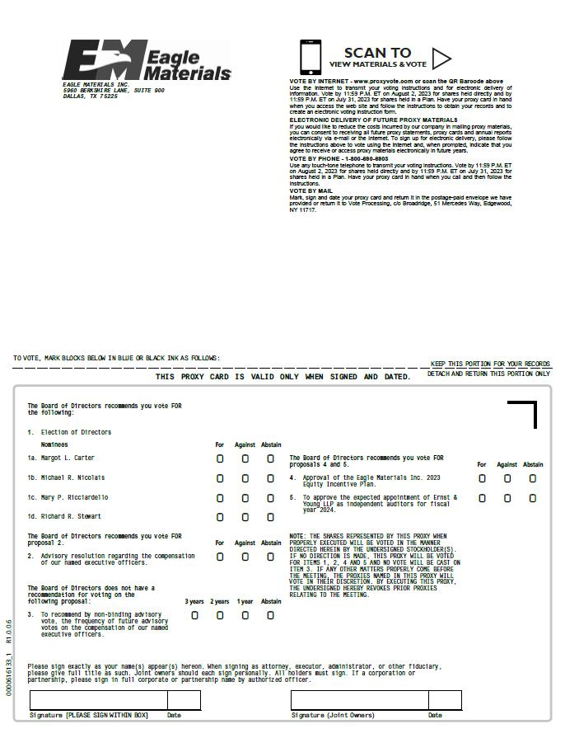
THIS PROXY CARD IS VALID ONLY WHEN SIGNED AND DATED. KEEP THIS PORTION FOR YOUR RECORDS DETACH AND RETURN THIS PORTION ONLY TO VOTE, MARK BLOCKS BELOW IN BLUE OR BLACK INK AS FOLLOWS: Signature [PLEASE SIGN WITHIN BOX] Date Signature (Joint Owners) Date SCAN TO VIEW MATERIALS & VOTE 0 0 0 0 0 0 0 0 0 0 0 0 0 0 0 0 0 0 0 0 0 0 0 0 0 0000616133_1 R1.0.0.6 EAGLE MATERIALS INC. 5960 BERKSHIRE LANE, SUITE 900 DALLAS, TX 75225 VOTE BY INTERNET - www.proxyvote.com or scan the QR Barcode above Use the Internet to transmit your voting instructions and for electronic delivery of information. Vote by 11:59 P.M. ET on August 2, 2023 for shares held directly and by 11:59 P.M. ET on July 31, 2023 for shares held in a Plan. Have your proxy card in hand when you access the web site and follow the instructions to obtain your records and to create an electronic voting instruction form. ELECTRONIC DELIVERY OF FUTURE PROXY MATERIALS If you would like to reduce the costs incurred by our company in mailing proxy materials, you can consent to receiving all future proxy statements, proxy cards and annual reports electronically via e-mail or the Internet. To sign up for electronic delivery, please follow the instructions above to vote using the Internet and, when prompted, indicate that you agree to receive or access proxy materials electronically in future years. VOTE BY PHONE - 1-800-690-6903 Use any touch-tone telephone to transmit your voting instructions. Vote by 11:59 P.M. ET on August 2, 2023 for shares held directly and by 11:59 P.M. ET on July 31, 2023 for shares held in a Plan. Have your proxy card in hand when you call and then follow the instructions. VOTE BY MAIL Mark, sign and date your proxy card and return it in the postage-paid envelope we have provided or return it to Vote Processing, c/o Broadridge, 51 Mercedes Way, Edgewood, NY 11717. The Board of Directors recommends you vote FOR the following: 1. Election of Directors Nominees For Against Abstain 1a. Margot L. Carter 1b. Michael R. Nicolais 1c. Mary P. Ricciardello 1d. Richard R. Stewart The Board of Directors recommends you vote FOR proposal 2. For Against Abstain 2. Advisory resolution regarding the compensation of our named executive officers. The Board of Directors does not have a recommendation for voting on the following proposal: 3 years 2 years 1 year Abstain 3. To recommend by non-binding advisory vote, the frequency of future advisory votes on the compensation of our named executive officers. The Board of Directors recommends you vote FOR proposals 4 and 5. For Against Abstain 4. Approval of the Eagle Materials Inc. 2023 Equity Incentive Plan. 5. To approve the expected appointment of Ernst & Young LLP as independent auditors for fiscal year 2024. NOTE: THE SHARES REPRESENTED BY THIS PROXY WHEN PROPERLY EXECUTED WILL BE VOTED IN THE MANNER DIRECTED HEREIN BY THE UNDERSIGNED STOCKHOLDER(S). IF NO DIRECTION IS MADE, THIS PROXY WILL BE VOTED FOR ITEMS 1, 2, 4 AND 5 AND NO VOTE WILL BE CAST ON ITEM 3. IF ANY OTHER MATTERS PROPERLY COME BEFORE THE MEETING, THE PROXIES NAMED IN THIS PROXY WILL VOTE IN THEIR DISCRETION. BY EXECUTING THIS PROXY, THE UNDERSIGNED HEREBY REVOKES PRIOR PROXIES RELATING TO THE MEETING. Please sign exactly as your name(s) appear(s) hereon. When signing as attorney, executor, administrator, or other fiduciary, please give full title as such. Joint owners should each sign personally. All holders must sign. If a corporation or partnership, please sign in full corporate or partnership name by authorized officer.

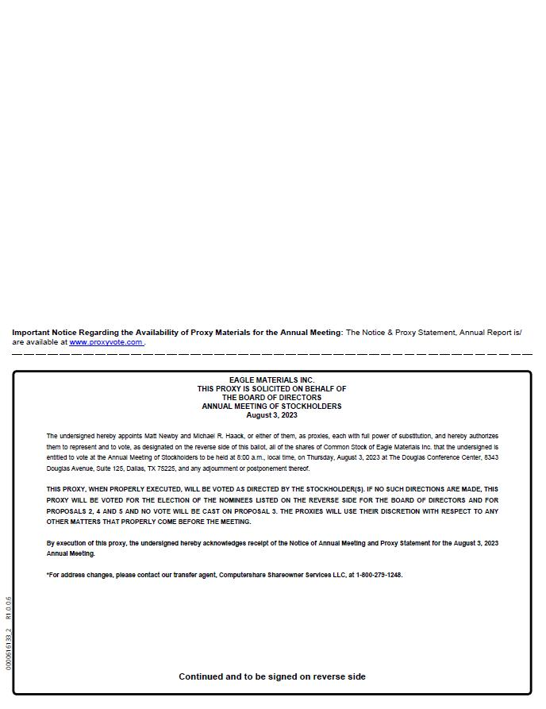
0000616133_2 R1.0.0.6 Important Notice Regarding the Availability of Proxy Materials for the Annual Meeting: The Notice & Proxy Statement, Annual Report is/ are available at www.proxyvote.com . EAGLE MATERIALS INC. THIS PROXY IS SOLICITED ON BEHALF OF THE BOARD OF DIRECTORS ANNUAL MEETING OF STOCKHOLDERS August 3, 2023 The undersigned hereby appoints Matt Newby and Michael R. Haack, or either of them, as proxies, each with full power of substitution, and hereby authorizes them to represent and to vote, as designated on the reverse side of this ballot, all of the shares of Common Stock of Eagle Materials Inc. that the undersigned is entitled to vote at the Annual Meeting of Stockholders to be held at 8:00 a.m., local time, on Thursday, August 3, 2023 at The Douglas Conference Center, 8343 Douglas Avenue, Suite 125, Dallas, TX 75225, and any adjournment or postponement thereof. THIS PROXY, WHEN PROPERLY EXECUTED, WILL BE VOTED AS DIRECTED BY THE STOCKHOLDER(S). IF NO SUCH DIRECTIONS ARE MADE, THIS PROXY WILL BE VOTED FOR THE ELECTION OF THE NOMINEES LISTED ON THE REVERSE SIDE FOR THE BOARD OF DIRECTORS AND FOR PROPOSALS 2, 4 AND 5 AND NO VOTE WILL BE CAST ON PROPOSAL 3. THE PROXIES WILL USE THEIR DISCRETION WITH RESPECT TO ANY OTHER MATTERS THAT PROPERLY COME BEFORE THE MEETING. By execution of this proxy, the undersigned hereby acknowledges receipt of the Notice of Annual Meeting and Proxy Statement for the August 3, 2023 Annual Meeting. *For address changes, please contact our transfer agent, Computershare Shareowner Services LLC, at 1-800-279-1248. Continued and to be signed on reverse side

