UNITED STATES
SECURITIES AND EXCHANGE COMMISSION
WASHINGTON, D.C. 20549

SCHEDULE 14A
Proxy Statement Pursuant to Section 14(a) of the
Securities Exchange Act of 1934
(Amendment No. )

Filed by the Registrant ☒
Filed by a Party other than the Registrant ☐
Check the appropriate box:

☐ | Preliminary Proxy Statement

☐ | Confidential, for Use of the Commission only (as permitted by Rule 14a-6(e)(2))

☐ | Definitive Proxy Statement

☒ | Definitive Additional Materials

☐ | Soliciting Material Pursuant to § 240.14a-12
EAGLE MATERIALS INC.
(Name of Registrant as Specified In Its Charter)
(Name of Person(s) Filing Proxy Statement, if other than the Registrant)
Payment of Filing Fee (Check the appropriate box):

☒ | No fee required.

☐ | Fee paid previously with preliminary materials.

☐ | Fee computed on table in exhibit required by Item 25(b) per Exchange Act Rules 14a-6(i)(1) and 0-11

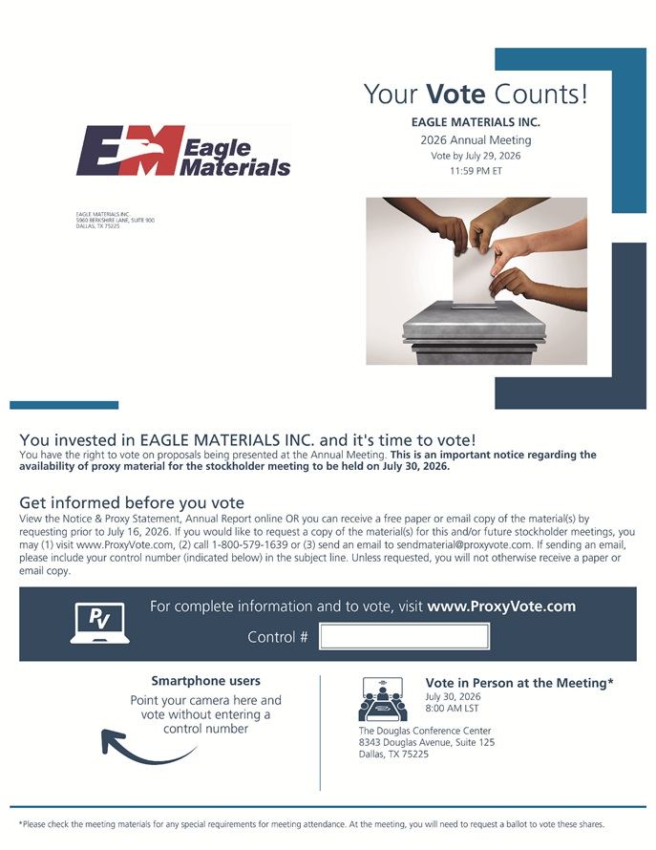
Eagle Materials EAGLE MATERIALS INC. 5960 BERKSHIRE LANE, SUITE 900 DALLAS, TX 75225 Your Vote Counts! EAGLE MATERIALS INC. 2026 Annual Meeting Vote by July 29, 2026 11 :59 PM ET You invested in EAGLE MATERIALS INC. and it’s time to vote! You have the right to vote on proposals being presented at the Annual Meeting. This is an important notice regarding the availability of proxy material for the stockholder meeting to be held on July 30, 2026. Get informed before you vote View the Notice & Proxy Statement, Annual Report on line OR you can receive a free paper or email copy of the material(s) by requesting prior to July 16, 2026. If you would like to request a copy of the material(s) for this and/or future stockholder meetings, you may (1) visit www.ProxyVote.com, (2) call 1-800-579-1639 or (3) send an email to sendmaterial@proxyvote.com. If sending an email, please include your control number (indicated below) in the subject line. Unless requested, you will not otherwise receive a paper or email copy. Smartphone users Point your camera here and vote without entering a ~Inumber Vote in Person at the Meeting* July 30, 2026 8:00 AM LST The Douglas Conference Center 8343 Douglas Avenue, Suite 125 Dallas, TX 75225 *Please check the meeting materials for any special requirements for meeting attendance. At the meeting, you will need to request a ballot to vote these shares.

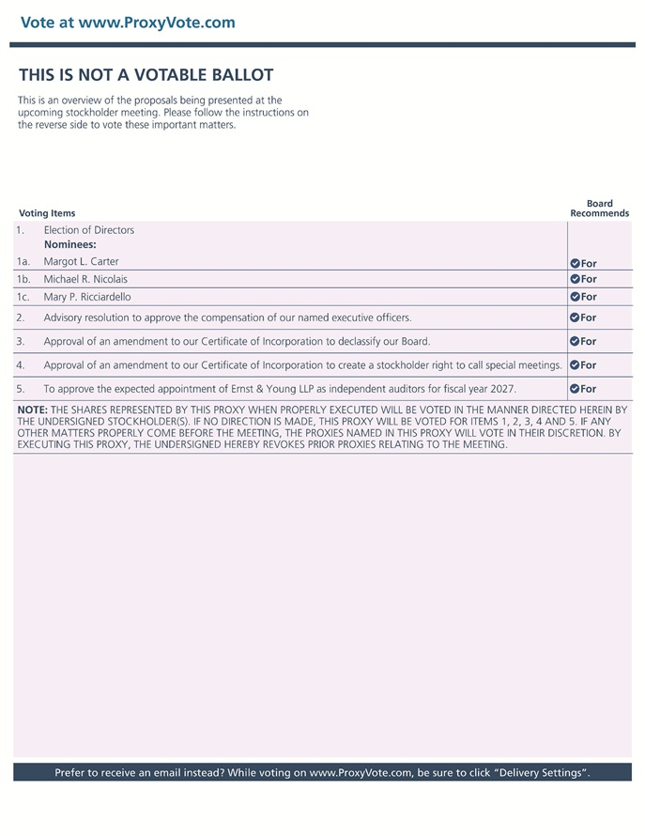
Vote at www.ProxyVote.com THIS IS NOT A VOTABLE BALLOT This is an overview of the proposals being presented at the upcoming stockholder meeting. Please follow the instructions on the reverse side to vote these important matters. Board Voting Items Recommends 1. Election of Directors Nominees: 1a . Margot L. Carter 0 For 1b . Michael R. Nicolais 0 For 1c . Mary P. Ricciardello 0 For 2. Advisory resolution to approve the compensation of our named executive officers. 0 For 3. Approval of an amendment to our Certificate of Incorporation to declassify our Board. 0 For 4. Approval of an amendment to our Certificate of Incorporation to create a stockholder right to call special meetings. 0 For 5. To approve the expected appointment of Ernst & Young LLP as independent auditors for fiscal year 2027. 0 For NOTE: THE SHARES REPRESENTED BY THIS PROXY WHEN PROPERLY EXECUTED WILL BE VOTED IN THE MANNER DIRECTED HEREIN BY THE UNDERSIGNED STOCKHOLDER(S). IF NO DIRECTION IS MADE, THIS PROXY WILL BE VOTED FOR ITEMS 1, 2, 3, 4 AND 5. IF ANY OTHER MATTERS PROPERLY COME BEFORE THE MEETING, THE PROXIES NAMED IN THIS PROXY WILL VOTE IN THEIR DISCRETION. BY EXECUTING THIS PROXY, THE UNDERSIGNED HEREBY REVOKES PRIOR PROXIES RELATING TO THE MEETING. Prefer to receive an email instead? While voting on www.ProxyVote.com, be sure to click “Delivery Settings”.

